ISSUE 293

Observable entities, dimensions and measurements

Since E54 Dimension is conceived as approximation of quantifiable properties, true quantities independently on the numerical values, we may have different kinds of measurements:
• space * related issue 388 – it seems that in some cases we measure approximations of phenomenal places in the context of an observation event. All this information falls within the time of observation events.
• time *
Existing example in CRM: “The AD1262-1312, 1303-1384 calibrated C14 date for the Shroud of Turin”
• static things (quantities/qualities of things such as height, weight, etc. or for example conceptual (through carriers) : can I count the letters of a word or the numbers?
• continua (things like the water flow, the tide, the speed of the wind, etc.)= it seems that we measure properties that we observe in evolving dynamic space-time procedures, and in that sense we can describe such a reality.

Below I mention information from different cases of measurements we have studied from
case studies from InGeoCloudS - INspiredGEOdata CLOUD Services D2.2 2012;D2.3 2013:

1. GEOLOGICAL DATA:
Scenario based on hydrogeological datasets, which refer on the measurement of the water level within a borehole. The lab keeps information about the date of the measurement, along with some characteristics as the quality of the measurement and the method, which was followed on this activity. They also keep information about the person who did the measurement and they correlate the measurement with the borehole where it took place and the intake, which was measured. In this activity different calculations take place apart from the water level, such as the water level in meters over the main sea level, the water level under terrain and the water level under the given reference point.

A CASE OF A FIELD MEASUREMENT OF WATER LEVEL
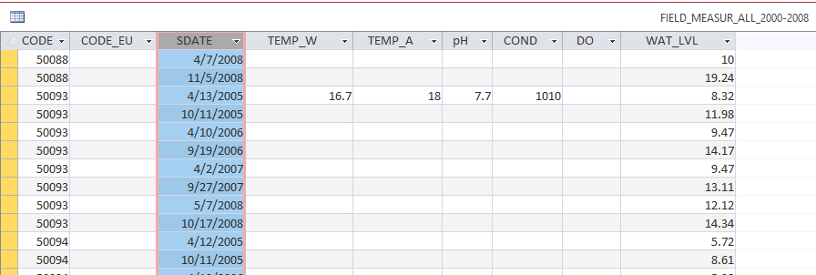

A CASE OF CHEMICAL ANALYSIS
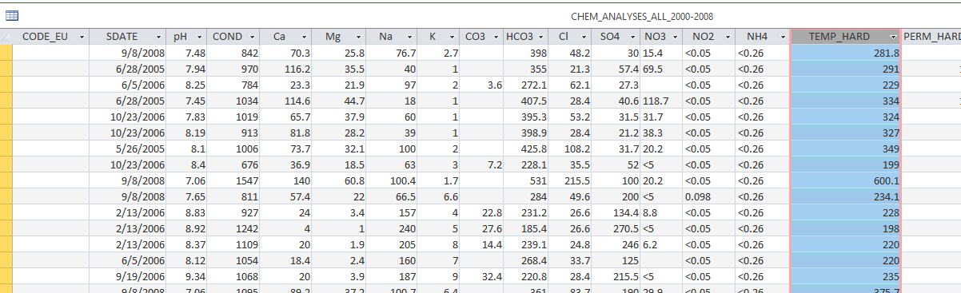

2. SEISMOLOGICAL DATASETS are about:
- Earthquake
- Network of sensors
- Recordings
- ShakeMap calculation output

A scenario of Seismic Recording
The emergence of an earthquake event triggers its recording by the sensors which are located in the geophysical stations. For every such event they relate its recording with the sensor (e.g Accelerometer) which measured it. Every recording can be multiply classified as the original shockwave recording and as the result of the evaluation over the recordings which came from the sensors (Data_Evaluation) which can be the result of filtering or other type of processing. This multiple classification leads to different related properties. Considering a recording as an original shockwave recording, the relation O17.has_dimension is used to describe the intensity value of the observation (notion Intensity) and the regression distance (notion Distance). On the other hand if we consider a recording as a derivative of the original recording we measure different features of the recording. Every recording comes from three different channels namely, HHE, HHN, HHZ. For each one of these channels the scientists are interested in the peak velocity (notion pgv), the peak acceleration (notion pga) and the spectral acceleration at 0.3, 1.0, 3.0 seconds (notions psa03, psa10, psa30).
Seismic events are recorded by geophysical stations. For each station they keep its location (Latitude, Longitude), its name (notion Site) and they measure the shear-wave velocity between 0 and 30 meters depth (notion VS30). Each station consists of sensors, which are the recording instruments for earthquakes. Sensors have allocation, meaning a sensor belongs in a station. Each sensor has information about its communication type (analog or digital) using notion commtype and a description of the instrument type (notion insttype). The available sensors from a specific station constitute a network, which is also described.
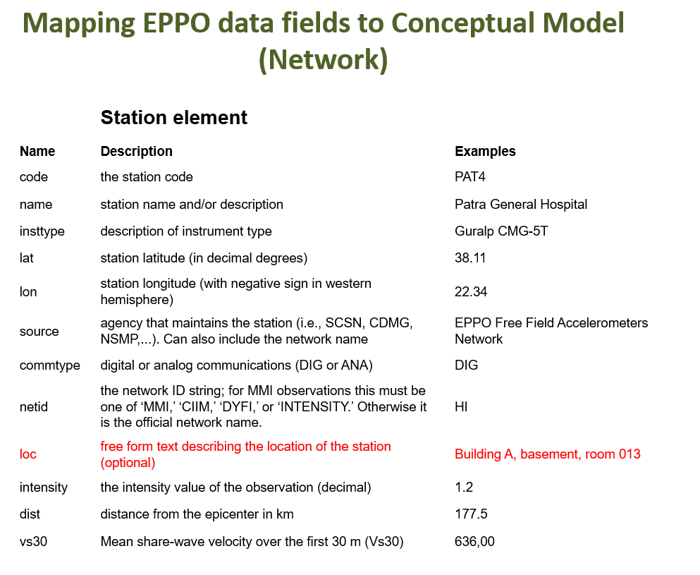

Xml instance describing data kept for stations and earthquake dimension:
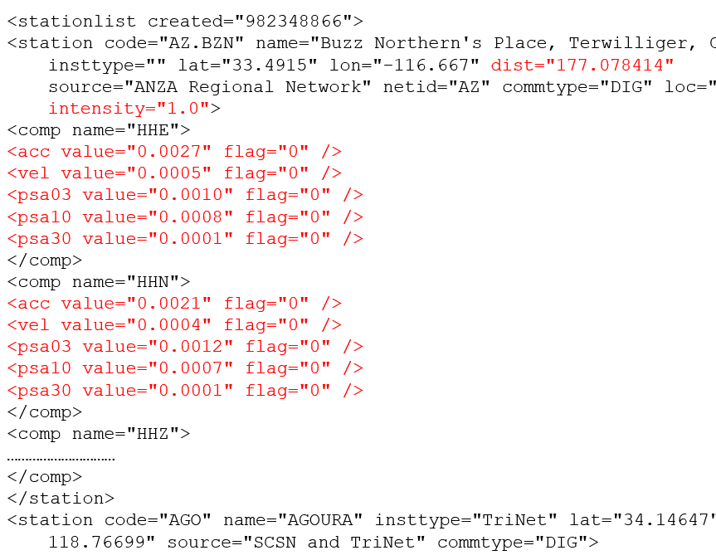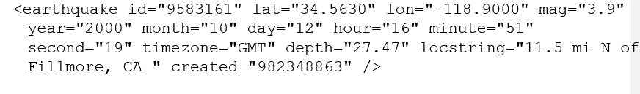
3. LANDSLIDE INFORMATION: what is being documented and measured:

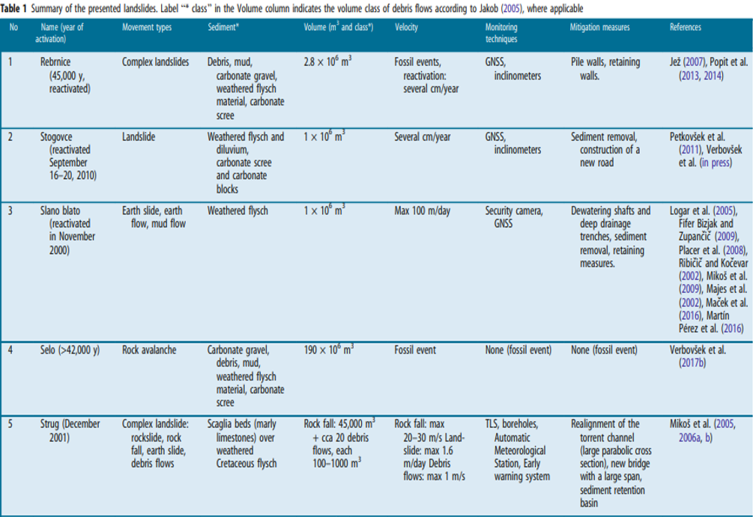
Jemec Auflič, M., Jež, J., Popit, T. et al. Landslides (2017) 14: 1537.

