ISSUE 358: CRMsoc and scope of CRM modules
- MD presented his slides on the Business Model (Martin’s post and ppt on 22/3/2019, See appendix A)
  - There was a question regarding the nature of proposed class SO3 Obligation, and MD clarified that it is considered as a debt essentially. Proposed properties SC2, SC3, SC4, SC5 who take SO3 Obligation as range amount to linking the activities of generating, increasing, decreasing and debt repayment.
  - HW: MD, GB, AG, CEO are to provide the definition of the classes and properties of the Business model and their FOL representation.
- Introduction and scope of CRMsoc by GB, TV, FB, VA (skype):
  - There were questions regarding the accessibility of the material and relevant discussions on CRMsoc through the CRM site, given that the document of the last updated version of CRMsoc (including definitions of classes and properties) was an export from ONntoME.
GB proposed that the discussion be transferred to the Issues list, under a CRM-soc designated block in the CRM-site and that comments on the classes and properties be made through OntoME.
TV considers it best not to resume the discussion regarding CRMsoc under two different channels, and proposed to use OntoME for editorial changes of the definitions.
FB, MD, CB suggested that the main discussion concerning the CRMsoc should go to the CRMsig list, so that anyone who wishes to can comment.
DECISION: a new sub-site for CRMsoc is to be created within the site of CRM. The introductory text on the site should refer to the use of OntoME.
  - The sig went through the introduction (scope and naming conventions).
DECISION: The CRM-sig accepted the introductory text to CRMsoc with minor modifications (See Appendix B). There was also agreement regarding the proposed naming conditions.
DECISION: The main focus of Issue 358 was to declare the scope and naming conventions for CRMsoc. This has been achieved, hence the issue is closed. Discussions on CRMsoc will resume in a separate, new issue.
  - The CRM-sig then decided to go through the Activity Plans (related issue 333) and Rights (related issue 408) and examine them separately and then resume the property definitions proposed for CRMsoc and decide on the issues to be merged.

Appendix A
Issue 385 Martin’s proposal
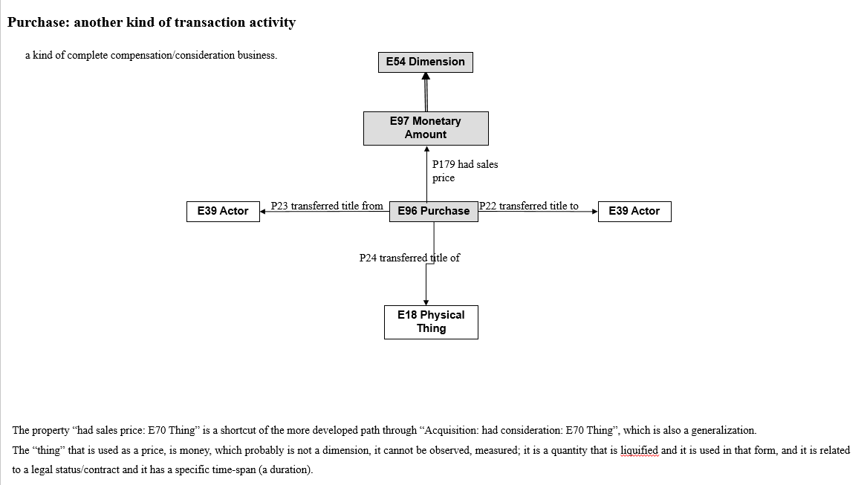
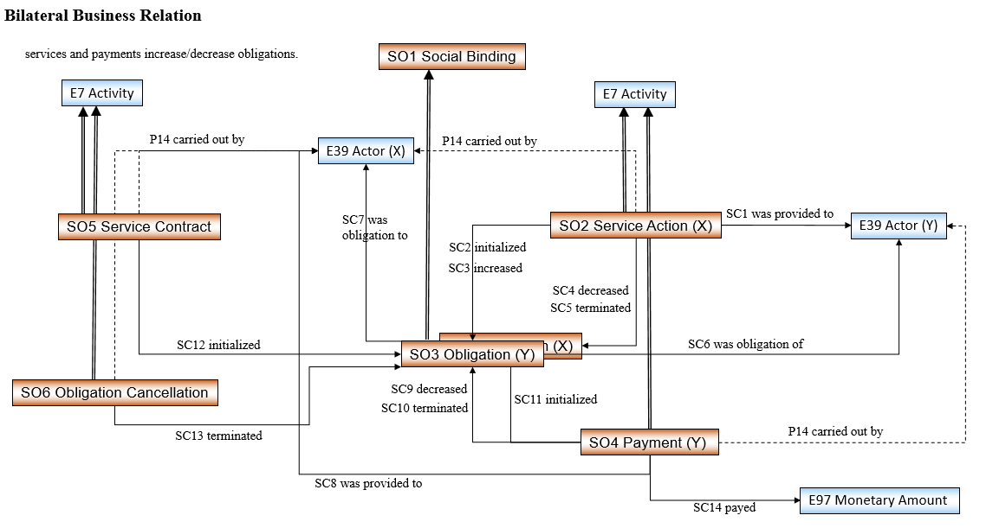
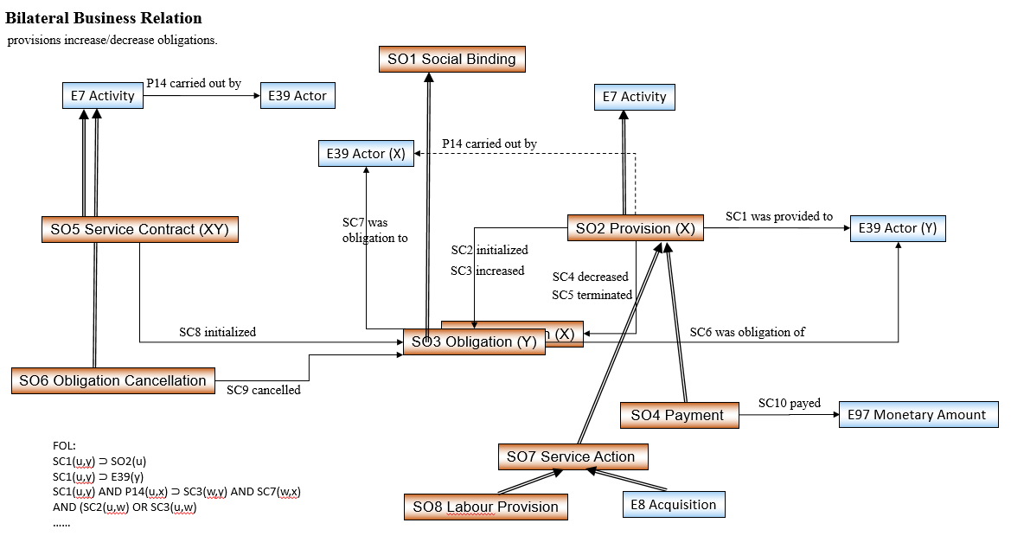

Appendix B

CRMsoc Introduction (scope and naming conventions text)
1.1 Introduction
1.1.1 Scope

This document presents CRMsoc, an extension of CIDOC CRM created to support and capture social documentation.
CRM Social is a domain ontology extending the ISO21127 ontology CIDOC CRM, that can be used to (re-)encode data that document social phenomena and constructs that are typically recorded by humanities and social science scholars based on their analysis and transcription of primary documentary evidence or their representation of observational data in structured digital form. The kinds of social phenomena and constructs recorded by humanities and social science scholars extend beyond the practical scope of the CIDOC CRM in that they relate to the recording of indirectly observable, social phenomena and facts. CRM Social is being developed as a compatible extension of CIDOC CRM in order to be able to draw on its event oriented modelling and its capacity to represent facts related to cultural heritage while extending this to be able to represent and relate social facts and life. The expanded breadth and scope of CRM Social is presently under development but aims to take under its aegis documentation related to the representation of social facts recognizable by social agents and interpreters through intuition and inference. At this moment the following areas of analysis have been identified to be of interest and to fall within this scope:
- Characteristics of human beings, as individuals or groups (Mental attitude)
- Social relations, including between people (such as family and professional relationships), between people and groups (such as nationality and gender), and between groups (companies, NGOs, political parties).
- Rights and duties (such as ownership by inheritance and legal requirements by birth)
- Economic activities, including relations between people and things, such as financial transactions leading to ownership.
- Plans, including expressing proposed activities (for example in conservation and collection care planning) and legislation.
- Evaluations, including assessing risks and estimating the value of things.

CRM Social is being developed in relation to a growing body of primary humanities and social science schemas offered for analysis and incorporation by an active community of researchers. At present the list of considered schemas includes : the SPECTRUM museum standard (e.g. Acquisition and Accessioning procedure and Documentation planning procedure), the Linked Art community, Data for History consortium and the domain of heritage conservation.

1.1.2 Status

Under development!
1.1.3 Naming Convention

CRM Social classes and properties are given both a name and an identifier following the conventions of the CIDOC CRM. Class identifiers start with the letters "socE" and are followed by a number. Property identifiers start with the letters "socP" and are also followed by a number. When using a property in the reverse direction (inverse property) the identifier is further followed by the letter “i” (see also section Applied Form → Naming Conventions of the CIDOC-CRM definition document).

