ISSUE 459: Modelling Principles (Intro to the CRM)
The sig went through the text of the introduction to the CRM section that has to do with the modelling principles and the examples supplied and reviewed the changes that the reviewers proposed. The sig only discussed parts of the text that had previously been judged unclear by the reviewing team. There were no issues regarding the rest of the document. The text in its final form appears in the appendix.
DECISION (overall) regarding the introductory section of the CRM: Given that the document still needs editing it won’t be ready to be submitted at ISO before the 47th sig meeting. In view of that, it was decided that the next version (7.0) will become the official version for the sig community (because we can’t rely on 6.2.1 with all the changes implemented over the last year). This version will appear in RDF as well. Extensive email votes will be held in the period leading up to the next meeting.
Following the next sig meeting, updates in the introduction will also be incorporated in the official version (v.7.1) which will then be submitted to ISO.
- Reality, Knowledge Bases and CIDOC CRM (first paragraph)
DECISION: The sig appointed MD to rephrase the first paragraph (see below) of this section [HW]
  - The reformulation should not refer to a “vocabulary” –to avoid confusion with thesauri (even though this is an unwarranted connection). Also, the reference to the definition of formal ontology by Guarino should be made into a footnote.
  - It should be made clear what is meant by “non-technical audience”, namely they are not necessarily computer scientists.
The CIDOC CRM is a formal ontology in the sense introduced by N. Guarino that is a specific vocabulary used to describe a part of reality, plus a first-order logical theory narrowing down the intended meaning of the vocabulary words (N. Guarino 1998). The syntax and formal semantics of this first-order theory are given in (Meghini & Doerr 2018), where the computational aspects are also discussed. The present document is intended for a non-technical audience; therefore, it focuses on the informal semantics and on the pragmatics of the CIDOC CRM vocabulary, offering a detailed discussion of the main traits of the conceptualization underlying the CIDOC CRM through the basic usage patterns
DECISION: Editorial change, DELETE “descriptions of”
A formal ontology, such as the CIDOC CRM, constitutes a controlled language for talking about particulars. I.e., it provides descriptions of classes and properties for categorizing particulars as so-called “instances” in a way that their individuation, unity and relevant properties are as unambiguous as possible.
DECISION: provide links or references to the classes and properties’ definitions mentioned throughout the introduction, given that they have not been previously introduced in this section of the document.
- Knowledge Creation Process of Knowledge Base Contents
DECISION: This section has been renamed “Authorship of Knowledge Base Contents”.
DECISION: The following sentence needs be further revised; it must be made clear that incompleteness of information is not the same as the existence of contradictory statements within a DB. CEO is on the rewrite [HW]. MD proposed that it be made into a footnote. Once it’s been edited, it will be put up for an e-mail vote.
Statements in a KB may be in contradiction to the ontologically defined quantification of properties without the KB being broken or invalid in any sense, either because necessary properties are unknown or there exist good reasons to assume alternative values for properties with limited cardinality, be it by the same or by different maintainers
- Extensions of CIDOC CRM
DECISION: Add a clause at the end of the second paragraph: “These ‘underdeveloped’ concepts can be considered as candidate superclasses for compatible extensions, in particular for disciplines with a respective focus. Additions to the model are known as extensions, while the main model is known as CRMbase.”

  - Mechanism 4, conservative extension
DECISION: The sig edited the 4th, 5th & 6th paragraphs of this subsection. The edited text can be found below (edits are marked in boldface):
If case (2) should be documented and implemented in an extension module separate from the CIDOC CRM, it may come in conflict with the current way knowledge representation languages, such as RDF/OWL, treat it, because in formal logic changing the range or domain of a property is regarded as changing the ontological meaning completely; there is no distinction between the meaning of the property independent of domain and range and the specification of the domain and range. It is, however, similar to what in logic is called a conservative extension of a theory, and necessary for an effective modular management of ontologies.
Therefore, for the interested reader, we describe here a definition of this case in terms of first order logic, which shows how modularity can formally be achieved:
Let us assume a property P defined with domain class A and range class C also holds for a domain class B, superclass of A, and a range class D, superclass of C, in the sense of its ontological meaning in the real world. We describe this situation by introducing an auxiliary formal property P’, defined with domain class B and range class D, and apply the following logic:
A(x) ⊃ B(x)
C(x) ⊃ D(x)
P(x,y) ⊃ A(x)
P(x,y) ⊃ C(y)
P’(x,y) ⊃ B(x)
P’(x,y) ⊃ D(y)
Then, P’ is a conservative extension of P if: A(x) ∧ C(y) ∧ P’(x,y) ≡ P(x,y)
In the Extensions of CIDOC CRM, in the third paragraph of mechanism 4, the following phrase was added:
“This case is a monotonic extension and generally recommended, because it enables bottom-up evolution of the model”
DECISION: This addition resolves issue 298; which should be closed.
- Monotonicity
DECISION: The sig deleted the phrase “Additions to the model are known as extensions, while the main model is known as CRMbase” from the 3rd paragraph, as it was moved to extensions, above. The paragraph now reads:
A first consequence of this commitment, at the level of the model, is that the CIDOC CRM aims to be monotonic in the sense of Domain Theory. That is to say, the existing CIDOC CRM constructs and the deductions made from them should remain valid and well-formed, even as new constructs are added by extensions to the CIDOC CRM. Any extensions should be, under this method, backwards compatible with previous models. The only exception to this rule arises when a previous construct is considered objectively incorrect by the domain experts and thus subjected to corrective revision. Adopting the principle of monotonicity has active consequences for the basic manner in which classes and properties are designed and declared in the CIDOC CRM. In particular, it forbids the declaration of complement classes, i.e. classes solely defined by excluding instances of some other classes
DECISION: hierarchical relations of specialization are to be constantly abbreviated by IsA throughout the text.
DECISION: editorial change: preposition selection
Such a system supports scholars being able to integrate all information about potentially relevant phenomena into the information system without forcing an over or under commitment to knowledge about the object.
DECISION: edit reference to paragraph “Knowledge generation process of Knowledge Base Contents” to “Authorship of Knowledge Base Contents”.
- Disjointness
DECISION: The sig deleted any reference to possible worlds from the definition of disjointness. Necessity was expressed through modal operators. Only the opening sentence of this section changed. The new text reads:
Classes are disjoint if they cannot share any common instances at any time, past, present or future.
- Introduction to the basic concepts
DECISION: paragraph 5., deletion of the last sentence as it appears verbatim in paragraph 6. The new text reads:
The real-world entities, which the event centric modelling of the CIDOC CRM aims to enable the accurate historical description of, are captured through E77 Persistent Item and its subclasses. E77 Persistent Item is used to describe entities that are relatively stable in form through the passage of time, maintaining a recognizable identity because their significant properties do not change. Specific subclasses of E77 Persistent Item can illustrate this point. E22 Human Made Object is used for the description of discrete, physical objects having been produced by human action, such as an artwork or monument. An artwork or monument is persistent with regards to its physical constitution. So long as it retains its general physical form it is said to exist and to participate in the flow of historical events. E28 Conceptual Object is also used to describe persistent items but of a mental character. It is used to describe identifiable ideas that are named and form an object of historical discourse. Its identity conditions rely in having a carrier by which it can be recalled. The entities described by E77 Persistent Item are prone to change through human activity, biological, geological or environmental processes, but are regarded to continue to exist and be the same just as long as such changes do not alter their basic identity (essence) as defined in the scope note of the relevant class. Continuous matter, such as atmosphere, or things lacking sufficient stability or differentiation, such as s=clouds, are not instances of E77 Persistent Item. Discourse about such items may be documented with concepts of the CIDOC CRM as observations in relation to things of persistent identity, such as places.
  - FIGURES
    - Figure 1: properties of basic properties;
DECISION: The figure to be moved where its caption is.
    - Figure 2: Winkelmann sees the statue of Laocoon.
DECISION: The sig agreed with the diagram provided and the text explaining it (Appendix, Introduction to the basic concepts, figure 2). Minor suggested editions involve clarifying that the thumbnail pictures represent the person/object and do not stand for the visual items representing said entities (maybe in a footnote).
    - Figure depicting how the paths of Winkelmann and the statue of Laocoon cross in space and time (i.e. how the spacetime volumes of Winkelmann and Laocoon’s statue meet).
DECISION: the figure is going to be incorporated in the CIDOC CRM definition (introduction to the basic concepts section). It will become figure 3 in version 7.0. However, the specifics of the representation need be reworked, because the diagram in its current form gives the wrong impression regarding the direction of movements and the succession of movements from one place to the next.
HW: ML is to contact KD to provide a better visualization for that.

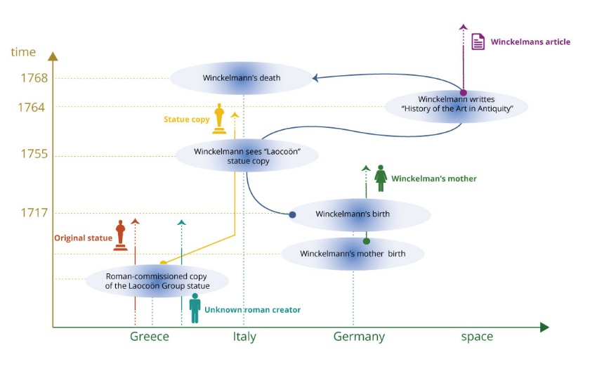
    - Figure 3 (current): Spatial information
DECISION: The sig reviewed the diagram and accepted it as is. It will be renamed “Figure 4: reasoning about spatial information”.
NOTE: P157 is at rest relative to (provides reference space for) was deliberately omitted in the diagram on spatial information. It is represented in (current) figure 5.
    - Figure 4 (current): Temporal Information
DECISION: The sig edited the cardinalities for P4 has time span and P170 defines time.
- the cardinality of P4 has time-span [D: E2 Temporal Entity; R: E52 Time-Span] changed from (1,1:1,n) to (0,1:0,n), and
- the cardinality of P170 defines time [D: E61 Time Primitive; R: E52 Time-Span] changed from (1,1:0,n) to (0,1:0,n).
DECISION: The sig opted for representing properties P173 through P185 with only one arrow rather than two or more
DECISION: Figure 4 (current) will be renamed “fig.5 reasoning about temporal information”
    - Figure 5 (current): reasoning with spacetime volumes
DECISION: The sig accepted the diagram as is, proviso the double arrow representing three properties among spacetime volumes. One arrow should suffice to represent all three properties (P10, P132, P133)
DECISION: Figure 5 (current) will be renamed “fig.6 reasoning with spacetime volumes”

