Temporal projections, time primitives and E52 Time-Span – some notes
C-E Ore, 31.07.2016
The homework issue is to rewrite the scope notes for the suggested new time primitives. There are six new time primitives, five new properties + one super property. They are all topological (along the time dimension), that is, express relations between the temporal extent of temporal entities. The rationale is to make a set of primitive temporal conditions that expresses influence between two activities (page 9 in the time primitives document). Can topological relations express influence or intentions? Hardly, but they can describe topological scenarios that are necessary for an intended continuation to be possible, for example, P134 continued (was continued by). All the existing 7 Allan-operators can be expressed by pairs of the new properties. This is fine.

E92 Spacetime volume
In 2013 CRM was extended with the class for spacetime volumes, E92 Spacetime volume. There are two projections, one for the temporal component and one for the spatial component(s).
E92 Spacetime volume P160 has temporal projection E52 Time-Span
E92 Spacetime volume P161 has spatial projection E53 Place
Before the introduction of E92 Spacetime volume and the two projections, E52 Time-Span may look a little superfluous and unnecessary. All the essential topological time operators were defined with E2 Temporal Entity as domain and range. The projections make it easier to see E52 Time Span as a pendant to E53 Space. With a minor change in the cardinality of P4 has time span every instance of E2 Temporal Entity and E92 Spacetime volume has one and only one instance of E52 Time-Span as its temporal projection. Then there will be a 1-1 relation between E2 Temporal Entity and E52 Time-Span, in fact an isomorphism. That is, every property in one of the classes can be seen as a property in the other by the use of the temporal projection (P4 has timespan/ P160 is temporal projection).
This 1-1 relationship implies that in the model the time primitives may have E52 Time-Span as domain and range instead of E2 Temporal Entity. The class E52 Time-Span is defined to be
“This class comprises abstract temporal extents, in the sense of Galilean physics, having a beginning, an end and a duration. […] “
The six new time primitives are defined in terms of start points and endpoints of temporal entities. It may be more correct and easier to understand if the new primitives are defined in terms of start and end of time spans. The class has already two properties that express possibly fuzzy starts and ends of an instance of E52: P81 ongoing throughout and P82 some time within. These properties can be used to express standard historical reasoning through terminus ante quem and terminus post quem.
A contra argument is that an instance of E18 Physical Thing is also an instance of E92 Spacetime volume and that the new time primitives are irrelevant for instances of E52 Time-Span being temporal projections of E18 Physical Thing.
In any case the single property with E52 Time-Span as domain and range, P86 falls within, has to be harmonized with the new time primitives. It can be expressed by the pair (Pxx starts within, Pxx ends within). In case the new time primitives have E2 Time Entity as domain and range, the scope note of P86 falls within should be adjusted.

P160 has temporal projection and P4 has time span
The cardinality constrains of
E92 Spacetime volume P160 has temporal projection E52 Time-span
is (1,1:1,1) and implies that it is a 1-1 correspondence between E92 Spacetime volume and a subset of E52 Time-Span and an 1-1 correspondence between E4 Period and (a subset of) E52 Time-Span (and correspondingly for classes below E4 Period).
From the scope note for P160 has temporal projection:
“The property P4 has time span [(1,1:1,n)] is the same as P160 has temporal projection if it is used to document an instance of E4 Period or any subclass of it”).
The model-technical difference between P4 and P160 is that P4 makes it possible for a single instance of E52 Time-Span to be the timespan of two or more instances of E2 Temporal Entity as long as they are not instances of E4 Period. From the scope note for E53 Time-Span:
This class comprises abstract temporal extents, in the sense of Galilean physics, having a beginning, an end and a duration. […] Used as a common E52 Time-Span for two events, it would nevertheless define them as being simultaneous, even if nothing else was known.
The scope note of P160 implies that instances of E2 Temporal Entities with more than one instance of E52 Time-Span associated through P4 cannot be instances of the subclass E4 Period. The “trick” of simultaneousness mentioned in the scope note of E52 Time-Span is only valid for instances of E2 Temporal Entity not being instances of E4 Period, that is, not being space time volumes. An alternative way to model simultaneousness of two instances x1, x2 of E4 Period is as follows: They are respectively uniquely associated with two instances y1,y2 of E52 Time-Span through P160 has temporal projection:
y1: E52 Time-Span P86 falls within y2: E52 Time-Span &
y2: E52 Time-Span P86 falls within y1: E52 Time-Span
Thus there is no need for using a common instance of E52 Time-Span to express simultaneousness. The cardinality of P4 can be restricted to (1,1:1,1). This will make the model more consistent and P4/P160 will have the function: to project a temporal entity/spacetime volume to its temporal component.
In any case the scope note of E52 Time Span has to be adjusted; each event has one and only one timespan.

Question
The original difference between E2 Temporal Entity and P4 Period is that the latter should have at least one spatial component through P8 took place on or within. The introduction of E92 Spacetime volume gives all instance of P4 Period a spatial component. All instances of E18 Physical Thing have a temporal component.
Is it possible to have a temporal entity without a spatial component? That is, is the class E2 Temporal entity really necessary?

Comments on spatial projection
The spatial projection of an instance of E92 Spacetime volume is
E92 Spacetime volume P161 has spatial projection E53 Place
The cardinality is (1,n:1,1). An instance of E92 Spacetime volume must have at least one possibly many instances of E53 Place as spatial projection. An instance of E53 Place is the result of a spatial projection of one and only one instance of E92 Spacetime volume. There are several properties from the sub classes of E92 Spacetime volume to E93 Place. It might be worthwhile to inspect their relationship with P161 has spatial projection. Here I will only check the following:
P4 Period P7 took place at (witnessed): E53 Place
The cardinality is (1,n:0,n). Every instance of E4 Period must have at least one instance of E53 Place where it took place. Every instance x of P53 Place that is a spatial projection of an instance y of E4 Period will also be a place where y took place. The opposite is not necessarily true. The identity of a spacetime volume is given by its volume in space-time. An instance x of E92 Spacetime volume can take place on an instance y of E53 Space which is not a spatial project projection of x, but y must be either contained by a spatial projection of x or a spatial projection of x must fall within y. Is this the case or am I wrong?

Time primitives and fuzziness
In historically focused disciplines like history, philology and archaeology (and in crime genre for that matter) one often use the terms terminus ante quem (latest) and terminus post quem (earliest). In CRM the property P82 some time within correspond to earliest possible start point and latest possible end point. The property P82 ongoing through out is an inner approximation to the certain part of the time interval.
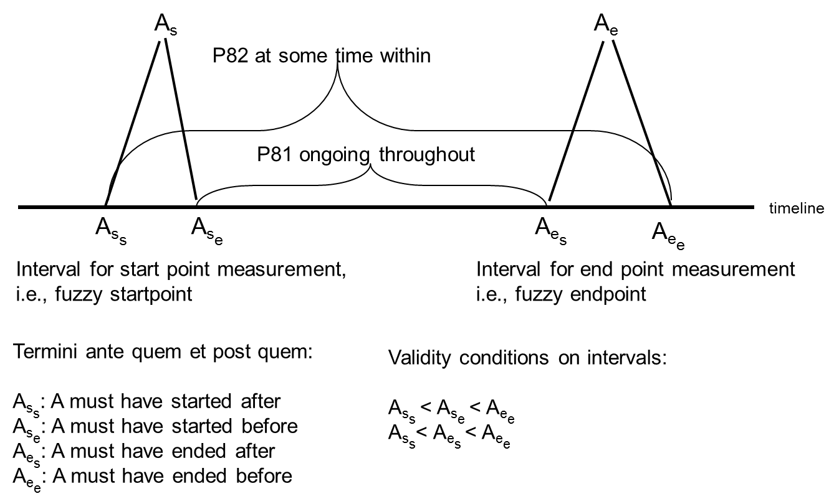
The distance between A_{ss} and A_{se} indicates the uncertainty or a fuzzy border. The figure below illustrates the correspondence with the graphical notation used in the time primitive document.

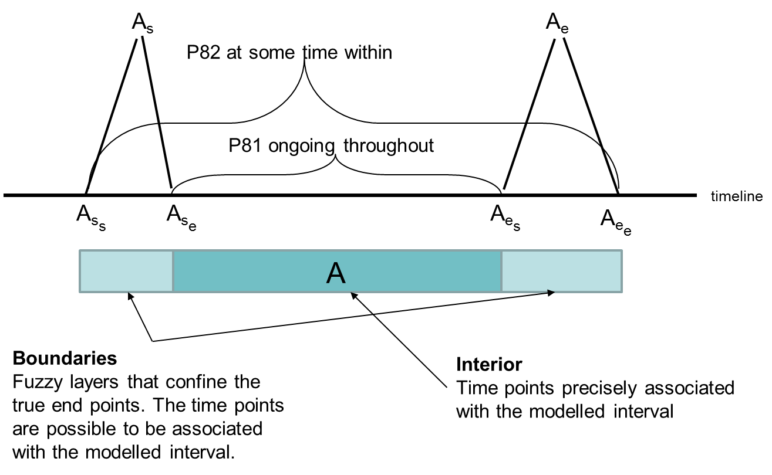
The Allan operators and the new time primitives can be expressed in terms of fuzzy start and end points. Below this is done for the new Pxx ends within as I understand it form the time primitive document, for the new Pxx ends within with the implementation used in Holmen & Ore 2009 and finally the Allan-operator P118 overlaps:
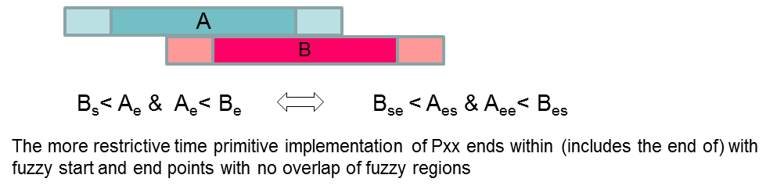

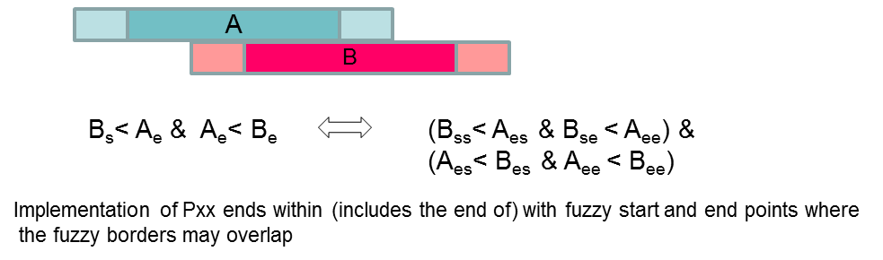
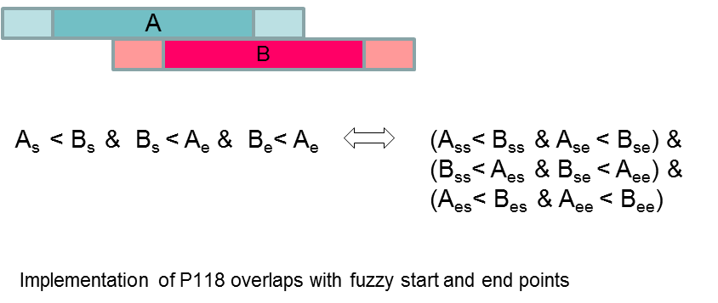

Conclusion
In the paper from CAA2009 (Holmen & Ore) we argue for possibly overlapping fuzzy boundaries from a deduction point of view. The Allan based algebra is unchanged. If we restrict the relations to non-overlapping fuzzy boundaries, the implementation will still be a model for the Allan-algebra.
The new time primitives may be the basis for an algebra on time intervals. For example, it is possible to express the Allan operators as pairs of the new primitive time operators. Thus a model satisfying the new operators will also be a model for the Allan-algebra. I have not checked in detail, but I assume that we may implement the new primitive with or without possibly overlapping fuzzy borders or without fuzziness altogether and all will be models for the algebra. Therefore my view is to leave the fuzziness to the implementation of E61 Time Primitive. I also suggest letting the domain and range of the new time primitives properties to be E52 Time-Span.

