Deleting F14 Individual Work, F15 Complex Work results in::

F1 Work
Subclass of: E89 Propositional Object
Superclass of: F16 Container Work
F21 Recording Work
F17 Aggregation Work
F18 Serial Work

Delete R9 realizes

R10 has member (is member of)
Domain: F1 Work
Range: F1 Work
Subproperty of: E89 Propositional Object. P148 has component (is component of): E89 Propositional Object
Quantification: (0,n:0,n)
Scope note: This property associates an instance of F1 Work with another instance of F1 Work that forms part of it.

R50 assigned to (was assigned by)
Domain: F42 Representative Expression Assignment
Range: F1 Work
Subproperty of: E13 Attribute Assignment. P140 assigned attribute to (was attributed by): E1 CRM Entity
Quantification: (1,1:0,n)
Scope note: This property associates the event of assigning a representative instance of F2 Expression with the instance of F1 Work to which it was assigned.

The idea:
An Expression realizes a work, it is not specified if it is the exclusive set of propositions of the expression or a more general set of ideas. This leaves the decision to the curator, which level is relevant. This changes the cardinality of R3.

Making F22 Self-Contained Expression => F2 Expression, deleting F23 Expression Fragment results in:

F2 Expression
Subclass of: E73 Information Object
Superclass of: F24 Publication Expression
F25 Performance Plan
F26 Recording
F34 KOS
F35 Nomen Use Statement
F43 Identifier Rule

Delete F23 Expression Fragment – replace by E90 Symbolic Object

R3 is realised in (realises) [=LRM-R4]
Domain: F1 Work
Range: F2 Expression
Superproperty of: F20 Performance Work. R12 is realised in (realises): F25 Performance Plan
F21 Recording Work. R13 is realised in (realises): F26 Recording
F1 Work. R40 has representative expression (is representative expression for): F2 Expression
Subproperty of: E70 Thing. P130 shows features of (features are also found on): E70 Thing
Quantification: (0,n:1,n)

R4 carriers provided by (comprises carriers of)
Domain: F2 Expression better: E90 Symbolic Object
Range: F3 Manifestation Product Type [revise based on how F3/F24 are worked out. In CRMbase, P165: PLB I'd prefer to use the "is incorporated in" Publication Expression/Manifestation structure. Might deprecate R4]
Superproperty of: F2 Expression. R41 has representative manifestation product type (is representative manifestation product type for): F3 Manifestation Product Type
Subproperty of: E73 Information Object. P128 is carried by: E24 Physical Man-Made Thing. P2 has type: E55 Type

R5 has component (is component of)
Domain: F2 Expression
Range: F2 Expression
Subproperty of: E89 Propositional Object. P148 has component (is component of): E89 Propositional Object
E90 Symbolic Object. P106 is composed of (forms part of): E90 Symbolic Object

R15 has fragment (is fragment of)
Domain: F2 Expression
Range: E90 Symbolic Object
Subproperty of: E90 Symbolic Object. P106 is composed of (forms part of): E90 Symbolic Object
Quantification: (0,n:0,n)

R17 created (was created by)
Domain: F28 Expression Creation
Range: F2 Expression
Superproperty of: F29 Recording Event. R21 created (was created by): F26 Recording
F30 Publication Event. R24 created (was created through): F24 Publication Expression
Subproperty of: E65 Creation. P94 has created (was created by): E28 Conceptual Object
Quantification: (1,1:1,n)
Scope note: This property associates the expression that was first externalised during a particular creation event with that particular creation event.

R40 has representative expression (is representative expression for)
Domain: F1 Work
Range: F2 Expression
Subproperty of: F1 Work. R3 is realised in (realises): F2 Expression
Quantification: (0,n:0,n)

R41 has representative manifestation product type (is representative manifestation product type for)
Domain: F2 Expression
Range: F3 Manifestation Product Type
Subproperty of: F2 Expression. R4 carriers provided by (comprises carriers of): F3 Manifestation Product Type
Quantification: (0,n:0,n)

R42 is representative manifestation singleton for (has representative manifestation singleton)
Domain: F4 Manifestation Singleton
Range: F2 Expression
Subproperty of: E24 Physical Man-Made Thing. P128 carries (is carried by): E73 Information Object
Quantification: (0,n:0,n)

R48 assigned to (was assigned by)
Domain: F41 Representative Manifestation Assignment
Range: F2 Expression
Subproperty of: E13 Attribute Assignment. P140 assigned attribute to (was attributed by): E1 CRM Entity
Quantification: (1,1:0,n)

R51 assigned (was assigned by)
Domain: F42 Representative Expression Assignment
Range: F2 Expression
Subproperty of: E13 Attribute Assignment. P141 assigned (was assigned by): E1 CRM Entity
Quantification: (1,n:0,n)
Scope note: This property associates the event of assigning a representative instance of F2 Expression with the F2 Expression which has been assigned.

The idea: Any Expression is self-contained. Not-self-contained parts are more generally E90 Symbolic Objects or Information Objects. The Expression Fragment is not needed, but the property is useful. An Expression Creation creates only self-contained content. If interrupted or in between, we talk about E65 Creation events as part of the overall Expression Creation.
The “representative fragment” is a fragment of the supposed-to-be-lost self-contained expression. This means, that the representative manifestation may not carry the whole expression, but only a fragment of it.

Merging F3 Manifestation Product Type with F24 Publication Expression

The idea: Carrier Production Events are more general than the Product Types. F3 and F24 appear as parallel paths. I propose to reuse the properties of F24 for F3, rename properties and rename F3 to Manifestation. If we accept original manuscripts to be Manifestations (not manually copied books), we cannot distinguish the Expression from the Manifestation, as long as we regard it as immaterial. Therefore, Manifestation MUST be a kind of Expression.

F3 Manifestation
Subclass of: F2 Expression

Properties: CLP2 should have type (should be type of): E55 Type
CLP43 should have dimension (should be dimension of): E54 Dimension
CLP45 should consist of (should be incorporated in): E57 Material
CLP46 should be composed of (may form part of): F3 Manifestation Product Type
CLP57 should have number of parts: E60 Number
We should reconsider the CLP104/105
We should reintroduce the “incorporates” property! Possibly R4? Or delete R4

Delete R6 carries (is carried by)

Delete CLR6 should carry (should be carried by)

R7 is materialization of (is materialized in) [=LRM-R4]
Domain: F5 Item
Range: F3 Manifestation
Subproperty of: E1 CRM Entity. P2 has type (is type of): E55 Type
Subproperty of: E24 Physical Man-Made Thing. P128 carries (is carried by): E73 Information Object
Quantification: (1,1:0,n)
Scope note: This property associates a publication with one of its exemplars.
It is a shortcut of the more developed path: F5 Item R28i was produced by F32 Carrier Production R26 produced things of type (was produced by): F3 Manifestation Product Type.

F32 Carrier Production Event [= LRM-R8 manufactured]
Subclass of: E12 Production
Scope note: This class comprises activities that result in instances of F54 Utilised Information Carrier coming into existence. Both the production of a series of physical objects (printed books, scores, CDs, DVDs, CD-ROMS, etc.) and the creation of a new copy of a file on an electronic carrier are regarded as instances of F32 Carrier Production Event.
Typically, the production of copies of a publication (no matter whether it is a book, a sound recording, a DVD, a cartographic resource, etc.) strives to produce items all as similar as possible to a prototype that displays all the features that all the copies of the publication should also display, which is reflected in property R27 used as source material F24 Publication Expression.
Clearly, F32 is more general than F3!
Properties: R26 produced things of type (was produced by): E99 Product Type
R27 materialized (was materialized by) F3 Manifestation
R28 produced (was produced by): F54 Utilised Information Carrier

R26 produced things of type (was produced by)
Domain: F32 Carrier Production Event
Range: E99 Product Type
Subproperty of: E12 Production. P186 produced thing of product type (is produced by): E99 Product Type
Quantification: (0,1:0,n) becomes optional!

R27 materialized (was materialized by)
Domain: F32 Carrier Production Event
Range: F24 Publication Expression F3 Manifestation
Subproperty of: E7 Activity. P16 used specific object (was used for): E70 Thing
Quantification: (0,n:0,n)
Scope note: This property associates an instance of F32 Carrier Production Event with the set of signs provided by the publisher to be carried by all of the produced items and any other foreseen physical feature.
The idea: F19 Publication Work and Manifestation Creation must pertain to the optical and material form of a distributable item. Rewrite scope note of F30. I would keep “Publication Work” as label.

F30 Publication Event [=LRM-R7 manifestation creation]
Subclass of: F28 Expression Creation
Properties: R23 created a realisation of (was realised through): F19 Publication Work
R24 created (was created through): F3 Manifestation

R23 created a realisation of (was realised through)
Domain: F30 Publication Event
Range: F19 Publication Work
Subproperty of: F28 Expression Creation. R19 created a realisation of (was realised through): F1 Work
Quantification: (0,1:0,n)
Scope note: This property associates an instance of F30 Publication Event with the instance of F19 Publication Work it realised.
Examples: Establishing in 1972 the layout, features, and prototype for the publication of Stephen Crane’s complete poems (F30) R23 created a realisation of Cornell University Press’s concepts for an edition of Stephen Crane’s complete poems (F19)

R24 created (was created through)
Domain: F30 Publication Event
Range: F24 Publication Expression F3 Manifestation
Subproperty of: F28 Expression Creation. R17 created (was created by): F2 Expression
Quantification: (1,n:1,n)
Scope note: This property associates the instance of F24 Publication Expression F3 Manifestation that was created during a particular F30 Publication Event with that F30 Publication Event.
Examples: Establishing in 1972 the layout, features, and prototype for the publication of Stephen Crane’s complete poems (F30) R24 created the set of signs and instructions as to manufacturing established by Cornell University Press for a publication of Stephen Crane’s complete poems (F24)

The following figure will become symmetric:

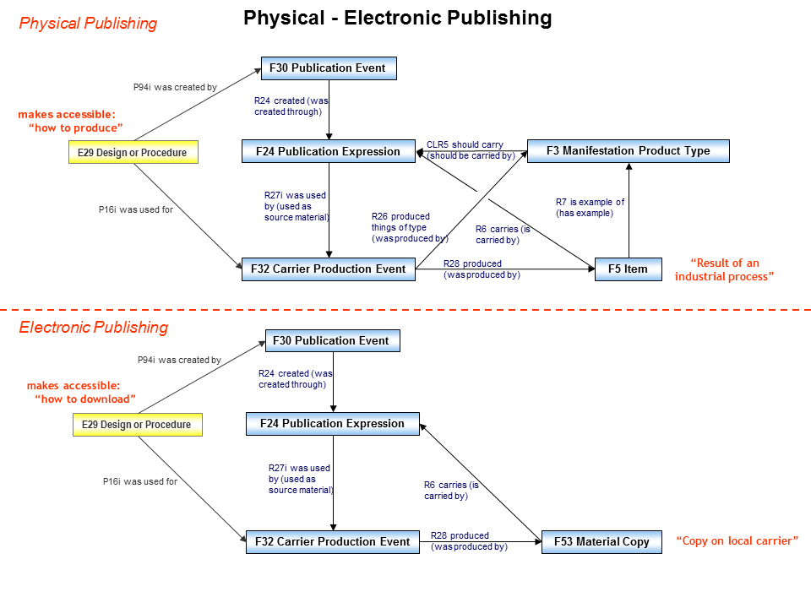
The following image becomes clear: F24 becomes F3
F4 Manifestation
Singleton
F28 Expression Creation
R6 carries (is
carried by)
R18 created
(was created by)
F24 Publication Expression
E12 Production
From Expression to Publication
E70 Thing
F2 Expression
F3 Manifestation
Product Type
R4 carriers provided by
(comprises carriers of )
F5 Item
R7 is example of
(has example)
F32 Carrier
Production Event
R26 produced
things of type (was
produced by )
R27 used as source
material (was used by )
R28 produced
(was produced by)
F33 Reproduction Event
R17 created
(was created by)
R29 reproduced (was
reproduced by)
E84 Information
Carrier
R30 produced (was produced by)
P165 incorporates
(is incorporated in)

