Temporal Relation primitives
  - based on fuzzy relations

Martin Doerr, Manos Papadakis
Information Systems Lab
Institute of Computer Science
Foundation for Research and Technology - Hellas

May 2015
Contents
Temporal relation primitives 3
Temporal primitives 4
Main conditions 4
Minor conditions - Complements and hypotheses 7
Definite temporal primitives 9
Visual representation 10
Continue in time and fuzziness 11
Fuzzy temporal primitives 11
Association with Allen operators 12
Visual Representation 13
Scope notes 14
P ΧΧΧ starts before the end of (ends after the start of) 14
P ΧΧΧ starts before (starts after the start of) 15
P ΧΧΧ starts within (includes the start of) 15
P ΧΧΧ ends before (starts after the end of) 16
P ΧΧΧ ends within (includes the end of) 16
P ΧΧΧ ends after (ends before the end of) 17

Temporal relation primitives
Reviewing the scope note of P134, the sig decided a proposal to be made about a set of temporal relation primitives which are based on fuzzy temporal relations.
P134: continued (was continued by): E7(Activity) → E7(Activity)
This property allows two activities to be related where the domain is considered as an intentional continuation of the range. Used multiple times, this allows a chain of related activities to be created which follow each other in sequence.

- The continuation of activities is similar to publishing a serial that presents itself as the continuation of another one, such as modeled in PRESSoo.
- An activity instance cannot continue another activity instance that takes place in the future. The end of the range should therefore take place after the beginning of the domain
  - Activities A (A^{s}, A^{e}) and B(B^{s}, B^{e})
  - A P134_continued by B
    - A^{s} < B^{e}
At the light of the above statements we decided that no Allen operator fits.
Finally we decided that
(a) Continuation happens at some point
(b) The current definition of “continuous” is ambiguous
(c) We propose to add a statement in the scope note for the P134 property, in order to make it clear that if activity B is a continuation of activity A, then the beginning of activity A must necessarily take place before the end of activity B.
The new proposal for P134 should satisfies the following:
Let As, Ae denotes the beginning and end of activity A respectively, and Bs and Be denotes the denotes the beginning and end of activity B respectively. Then we decided that
B continues A means B is influenced by A then As must be before Be.
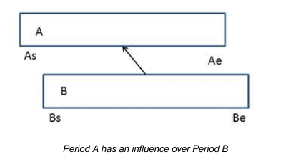

Temporal primitives
Continuation in time is a property that allows two temporal entity instances to be related both temporally and semantically. An intentional continuation in time among different instances of E7_Activity implies an influential correlation between the related entities. For instance, if an activity A is continued by an activity B then it is implied that the first instance affects the creation or existence and preservation of the second one. The required temporal condition, for such an intended continuation in time to take effect is that “an activity instance cannot continue another activity instance that takes place in the future”. In terms of endpoint the aforementioned statement is considered as “the end of the range instance takes place after the beginning of the domain one”.
Introducing a mathematical formalization:
Let Activities A (A^{s}, A^{e}) and B (B^{s}, B^{e}) be associated as A P134_continued by B then the required temporal condition is
A^{s} < B^{e} (base condition)

In the rest of the section, we analyze and outline all possible (exhaustive process) endpoint associations that can relate two activity instances without violating the base condition. First we summarize the available knowledge base are used for the mathematic resolution:
Knowledge base
A^{s} < B^{e} : influence condition
A^{s} < A^{e} & B^{s} < B^{e} : time interval definition (start exists before the end)

Main conditions
- A^{s} < B^{e} : starts before the end of
  - base condition
- A^{s} > B^{e} : starts after the end of
  - complement of (1)
- A^{s} < B^{s} : starts before the start of
  - Proof:
    - A^{s} < B^{s} (Hypothesis)
    - B^{s} < B^{e} (Fact)
  - A^{s} < B^{e} (true statement) (1)
- A^{s} > B^{s} : starts after the start of
  - complement of (3)
  - Proof:
    - A^{s} > B^{s} (Hypothesis)
    - A^{s} < B^{s} (applicable statement) (3)
  - (contradiction)
- A^{e} < B^{e} : ends before the end of
  - Proof:
    - A^{e} < B^{e} (Hypothesis)
    - A^{s} < A^{e} (Fact)
  - A^{s} < B^{e} (true statement) (1)
- A^{e} > B^{e} : ends after the end of
  - complement of (5)
  - Proof:
    - A^{e} > B^{e} (Hypothesis)
    - A^{e} < B^{e} (applicable statement) (5)
  - (contradiction)
- A^{e} < B^{s} : ends before the start of (clear before)
  - Proof:
    - A^{e} < B^{s} (Hypothesis)
    - A^{s} < A^{e} (Fact)
      - A^{s} < B^{s} (applicable statement) (3)
[it can be proved even at this step]
      - B^{s} < B^{e} (Fact)
  - A^{s} < B^{e} (true statement) (1)
- A^{e} > B^{s} : ends after the start of
  - complement of (7)
  - Proof:
    - A^{e} > B^{s} (Hypothesis)
    - A^{e} < B^{s} (applicable statement) (7)
  - (contradiction)

According to the logical proof, outlined above, the resulted set of endpoint relations that can be reduced to the base condition A^{s} < B^{e}, contains the following associations:

- A^{s} < B^{e}
  - starts before the end of
  - Expresses:
    - A
    - {before, meets, overlaps, starts, includes, finishes, equals}
(& inversed except after)
    - B
- A^{s} < B^{s}
  - starts before the start of OR starts before
  - Expresses:
    - A
    - {before, meets, overlaps, includes, finished-by}
    - B
  - End relation cannot be expressed by sub-relations
- A^{e} < B^{e}
  - ends before the end of
  - Expresses
    - A
    - {before, meets, overlaps, starts, during}
    - B
  - Complexed relation can be analyzed into sub-relations
    - Possible scenarios:
      - Ends before the start (clear before)
      - Ends after the start
- A^{e} < B^{s}
  - ends before the start of (clear before) OR ends before
  - Expresses
    - A
    - {before}
    - B
  - End relation cannot be expressed by sub-relations

Minor conditions - Complements and hypotheses
All relations listed above, introduce the main temporal associations that reveals temporal sequence without violating the base condition. In the following, further relations are formed by combining minor complement conditions (concluded in the first pass) with additional valid statements used as hypotheses.

- A^{s} > B^{e}
  - Cannot be justified, is the complement of the base condition, always FALSE,
- A^{s} > B^{s}
  - A^{s} < B^{e}
    - starts within
    - Expresses
      - A
      - {overlapped-by, during, finishes}
      - B
  - A^{e} < B^{e}
    - starts after the start of and ends before the end of
    - was during
    - Expresses
      - A
      - {during}
      - B
    - can be expressed with
      - starts within & ends within
  - A^{e} < B^{s}
    - A^{e} < A^{s} FALSE
- A^{e} > B^{e}
  - A^{s} < B^{e}
    - starts before the end and ends after the end
    - includes the end of OR ends after
    - Expresses
      - A
      - {overlapped-by, started-by, includes}
      - B

  - A^{s} < B^{s}
    - starts before the start and ends after the end
    - includes
    - Expresses
      - A
      - {includes}
      - B
    - can be expressed with
      - starts before & ends after
  - A^{e} < B^{s}
    - B^{e} < B^{s} FALSE
- A^{e} > B^{s}
  - A^{s} < B^{e}
    - starts before the end and ends after the start
    - overlaps with (in the sense of shared time points)
    - Expresses
      - A
      - {starts, overlaps, during, finishes, equals}
(& inversed)
      - B
    - can be expressed with
      - starts before & ends after
  - A^{s} < B^{s}
    - starts before the start and ends after the start
    - includes the start of
    - Expresses
      - A
      - {overlap, finished-by, includes}
      - B
    - can be expressed with
      - starts before & ends after
  - A^{e} < B^{e}
    - ends within
    - Expresses
      - A
      - {overlap, starts, during}
      - B

Definite temporal primitives
Summarizing, the final set of primitive temporal condition that express influence between two activities are separated into two groups. The first group refers to the temporal topology of the start point of the influencing Activity, whereas the second group is end-oriented. Every possible temporal association that implies the initial influence condition A^{s} < B^{e} can be expressed using single or pairs of the proposed relations. It is worth noting that the relations of each group exclude the effect of another applied relation within the same group. Particularly, we introduce the following defining limitations among two associated entities under the influence relation.
- At most two temporal primitives may be applied.
- Each applied primitive must refer to different type of endpoint (start / end).
Below we outline the list of the final group conditions:

- starts before
  - A^{s} < B^{s}
- starts within
  - A^{s} > B^{s} & A^{s} < B^{e}
- ends before
  - A^{e} < B^{s}
- ends within
  - A^{e} < B^{e} & A^{e} > B^{s}
- ends after
  - A^{e} > B^{e} & A^{s} < B^{e}

Visual representation
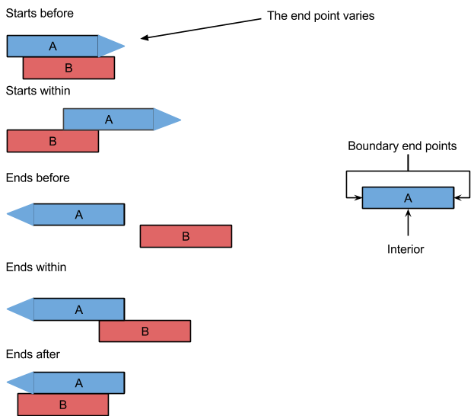

Continue in time and fuzziness
Allen algebra, introduces seven basic temporal association that describe the topology of individual intervals in terms of their end point association. Endpoint equality used in Allen operators imply a meeting in time, where the correlated intervals have common endpoints. Although the time point match cannot be observed, it is possible for a suitable observer to approximate a meeting in time by confining it using intervals. More specific, the true meeting exists but cannot be observed, therefore it is expressed with an indefinite interval which defines a possible time region that encloses the meeting in time.

According to the Fuzzy Interval Model, a fuzzy interval is comprised from a solid set of precise time points, forming the interior, and a set of imprecise points on either side demarcating the interval extent. The boundary set composes a fuzzy layer that represents all possible time points that result into a neutral attribution evaluating their association with the individual interval. In other words, boundary points illustrate interval parts, endpoints, with a fuzzy way representing the inadequate of observation.

Fuzzy temporal primitives
Integrating the Fuzzy Interval Model into the resulted endpoint relations, outlined above, absolute comparators must be extended in order to carry a fuzzy interpretation. Each comparative operator that forms the temporal conditions is loosened to its fuzzy representative. For instance, in terms of temporal topology, the base condition of the influence property associates the interval endpoints as follows A^{s} < B^{e}, adapting the fuzzy layer boundary the resulting condition is modified into A^{s} ≤ B^{e}. The equal operator express the boundary overlap, in other words the fuzzy layer overlap, rendering such modification over the temporal primitives without violating the base condition. The five basic relations that represent possible scenarios of continuation and hence influence over time are extended with the prefix fuzzy before the topology descriptor, as follows:

- starts fuzzy before
  - A^{s} ≤ B^{s}
- starts fuzzy within
  - A^{s} ≥ B^{s} & A^{s} ≤ B^{e}
- ends fuzzy before
  - A^{e} ≤ B^{s}
- ends fuzzy within
  - A^{e} ≤ B^{e} & A^{e} ≥ B^{s}
- ends fuzzy after
  - A^{e} ≥ B^{e} & A^{s} ≤ B^{e}

Association with Allen operators
- starts fuzzy before
  - A^{s} ≤ B^{s}
  - Expresses
    - A
    - {before, meets, overlaps, starts, started-by, includes, finished-by, equals}
    - B
- starts fuzzy within
  - A^{s} ≥ B^{s} & A^{s} ≤ B^{e}
  - Expresses
    - A
    - {met-by, overlapped-by, started-by, starts, during, finishes, equals}
    - B
- ends fuzzy before
  - A^{e} ≤ B^{s}
  - Expresses
    - A
    - {befores, meets}
    - B
- ends fuzzy within
  - A^{e} ≤ B^{e} & A^{e} ≥ B^{s}
  - Expresses
    - A
    - {meets, overlaps, starts, during, finishes, finished-by, equals}
    - B
- ends fuzzy after
  - A^{e} ≥ B^{e} & A^{s} ≤ B^{e}
  - Expresses
    - A
    - {meets, overlaps, starts, finishes, finished-by, equals}
    - B

Visual Representation
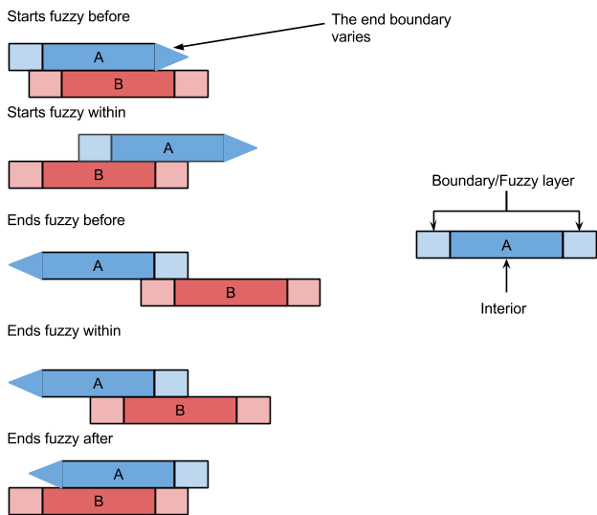

Scope notes

P ΧΧΧ starts before the end of (ends after the start of)
Domain: E7 Activity
Range: E7 Activity
Subproperty of: E7 Activity. P134 continued by (was continued by): E7 Activity
Quantification: many to many (0,n:0,n)
Scope note:
This property associates instances of E7 Activity, representing the temporal topology implied among the activities’
Time-Span, in order for an intentional continuation relation to hold between them. The domain is continued by the range and therefore the range activity is influenced by the domain one.

The main temporal primitive that fully expresses a continuation in time requires the starting time point of the domain activity to be before the ending time point of the range. Since, discrete endpoints extracted from a continuous spectrum (such as time) carry a level of imprecision, temporal endpoints are by nature vague, in terms of real phenomena. Consequently, adapting the fuzzy temporal interval model, we accept that the temporal endpoints are represented by fuzzy layers, which demarcate the possible time region in which the true endpoint exists. Consequently, the absolute comparative operators that form the temporal primitive is generalized in order to carry a fuzzy interpretation.

The final form of the temporal primitive states that the domain activity must have its starting time point before or at the ending time point of the range. It is worth noting that the inclusion of the the equality operator does not violate the initial temporal condition of continuation in time, since it refers to fuzzy zones overlap.
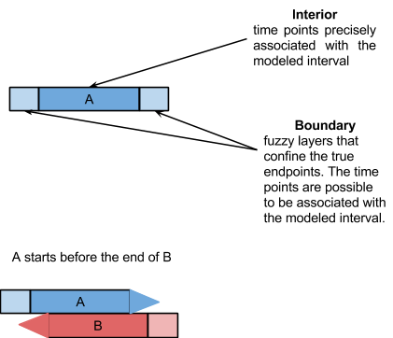

P ΧΧΧ starts before (starts after the start of)
Domain: E7 Activity
Range: E7 Activity
Subproperty of: E7 Activity. PXXX starts before the end of (ends after the start of): E7 Activity
Quantification: many to many (0,n:0,n)
Scope note:
This property allows the starting time point of an E7 Activity to be situated before the starting time point of another Activity.

This property can be expressed using a set of possible Allen operators such as: {before, meets, overlaps, starts, started-by, includes, finished-by, equals}. The temporal primitive is implied when the starting time point of the domain activity is before (or at) the start of the range. Time equality is considered as an overlap over fuzzy boundary zones, and serves the interpretation of time imprecision.

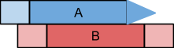

P ΧΧΧ starts within (includes the start of)
Domain: E7 Activity
Range: E7 Activity
Subproperty of: E7 Activity. PXXX starts before the end of (ends after the start of): E7 Activity
Quantification: many to many (0,n:0,n)
Scope note:
This property allows the starting time point of an E7 Activity to be situated during the time extent of another Activity.

This property can be expressed using a set of possible Allen operators such as: {met-by, overlapped-by, started-by, starts, during, finishes, equals}. The temporal primitive is implied when the starting time point of the domain activity is after (or at) the start of the range and before (or at) the end of the range. Time equality is considered as an overlap over fuzzy boundary zones, and serves the interpretation of time imprecision.

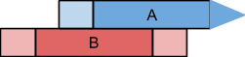

P ΧΧΧ ends before (starts after the end of)
Domain: E7 Activity
Range: E7 Activity
Subproperty of: E7 Activity. PXXX starts before the end of (ends after the start of): E7 Activity
Quantification: many to many (0,n:0,n)
Scope note:
This property allows the ending time point of an E7 Activity to be situated before the starting time point of another Activity.

This property expresses a clear before association. Including the fuzzy interpretation, the corresponding Allen operator set that expresses this property is {before, meets}. The temporal primitive is implied when the ending point of the domain activity is before (or at) the start of the range. Time equality is considered as an overlap over fuzzy boundary zones, and serves the interpretation of time imprecision.

P ΧΧΧ ends within (includes the end of)
Domain: E7 Activity
Range: E7 Activity
Subproperty of: E7 Activity. PXXX starts before the end of (ends after the start of): E7 Activity
Quantification: many to many (0,n:0,n)
Scope note:
This property allows the ending time point of an E7 Activity to be situated during the time extent of another Activity.

This property can be expressed using a set of possible Allen operators such as: {meets, overlaps, starts, during, finishes, finished-by, equals}. The temporal primitive is implied when the ending time point of the domain activity is after (or at) the start of the range and before (or at) the end of the range. Time equality is considered as an overlap over fuzzy boundary zones, and serves the interpretation of time imprecision.

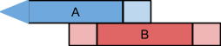

P ΧΧΧ ends after (ends before the end of)
Domain: E7 Activity
Range: E7 Activity
Subproperty of: E7 Activity. PXXX starts before the end of (ends after the start of): E7 Activity
Quantification: many to many (0,n:0,n)
Scope note:
This property allows the ending time point of an E7 Activity to be situated after the ending time point of another Activity.

This property can be expressed using a set of possible Allen operators such as: {meets, overlaps, starts, finishes, finished-by, equals}. The temporal primitive is implied when the ending time point of the domain activity is after (or at) the end of the range. Time equality is considered as an overlap over fuzzy boundary zones, and serves the interpretation of time imprecision.

