Open discussion about timed relations
Then Martin open a discussion about timed relations. Some comments of the discussion are:
- All properties having non-trivial validity in time should have a timespan.
- If we have nary relationship we make a class.
- State is relationship that have time
- If we make an extension I have a least temporality observed.
- MD: Within the time frame I see a bird flying. The place is the place of observation, when I want to document I need a more detailed description of place.
- A friendship is an ongoing process.
MD drew the following diagram on the board

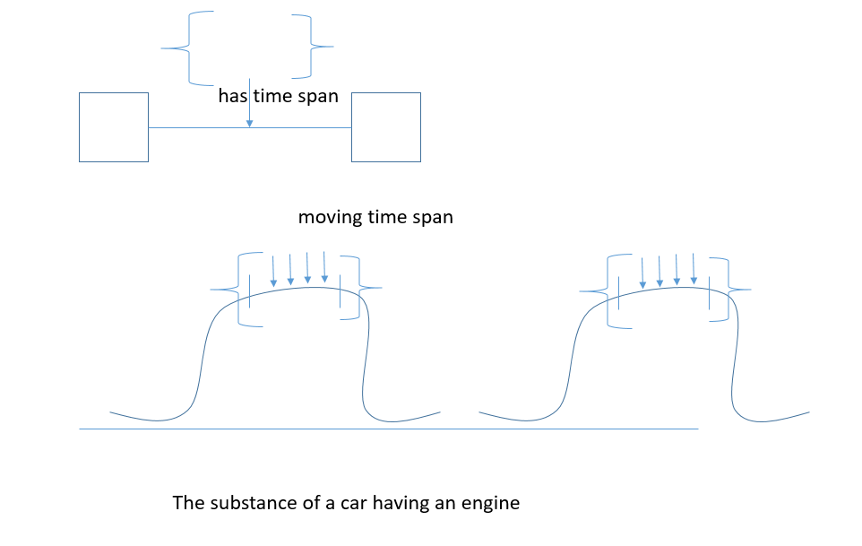
- To document the temporality of such properties we introduce activities and not PC classes
- For those properties that we regard as true relationships we should make use of PC classes.
- Then the sig went over the different cases on Francesco examples
- E5 Event scope note states that there is a change of state. But this is wrong. It needs to be rewritten.
Finally Martin presented a list of types of substance of relations (issue 329) and sig decided to work on substance of relationships
HW assigned to Steve, CEO, Francesco, MD, Achille, Maria to review and think about the list of properties and see if they can be pc, activity or something else.

