The 36nd joined meeting of the CIDOC CRM SIG and ISO/TC46/SC4/WG9 and the 29th FRBR - CIDOC CRM Harmonization meeting
1-4 August 2016
FORTH, Heraklion, Crete

Valentina Bartalesi (CNR-ISTI, IT), Chryssoula Bekiari (ICS-FORTH, GR), Francesco Beretta (Laboratoire de recherche historique Rhône-Alpes),George Bruseker (ICS-FORTH, GR), Lida Charami (ICS-FORTH, GR), Pierre Choffé (BnF, FR), Maria Daskalaki (ICS-FORTH, GR), Martin Doerr (ICS-FORTH, GR), Øyvind Eide (Universität Passau, DE), Annabel Enriquez (Getty Conservation Institute), Achille Felicetti (PIN Prato, IT), Athina Kritsotaki (ICS-FORTH, GR), Carlo Meghini (CNR-ISTI, IT), Christian Emil Ore (Unviversity of Olso, NO), Stephen Stead (Paveprime Ltd, UK),Thanasis Velios (University of the Arts, UK), Schmidle Wolfgang (DAI,DE), Maria Theodoridou (ICS-FORTH, GR)

Monday, 1st of August
Achille made a presentation
The CRM-SIG asked Achille to present a list of CRMarchaeo usage.
During Achille’s presentation the following comments and discussions have been made:
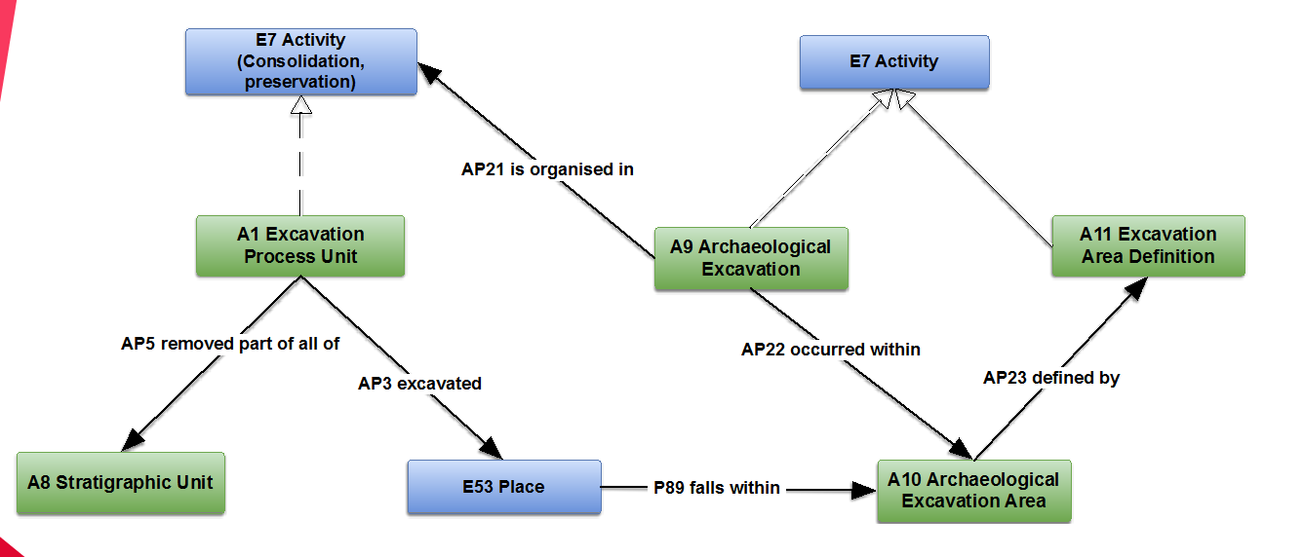
Figure 1: Archaeological Excavation
Achille proposed new classes and properties to be added to the CRMarchaeo about Archaelogical Excavation. These are:

1) The A11 Excavation Area definition:
A comment was that it should be distinguished the declarative place from phenomenal place

2) A9 Archaeological Excavation.AP21is organized in: E7 Activity:
A comment was that it should just be P9 because it is a part of relation. If it is not then it should be explored why this property is needed since the target is not constrained. Is there any relation with planning
3) AP3 Excavated:
There is a terminological question about the label since excavated property term sounds very active

Then Achille proposed new classes and properties to be added about Excavation Permission.
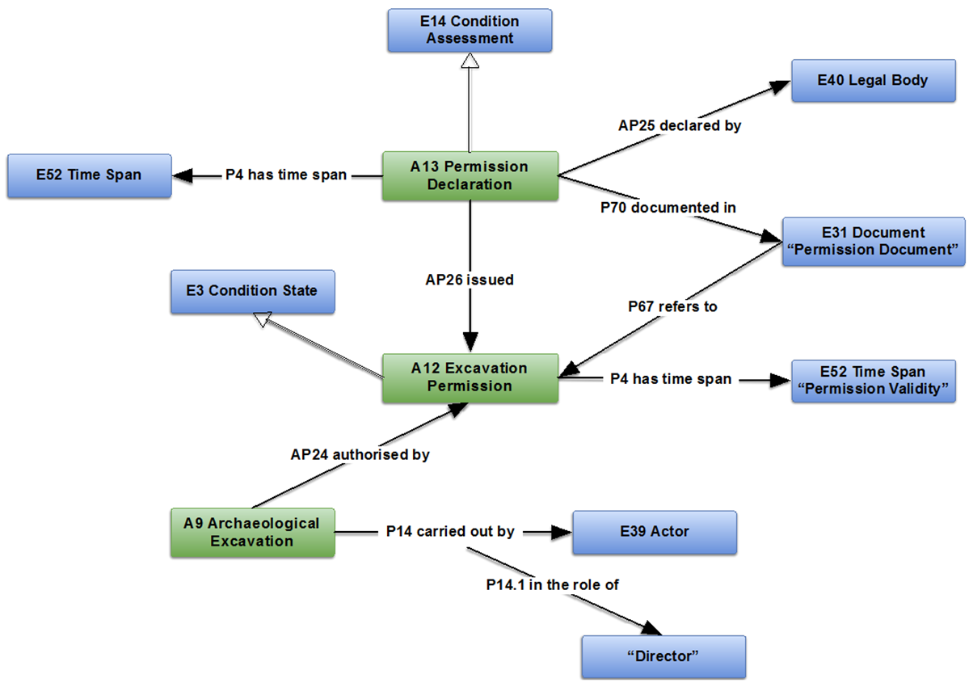
Figure 2: Excavation Permission
Then we drew the figure 3, on the board and we discussed about modelling laws and plans and if E29 Design or Procedure should be specialized. Martin said maybe an extension for plans is needed

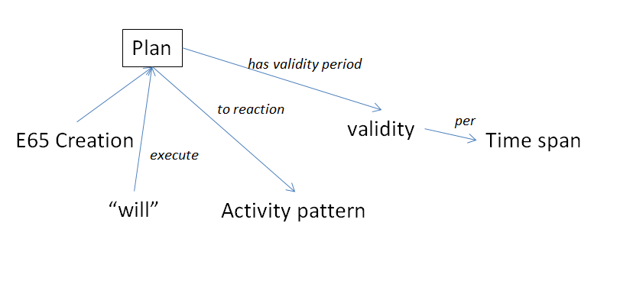
Figure 3 Plans
Comments made to the figure 3 are :
(a) Plan - foresees validity, creates a plan
(b) ‘Will’ to execute a plan, will have either time span or two events, declaration and withdrawal of will

4) the A12 Excavation Permission,
It was proposed that it should be an activity pattern.
A13 Permission Declaration is the “will”. It creates an information object that can be carried on a document or not. The document carries the links to the validity period.

Assigned: Achille, Oyvind, George, Wolfgang, Christian Emil should elaborate for specializing the E29 Design or Procedure.

5) The E31 Document (Permission Document) is a plan with a foreseen validity period. Any right is a plan which pertains to an activity pattern. The declaration of will is also a historical event. There is no superclass of CRM for the excavation permission validity.

Following Achille’s presentation, George informed the group about the on-going discussion and cooperation with the Dutch working on a model of ‘Archaeological Survey’ (Tymon de Haas and P.M. van Leusen). He remarked they have a problem with how to document negative results. They want to document that they observe nothing of a certain type. The comment of the CRM-SIG was that the same statement holds for the conservation.

Then the SIG agreed that an activity declaring of collecting samples similar to part removal is needed, i.e we picked up something that has a stability of form that give us an evidence for the past.

Assigned: Achille, George, Steve will communicate with the Dutch group and with Apostolos Sarris in order to consolidate ways we deal with areas of surveys and remote sensing.

Then we started the issues.

CRM archaeo - Issue 184 /306
An old issue was discussed: the examples in the scope notes of the CRMarchaeo. Achille said that a training program is running and they will use these examples in the new edition of CRMarchaeo. In the next meeting Achille will present a list of proposed examples.

CRM archaeo -Issue 282
In 33rd meeting the CRM-SIG decided that, since EH-CRM is more specific while CRMarcheo is more general, Achille should communicate with Keith for mapping CRMarcheo and EH – CRM.
Martin comment: physical feature IsA Place ?… question to discuss. In CRMSci this move has been made and creates inconsistency between CRMsci and CRMcore.
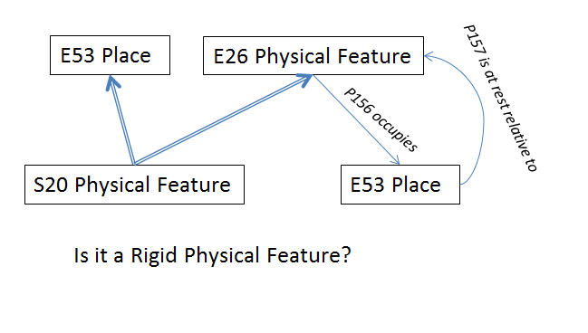
Figure 4 Physical feature
Comments to the above figure were:
P156 occupies, a thing may or may not occupy a place. If it does then it is a unique place. This place is P157 defined relative to the Physical Feature

If we can assume that for a physical feature we can always have a frame, then we can have a 1 to 1 relation. So we can say that the physical feature is associated with the place

Do all things that we regard as physical features (requires relative stability of form or have such a stability of form, that we can define on geometry for all its existence then it would always be at the same place.
Then a proposal of possible ‘Rigid Physical Feature’ for S20 came out. This is necessary for archaeological stratigraphic unit (needs stability of matter condition). So we could make S20 subclass of E26 (not equivalent).
For Example, we cannot say of all E26 Feature that there is this rigidity feature, but we could do so for S20

Assigned: to MD to write a scope note and to change the label

CRM archaeo -Issue 283
In the 33rd meeting, the CRM-SIG while reviewing CRMarcheo decided that the relevant superproperties/subproperties should be added in the definitions of properties in CRMarcheo.

During the current meeting this discussion was continued and it was observed that there are some inconsistencies.

Proposed: in order to be AP10 destroyed (was destroyed by) isA P13 destroyed (was destroyed), it should be A1 Excavation Process Unit isA E6 Destruction.

This change is accepted
Decision:
The CRM-SIG proposed the work on this continues and these will be sorted out through the process of making new editions and passing them to FORTH for presentation in RDFS format.

CRM archaeo -Issue 284

The scope note of A3 Stratigraphic Interface was discussed and revised.

Decision:
The changes should be incorporated in the new edition of CRMarchaeo . The following text outlines the new scope note:
A3 Stratigraphic Interface

Subclass of: A8 Stratigraphic Unit

Scope Note: This class comprises instances of A8 Stratigraphic Unit which are coherent parts of a boundary surface, which appear as the result of a stratigraphic genesis event or process. The interface marks the limit of the geometric extent of the effect of a genesis or modification event, and indicates in particular where the effect of this event ended. Each event of creation or destruction of a deposition layer implies the creation of new interfaces. Thus there are two main types of interface: those that are surfaces of strata (that can be directly related to the corresponding stratum via the AP12 confines property), and those that are only surfaces, formed by the removal or destruction of existing stratifications.
Examples:
The Stratigraphic Interface number [19] confines the number (2) Stratigraphic Volume Unit, in Figure 5

Properties:
AP12 confines (is confined by): A2 Stratigraphic Volume Unit

CRM archaeo 299
The CRM-SIG discussed whether a stratigraphic interface could contain finds. The SIG agreed that the stratigraphic interface cannot contain finds, therefore the following changes to this property are proposed for HW.
The proposed changes are:
(a) It would be better to use range S10 for the AP15 is or contains remains of (is or has remains contained in) e.g. ashes, traces of x`
(b) and to split out a new property which can be called ‘contains’ with domain A2 Stratigraphic Volume Unit and E18 Physical Thing
(c) to use the old definition of AP15 for the new property scope note

Assigned: The above homework is assigned to Lida

CRMsci - Issue 307 Harmonizing Measurement /229 correcting 156
Martin drew the following design
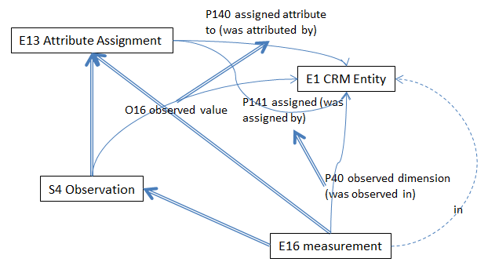
Figure 5: E16 measurement
The comments were:
(a) In the scope note of E16 should be defined that a measurement is a result of observation
(b) the measurement is not only produced by observation but also by evaluation
(c) S4 Observation produces information only when the object of observation is an image
Also it should be reflected the situation where taking an image of my “reality – object X” then we can make a statement

Assigned: HW assigned to MD, Achille, Thanasis to revise the scope note of E16 Measurement.

CRM archaeo – Issue 300

The sig reviewed the proposed scope note for the A8 Stratigraphic Unit. The outcome of this discussion is the following revised scope note:

“This class comprises instances of S20 Physical Features which appear as the result of a stratigraphic genesis event or process. The form of an instance of A8 Stratigraphic Unit should be of a kind that can be attributed to a single genesis event or process and have the potential to be observed. One genesis event may have created more than one SU. An instance of A8 Stratigraphic Unit is regarded to exist as long as a part of its matter is still in place with respect to a surrounding reference space such that its spatial features can be associated with effects of the genesis process of interest.
This also implies that a certain degree of coherent (“conformal”) deformation is tolerable within its time-span of existence. Therefore the place an instance of A8 Stratigraphic Unit occupies can be uniquely identified with respect to the surrounding reference space of archaeological interest.”

Decisions: The change will be incorporated in the next version of CRMarchaeo. The issue is closed

CRM archaeo – Issue 301
The sig reviewed the proposed scope note for the A2 Stratigraphic Volume Unit. The resulted scope note is the following:

“This class comprises instances of A8 Stratigraphic Unit which are connected portions of terrain or other solid structure on, in, or under the surface of earth or seafloor exhibiting some homogeneity of structure or substance and which are completely bounded by surfaces or discontinuities in substance or structure with respect to other portions of the terrain or surfaces of objects or finds.
Normally at least one of the surfaces, i.e. instances of A3 Stratigraphic Interface (such as the lower one), from the genesis event of the A2 Stratigraphic Volume Unit will remain during its existence.
An instance of A2 Stratigraphic Volume Unit may contain physical objects.”

Decision: The change will be incorporated in the next version of CRMarchaeo. The issue is closed

CRM archaeo – Issue 302
The CRM-SIG discussed about the examples of A6, A7 and A8.
(a) A6 Group Declaration Event: to keep the example and in order to take into account other type of grouping events, this class might have to be broadened. PIN will take on changing scope note of A6 and broaden the range of AP16 assigned attribute to (was attributed by): A8 Stratigraphic Unit (should we broaden range to E18?). Also they should consider specializing P141 property giving new labels (declared’ or ‘declared as remains’) and consult with CRM survey team (this will be facilitated by GB)
(b) A7 Embedding, A8 Stratigraphic Unit: the examples will be changed by Pin

Assigned: PIN HW to effectuate the above changes. GB to faciliate communication with Dutch Survey Group.

CRM archaeo - Issue 303

The CRM-SIG discussed that there is a link between the Range of AP20 to the range of AP19 of type p157 at rest relative to.

Assigned: HW to MD write the formal logic note

CIDOC CRM - CRMsci - Issue 251
The CRM-SIG discussing about the proposal of introducing S19 Encounter Event in CRM core, rejected the move. It is decided that it is well placed in CRMsci since it contains all issues of observation.
Also it is decided to update scope note in order to clarify difference between observation and data evaluation with paradigmatic example the identification of objects on photographs (a data evaluation)

Assigned: This HW was assigned to MD.

Decision: The issue 251 is closed, new issue (308) is opened to follow the discussion about the update of the scope note of S19.

CIDOC CRM – Issue 293 Dimension
The CRM-SIG discussed about the comment of the last meeting that an instance of the dimension is NOT the unit and amount but the actual dimension of a thing, assigned HW to GB to propose new examples by Thursday.
Assigned: GB to create new examples for Dimension.

Also it is mentioned that currently E16 Measurement can be used for measuring an instance of E1 CRM Entity BUT this is inconsistent with S4 Observation.O8 observed: S15 Observable Entity which is narrower since S4 Observation is superclass of E16 Measurement. Current definition of E16 Measurement gives unintended models. This incompatibility could be resolved by moving S15 Observable Entity in CIDOC CRM core.

Assigned: HW to MD, CEO, Oyvind to work on this issue. MD will make proposal. Must consider what is not observable. To be considered at next SIG

CIDOC CRM – Issue 292: Is EDM compliant with CRM?
The sig discussed the interpretation of EDM compliance with respect to ISO21127:2014.
Athina has collected the info about the equivalence statements that they gave. Group reading of the claim on the website concludes that they do not claim that they are compliant (at this point on the website). They rather say that they were working towards compliance with the modelling methodology. Athina underlines that they suggest a certain level of compliance given that they make tables were they indicate equivalent classes and relations.
Decided: a mapping of EDM to CRM should be published by the sig in the following formats: (a) X3ML, (b) text and (c) graph representation.

Assigned: These will be created by Athina and will be presented in the next SIG.

CIDOC CRM - Issue 237: Amendments to the ISO 21127

In the 36th joined meeting of the CIDOC CRM SIG and ISO/TC46/SC4/WG9 and the 29th FRBR - CIDOC CRM Harmonization meeting, the SIG discussed about the differences between the version 5.0.5 and the second revision of ISO 21127 and decided to make statement that v5.0.5 is the same except the compliance statement adding a citation to the second edition of ISO standard. Also comments (in footnotes) should be added to version 5.0.5 to the parts that are considered wrong.

Decision: The issue is closed

Presentations
At the end of this day, Achille presented about CRMepi and CRMtex updates. Carlo Meghini presented about narratives.

Tuesday, 2nd of August

CIDOC CRM – Issue 195 / issue 309
We discussed the points that CEO brought into light through emails. Martin drew on the board the following figure:
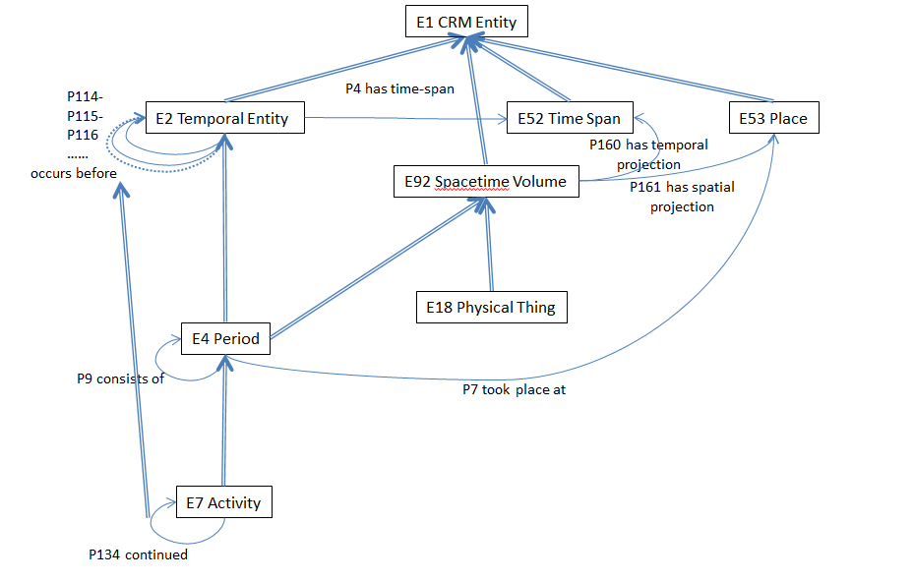
Figure 6 STVs, time-Span, period
Comments from the discussion include:
- there is an inconsistency with CRMgeo: E52 is a phenomenal time, the space time volume is a declarative or phenomenal.
- fuzziness of the phenomena itself and fuzziness of our knowledge are two different things
- our knowledge should somehow be related to the fuzzy zones of the phenomena e.g. birth… we give a very fuzzy idea, 1979, but we in fact know much closer 9/8/79
- Example of B continues A, just before A ends, something happens in B that substantially influences A,
- e.g. A is a battle event, B is a different battle event, people in battle A learn of loss of their side in battle B, they therefore run away. (B causally influencing A, is enough to say that A and B are ongoing in a true sense, not in a fuzzy zone). By definition they are not in a way that they can’t be decided. They are not fuzzy.
- If we describe temporal relation derived from phenomenon and not from measurement, then we can know that fuzziness is not happening
- If we want to describe new properties that are necessarily implied from phenomenal relations
- we can’t link the phenomenon directly to the time span then, because then it will be a construction
- So perhaps we should kill P4 has time span, We end up with an inconsistency in IsA hierarchy.
- Thus in the above figure we read : E2. P4 has time span E52, E4 isA E2, E4 IsA STV p160 has temporal projection E52, E18 thing IsA STV p160 has temporal projection E52
- We want to be able to say that if a thing is involved in an event, we want to be able to say that their STVs overlap OR we could say E2 IsA E52
- The following discussion was held on this subject:
- Perhaps E2 is a STV (MD)
- We should try to keep some separate notion of time (Oyvind)
- can we think of an E2 that is not a STV? (MD) - we can talk about things comparatively through time independently, like we compare ancient Greece and ancient China even though they have no ST overlap (Oyvind)
- we should compress E52 into E2, because though they are ontologically distinct, we use them the same. We do this like we did STV and its subclasses. (MD)
- aren’t there instances of E52 that are not STVs? (CEO)
- one solution could be given if we find how are time, stv and temporal entity related?
- make both E2 and STV isA of E52… this simplifies life, but there is still an inconsistency… we regard E52 as phenomenal, but the STV itself is either declarative or phenomenal
- other solution: if we make E2 and E92 IsA Time Span, then we just talk about approximating a time span with time primitives, then E52 becomes phenomenal (i.e. when it is a subclass of itself then it becomes a phenomena)
- So a pure instance of E52 Time Span is declarative (so this would be inconsistent on substance, but we can describe this in the scope note, we must make sure that there cannot be a 1:1 relation if you want to have an E2 that isa E52, such that when the one ends, the other ends)
- there are modalities in the model, some known to be true, some assumed, some declared
- it’s a tough exercise to combine known with assumed or declared. It is valuable as an exercise. in logic, you cut this problem by adding modal operators. (Carlo)
- at some point that there might be a way out in duplicating entities, e.g. fiction vs real entities
- fiction, may well not be consistent (author may not be clever enough to make it consistent),(CEO) consistency is not required (people fly, things can duplicate) (Carlo)
- Carlo found a kind of calculus for STV for calculating STVs, could try to see how this works with CRM (it gives 8 predicates, that calculate everything) Region Connection Calculus
Proposal:
- make E2 and E92 child of (isA) E52, this means that every physical thing gets an on going through out, as well as occurs within for endurance though it makes more sense to say existing ongoing throughout (for p81). It also makes p4 and p161 redundant
- to think about the difference between perdurants and endurants, MD thinks that for perdurants we look at substance of change, for endurance we look at substance of sameness
- getting rid of P4 is not backwards compatible, but we could build a transformation rule (MD)

Decisions:
- try to make this model? MD, CEO, Wolfgang, Carlo, GB, Maria Daskalaki
- Oyvind will criticize, so will Wolfgang.

Then SIG reviewed the document about time primitives proposed by MD. The document is attached to these minutes. The following comments arose during the discussion:
Proposals made about the notation
About graphics:
- Should ensure gradient in fuzzy area in order to indicate the movement away from
- On second graphic with the arrow, it could be changed to a number of continuing smaller boxes that move towards lines. (like a cigarette)
- to make a distinction between what is precise and observable and precise but not observable (in relation to the hard line in the graphic which seems to indicate a precise point. It is indeed precise, but not observable.) [4 combinations between precise and observable, should make different graphs to represent this] (Carlo’s comment on the ‘hard line’ )
- In definition of ‘interior’ in the notation section, we should change the wording to ‘definite’ from ‘precisely’
A paragraph should be deleted from “Overview of Temporal Relation Primitives” section
About the property labels:
- the labels of the proposed properties should be look over and made simpler both conceptually and linguistically
About the number of properties:
- Proposal to add first 8 properties of table 1, properties 9 to 12 can be considered conveniences which are not necessary to introduce at this point

Assigned: Wolfgang could analyze against some use cases

Decisions:

About the scope note:
- there should be a reference in the scope note to the introductory text that explains the overall use of these properties
- we are close to an agreement on the scope note, however, there is still an open question of whether the ‘domain’ and ‘range’ elements in the definition to differentiate A from B are accurate.

About fuzziness:
- We should introduce into the introduction clear distinction between actual fuzziness and lack of knowledge and maybe can make a reference, to this difference between intrinsic fuzziness and fuzziness of observation

About Allen Operators:
- Would Allen agree, that his set of relations assumes perfect knowledge? (Carlo), This assumption is implicit to his logic (MD)
- Can we make a formulation of Allen with fuzzy blocks with zero fuzziness that represents Allen, and this does not affect the algebra ? there is a guy in my lab, he might be persuaded to read this and give feedback(Carlo)
Overall decision: on-going. Goal would be to be able to close by next meeting

Assigned:

- Lida will check super and sub properties..
- Text improvement by MD and Maria Daskalaki
- Scope note template improvement by CEO
- Carlo volunteers will revise formalization of formal properties of temporal primitives

CIDOC CRM – Issue 234
The sig reviewed the following explanation of the shortcut in P7 given by CEO:
“E4 Period is a subclass of E92 Spacetime Volume. By the definition of P161 has spatial projection an instance of E4 Period takes place on all its spatial projections, that is, instances of E53 Place. Something happening at a given place can also be considered to happen at a larger place containing the first: The assault on the Bastille July 14th 1789 took place in Paris but also in France.”

and made the following comments:
- The scope note must clearly express that P7 is a wider approximation of the place than occupies.
- ‘Paris’ and ‘France’ can be modified to be called ‘The area covered by Paris in 1789’ and ‘The area covered by France in 1789’, to avoid confusion about E53 Place use.

Assgined: CEO to rewrite the scope note taking into account the comments.

The sig reviewed the examples for P133 proposed by George Bruseker.

The SIG made the following comments:
- Asked George to rewrite non-trivial examples. There is a definite gap in space and time
- the label of P133 should be changed to spatiotemporally separated from
- the example should referred to a thing in an event, like two people at a meeting, or in this case not at a meeting
- To look for an example from CRMarchaeo of two periods that overlap in time but separated in space, buildings with share walls, different pottery styles example,. or geopolitical examples from recent history
Assigned: to implement the above, GB

Mapping Issues
Maria Theodoridou presented the “Methodological tips for mapping to CIDOC CRM” which has been presented in Oslo at CAA2016.

There was a discussion about how geopolitical units map to a period. Comments are:
- The period is defined as the geopolitcal unit (Claim of power / jurisdictional area is not just a paper entity but is a real phenomenon)
- Can add more explicit explanation of geopolitical unit
- It is suggested the scope note of Period to be improved (no particular person assigned)
There was a discussion about those that are mapped to propositional objects. It is proposed to add examples to E89 Propositional Object about fictitious persons and places (by Oyvind).

Also, it was proposed, with regards to the mapping examples, questions that contributions can be made about

(i) How we can systematically collect mapping advice material
(ii) How we index this material
(iii) If we know how to classify to bring it in adequate format

Assigned: input on the above questions to be provided by Achille, Steve, Pierre, Dominic. (Potential other sources could be CHIN in Canada or AAC in America).

Proposed: potentially good mapping examples could be credited like an encyclopaedia

Martin asked which is the position of CRM-SIG about X3ML

Steve proposed a handbook of examples of mapping problems to be prepared by the group and then we should make the examples available in X3ML.

Also the SIG proposed a text to be written describing the X3ML in order to propose it as a standard.

Assigned: the sig decided that the documentation that is on github of X3ML should be reviewed by George and Steve and Wolfgang and discussed in the next meeting.

Then Martin drew on the board the following examples to be considered.
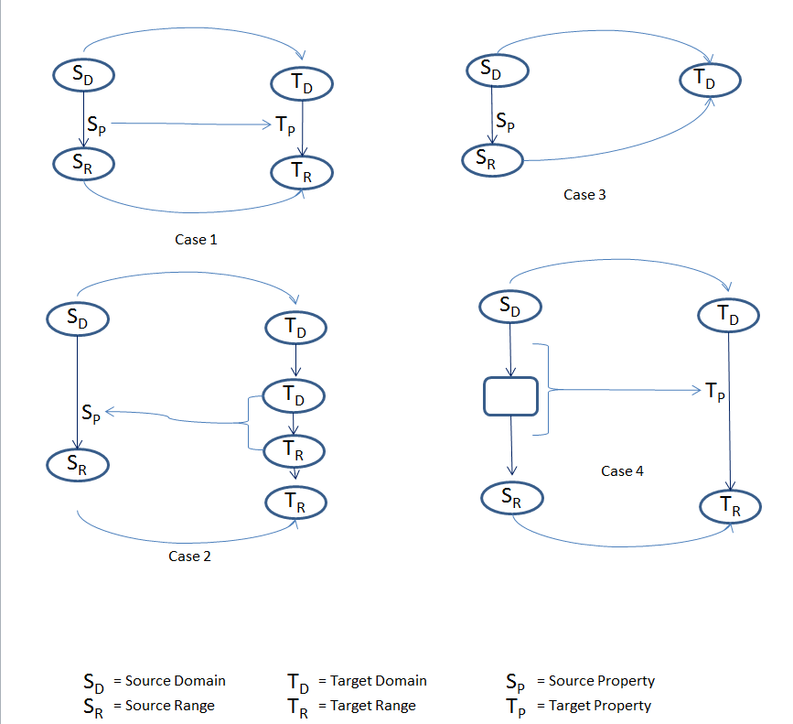
Figure 7 mapping cases

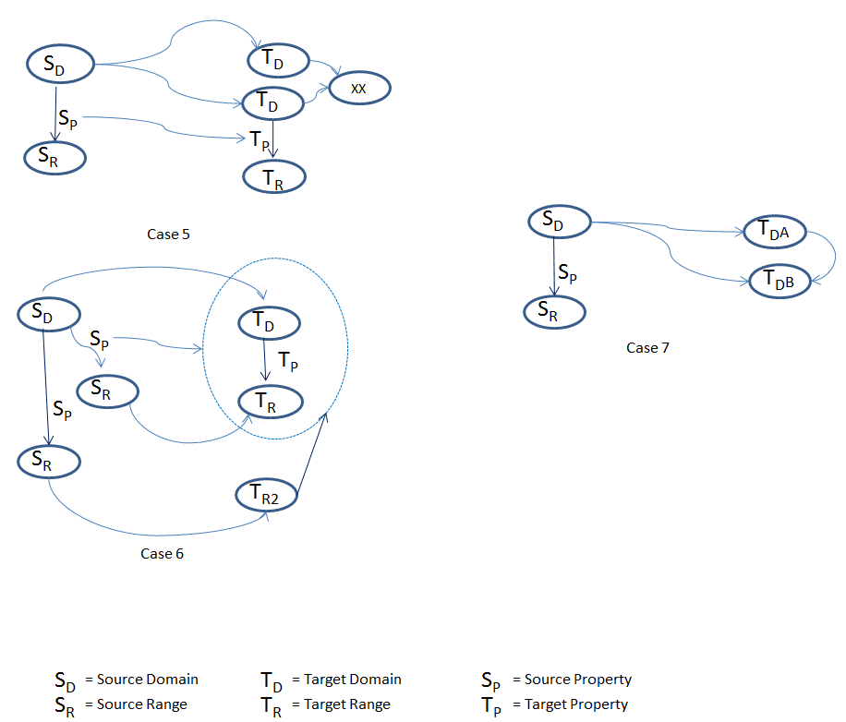
Figure 8 mapping cases

CIDOC CRM – Issue 276
The SIG reviewed the proposal made by Steve about the definition of P62. Questions turned around whether or not to include ‘intentionality’. Finally, a few changes were made and the proposal was accepted.

Then, the SIG reviewed the text written by Carlo about the logical expressions of the CRM. The intention of this text is that it be added to the introduction of the CIDOC CRM document.

Some of the comments were:
- The example proposed in the text is confusing because of choice of ‘place’ which enters into a long time confusion of how to talk about ‘places’ and ‘periods’. Better to use some example like a person or actor.
- References to objects and constant symbols need not be talked about here because they don’t appear in the specification - > can be rephrased by Carlo and examples can be added
- In the reference, Harvard style should be used
- axioms assumed to pertain to reality, KB may differ from this… should get a discussion of how we talk about reality

Assigned: the SIG asked Carlo to make the proper changes up to the end of this sig meeting.

Wednesday, 3rd of August

Presentations
- George Bruseker presented the “Education Matrix”
- Steve Stead presentation
All the material presented by CIDOC Training Group concerning CIDOC CRM should be submitted to the CRM-SIG meeting for a formal acknowledgement. This material should be reviewed every two years any data set should have a creative common license.

CIDOC CRM Training Material
After Steve’s presentation, CRM-SIG discussed about the material presented by CIDOC Training Group. The CRM-SIG concluded to the following:
- All material has to be presented to meeting and formal acknowledgements have to be made of work used or referenced
- We accept that they can license and charge, even if we don’t agree
- There should be a periodic review, add an agenda item for SIG meeting each year
- Need to discuss with the licensing of material, that datasets should be CC. Foundation material will need this material and it must be accessible. But it need not fall under their exclusive license.
Question of other, Open Source, of CRM referring training material
- CRM-SIG should play a role of certifying

Decision: the present ‘CRM language’ course should be reviewed already

Assigned: Steve will revise it and send it to CEO, Maria Daskalaki, GB, Chryssoula, Thanasis. The order of training material should be reviewed by : CEO, GB
Other comments are:
- it should be declare a list of learning objectives under each learning aim.
- (Objective = small bit, piece of knowledge), learning goal = overall category of bits of info to fit together)
- need a course that teaches very basic things, event oriented, ideas as tracked, appellations, declarative vs real(by CEO)
- Fundamental principles and patterns in CRM (MD)
- Questions course discussion: what kind of questions do people ask. CEO will find out about questions to museums
- Mapping Course Gen Principles: Steve, George, Achille HW
- In negotiation we will ask for the results of the survey distributed to students. We should have access to the evaluation form for courses
- An updated hyperlink version of CIDOC CRM is needed

Presentations
After lunch the following presentations took place
- The symogih.org project and the issue of defining an ontology for collaboratively producing, sharing and curating historical data”, Francesco Beretta (Laboratoire de recherche historique Rhône-Alpes)
- “The chronOntology time gazetteer project” Wolfgang Schmidle, (DAI)
- Getty Conservation Institute -Annabel Enriquez, Data Specialist

Thursday, 4th of August

Annual CIDOC meeting 2016
George informed the CRM-SIG group about the activities taken place on annual CIDOC meeting held in Milan in July, 2016.:
Directly representing the CRM-SIG were Dominic Oldman, co-chair of CRM-SIG and George Bruseker; Stephen Stead was also present in his capacity of Chair of the Archaeological Sites working group. The preparatory work for CRM SIG’s contribution to the CIDOC portion of the conference was carried out by CRM-SIG co-chair Christian Emil-Ore. The following events occurred during the conference.

Sunday July 3rd: Meeting of the out-going CIDOC Board : A meeting was held with the old and new members of the CIDOC Board present. The new chair of the committee, Monica Hagedorn-Saupe, took up office. The date of the next conference as occurring in September or early October 2016 was discussed.
It was noted that there the finance rules in France where ICOM is based dictate that organizations like CIDOC can only have a certain amount of cash in their running account. This will mean that CIDOC has to find a way to respect these rules, potentially by investing in relevant projects. [This is not just the case for CIDOC committee.]
The committee does not have a clear idea of membership numbers. These are kept by ICOM central and there is difficulty in communication/documentation.
Monday July 4th: CIDOC Documentation Introduction: Dominic Oldman presented the work of the CRM SIG to the general audience and invited people to participate in the next day’s workshops.
Tuesday July 5th: CIDOC CRM SIG and Joint Research Environments: On Tuesday two sessions were jointly organized with the Semantic Research Environments Research Group, demonstrating the implementation of CIDOC CRM for use in research infrastructure environments. The morning session had the following papers:
- Using CIDOC CRM in “150 Years of Canadian Art” Demonstration Project Heather Dunn (CHIN)
- Behind the Lines: Documenting Argumentation in Virtual Reconstruction,George Bruseker (FORTH) and Anais Guillem (UL-FGG), presented by George Bruseker
- CRMArchaeo: a CIDOC CRM extension to support archaeological excavations – Achille Felicetti (PIN)
- Selected Wisski Projects at the Germanic National Museum in Nuremberg – Siegfried Krause (Germanic National Museum)
- Desiging an Application Ontology for Architectural 3D Reconstruction, Piotr Kuroczynski, presented by Günther Görz – Friedrich-Alexander University - Nuremeberg
- Research Space, Dominic Oldman (British Museum – ResearchSpace)
Additionally, members of the CIDOC board met with an official delegation from China, who informed the group of their official creation of a documentation committee. This committee had been inspired by the Shanghai ICOM meeting and presented several of its on-going documentation projects, including standards which they had written up and were interested in having critiqued. George Bruseker sent their representative a copy of the CRM standard which had been translated into Chinese. The committee was very interested in collaborations and offered to translate the CIDOC website into Chinese.
Wednesday July 6th:
- On Wednesday, the Archaeological Sites group made room for an additional presentation on CIDOC CRM about “Doremus Project”, by Pierre Choffe (Doremus)
- In the afternoon, the Annual General Meeting was held. At this point, George Bruseker made a presentation of CRM SIG’s mission and activities summarizing the current foci as enabling technologies, training and thematic research. Following the AGM, the board met again. Issues discussed included whether there was an advantage to holding the CIDOC meeting together with ICOM or if only special representatives should be sent to ICOM to participate in other WGs and spread the message of CIDOC. Members were encouraged to check the CIDOC website and see if it was up to date as well as to publicize their activities on platforms such as Twitter, tagging CIDOC. It was decided that the board would meet at the beginning of each year in order to have a working meeting to get the activities of the year going.

Next meeting
The CRM SIG decided the next two upcoming meetings in the following days:
- 5-8 December, 2016 in Berlin
- 3-6 April 2017 in Heraklio

CIDOC CRM – Issue 273
Then the CRM SIG discussed about financial transactions reviewed the proposal made by Steve.

Decision: The outcome of the discussion was the definition of the properties P179, P180, P181.

Assigned: It remains open the subproperty of P179 had sales price (was sales price of).

Proposed: The CRM SIG proposed to define a new property P?? had consideration() to generalize the contractual application.

CIDOC CRM – Issue 276 (continued)
The CRM SIG continued to discuss the rest of the subjects of issue 276. In the beginning of the discussion reviewed the explanatory text written by Carlo about for FOL.

Decision: The CRM SIG accepted the text and decided to add this text to the CIDOC CRM definition, in a new section in applied form after the naming convention chapter.

Then, the CRM SIG continued the discussion about :
a) “current data” in P105 right held by (has right on). In previous meetings it was mentioned that there is a problem with the “current” when data is aggregated. There is no problem with local data. In this meeting, it was commented that the indication “current” points to a state and not to an activity. This comment opens up the entire issue of ‘current’ properties. It is proposed that there is a new issue for examining the notions of acquisition, ownership, ownership of the right along with the notion of “current properties
Some other comments stated about the “current notion” are
(i) Sometimes it says in scope note that the time does not count (stated by Wolfgang)
(ii) for properties if not otherwise stated the validity does not cover the span of existence of the domain or range, except if the statement is necessary (stated by Martin)
(iii) The sig accepted Steve’s proposal saying that the definition of the property in the terminology section should be updated in order to indicate this aspect of timelessness with regards to properties (HW with Wolfgang, Steve and MD)
(iv) The reason that we have added notes about time in the scope notes it is to respond to issues. Does not think that we should remove these from the scope? (stated by Steve)
(v) New Issue: deprecate current properties? HW to Steve should be published to CRM SIG
(vi) P53: There is a problem with ‘or’, we don’t know which the location is. It is expressed that a weak shortcut, allows inference of short path from long one but no inference for long path from short path. A strong shortcut allows inference from short path to long path and back. It is decided that P53 is a weak short cut and the weak shortcut axiom should be added and noted in this property. It is assigned to MD this HW. Also it is proposed a systematic review of all the examples referenced to places in the sense of CRM . This is assigned to CEO, MD

CIDOC CRM – Issue 281
The SIG asked Steve to review the text prepared by GB and CEO for terminology section with the additions indicated to the previous meeting. These are :
(1) To put property numbers when reference is made to categories of properties i.e properties referred to time/space/transitive
(2) To put class numbers when reference is made to them,. i.e In the examples referred to classes
(3) a definition to be added for "directed property" and "symmetry" in order to be added into terminology
Then the CRM SIG discussed the issue of the license under which the CIDOC CRM is made available.
Some of the comments of the discussion are:
(a) CEO argued we should use CC BY 4.0. This allows anyone to use it for anything including commerical uses, but we should be credited
(b) ‘Who’ gives the license to use? Oyvind suggested that the license be granted by the editors as one solution. Steve questioned if the copyright did not belong to ICOM. Suggestion made to inform ICOM that CC BY license will be used. If they do not accept this, then ICOM name could be dropped.
Decision: One of the chairs should write to ICOM and cc board mentioning the conversation that already happened approving this.
Assigned: CEO will talk with Monica and then Monica will identify person in charge. MD will send to appropriate person.

New comers impression
Then the CRM SIG discussed with new comers subjects needed clarification for a new comer. The outcome of this discussion was a proposal to be answered in an FAQ ‘what is intangible heritage’.
Assigned: This is Assigned HW to CEO.

New CIDOC CRM web site
Then Chryssoula presented the new CIDOC CRM web site. The discussion focussed on the following subjects
Separate publications into categories:
- If any member ask something to be uploaded to the site, should give the appropriate category along with the material
- To switch to new CIDOC CRM site and ask people to provide new texts or make revisions. For text approval we should make vote item, in order to get motion
Releases Workflow
- To add editorial status of CIDOC CRM definition texts. See the table below
- To express in RDF, only the published ones
- People are encouraged to use published… there will be updates but we try to be backward compatible

Document types of CRM in the new CIDOC CRM type
Under the obligation any documents of CIDOC CRM texts or CRM family models to be visible the CRM SIG proposed to add the information about the editorial status of the current version. Thus the following definitions are proposed:

There is proposed to add annotation in the front page of the CIDOC CRM text about the type of document and its editorial status.
If the Type of Document is Official or Published then the editorial status is closed. This means that this document is no longer under editorial revision. It is no longer subject to change and its contents will remain stable.
If the Type of Document is Current then the editorial status is open. This is an unrevised and as yet incomplete community version of the CIDOC CRM. This is the currently edited version of the CIDOC CRM text. It represents a working version of the CIDOC CRM and should not be used for implementation, reference or other official purposes. The function of this document is as a reference resource for developers of the CIDOC CRM standard to discuss on-going, proposed but not yet accepted changes to the model. The contents of this document are not stable and are subject to change. In this case, we distinguish two types of editorial status, the following

In Progress
The currently edited version of CIDOC CRM contains open issues that are actively being worked on. The document may therefore change at any time since it is being updating according with the last CIDOC CRM SIG meeting discussions and their conclusions. This copy of the standard should be used only for the purpose of following present modelling discussions on the CIDOC CRM SIG meeting. This document is not meant to support implementations, referencing or other official activities.

Under Revision.
This is the currently edited version of the CIDOC CRM standard contains open issues that have been declared and specified and which are scheduled to be addressed in an upcoming meeting of the CIDOC CRM SIG. The document may change relative to decisions taken at the next CIDOC CRM SIG meeting. This copy of the standard should be used only for the purpose of following present modelling discussions on the CIDOC CRM SIG list and meetings. It represents a step before a potential stable release of the standard. This document is not meant to support implementations, referencing or other official activities.

