Issue 385: Social Relationships
The sig reviewed MD’s HW class definition of Formal Social Binding.

socExx Bond (former “Formal Social Binding”)
The sig reviewed the definition of socExx Bond (MD’s HW), edited and accepted it. New class definition can be found below.
DECISION: Aside minor editorial changes, the sig resolved to delete property socPxx to [D: socExx Bond, R: E31 Document].
The sig then revisited the properties linking socExx Bond to Actors (their subproperties too) and did some editing.
DECISION: proposed property socP6 [D: socE1 Bond, R: E70 Thing]: its range was changed from E77 Persistent Item to E70 Thing –in accordance with the scope note definition.
NOTE: The indexes on the classes and properties listed here are preliminary and refer to the schema below:
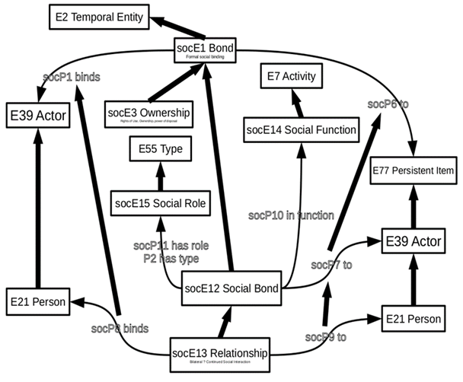
HW: GB, MD to do some literature review regarding speech acts, to best capture bonds as temporal entities.

Bond
Subclass of: E2 Temporal Entity
Superclass of: socE Ownership
socE Social Bond
Scope note:
This class comprises phenomena of formally defined and socially respected bindings between different instances of E39 Actors or between multiple actors and instances of E70 Thing. Instances of SOxxx Formal Social BindingBond come into being and end with an explicit act of declaration or indirectly through other publicly acknowledged events, such as via heritage at birth or death. Depending on their type, they are associated with characteristic rights and obligations, which are subject to the formal legal system of the respecting society, regardless whether this is based on written laws or oral tradition.
Formal Social Bindings Bonds are not observable as such, even though the behavior of involved actors may suggest their existence, such as being married. They are exclusively a consequence of the establishing event, which should be kept as social memory in a persistent documented form or as oral tradition, and the continued respect of this kind of binding by a target community. For instance, a community may declare a certain kind of marriage as invalid from some date on, and later redeclare it as valid. Their existence does not depend on the existence of social memory. Documents may be lost or involved actors may not have been aware of the respective establishing events, but later evidence of the establishing events may be found. In these cases, the society may not act according to the respective rights and obligations as long as the fact remains unknown, but is obliged to when the necessary evidence has been provided. Involved actors may have difficulties proving the existence of the binding to authorities when respective documents are lost, but that does not affect their actual existence. However, certain legal systems may require in certain kinds of cases the provision of evidence itself as part of the establishing event.
In some contexts, Formal Social Bindings are also called social institutions. Examples include memberships, employments, ownerships, rights of use, marriage, parenthood and others. In documentation practice, instances of Formal Social Bindings may bye shortcut by simple binary relations, such as “is married to”.
Examples: John owns his house.
Properties: socP binds: E39 Actor
Also the sig decided to close this issue. Further discussions on CRMsoc will resume in a separate, new CRMsoc issue.

