388
Proposal consists of:
- A definition of Sxx1 Position Measurement isA S4 Observation and set of properties that use it
- diagram showing the modelling constructs that Position Measurement forms part of.
- use case that illustrates instance of the modelling construct (how to deal with measuring from known positions –especially relevant for historical documents)

Sxx1 Position Measurement definition
Sxx1 Position Measurement
Subclass of: S4 Observation

Scope note: This class comprises activities of measuring positions in space and time. The measured position is intended to approximate a part or all of the extent of the presence (instance of E93 Presence) of an instance of E18 Physical Thing or E4 Period of interest, such as the outer walls of an excavated settlement, the position of a ship sailing or the start and end of athlete's run in a competition. Characteristically, a theodolite or GPS device may be positioned on some persistent feature. Measuring the position of the device will yield an approximation of the position of the feature of interest. Alternatively, some material item may be observed moving through a measured position at a given time.
A position measurement is an evaluation of a combination of measurement of multiple associated distances and/or angles (instances of E54 Dimension) from a particular spot to certain reference points of previously known position in the same reference space. A particular role is played by the Earth's magnetic field and rotational axis as reference for an angle or direction. Often, the observed constituting dimensions are not documented, or hidden in an electronic device software.The measured position is given as an E94 Space Primitive corresponding to a declarative place. Together with the measured time-span covering the time-critical observations it forms a spacetime volume, which should normally overlap with the spatiotemporal extent of the thing or phenomenon of interest.
Properties: Oxx1 determined position (was determined by): E94 Space Primitive
Oxx2 has validity time-span (is position validity for): E52 Time-Span
Instead of
Oxx3 overlaps with presence: E93 Presence
    - Oxx3 measured position of (was located by): S15 Observable Entity
    - Observable Situation. Oxx5 forms part of (consists of): Observable Situation
      - Oxx5 for the sake of completion: will be considered after the Observable Situation construct has been admitted to CRMsci.

Examples:

In First Order Logic:
Sxx1(x) ⇒ S4(x)
Sxx1(x) ⇒ (∃y,z) [E94(y) ∧ S15(z) ∧ Oxx1 (x,y) ∧ Oxx3 (x,z)]
(Oxx1 determined position and Oxx3 measured position of are necessary properties)

Logical inferences for properties of Position Measurement
Oxx1(x,y) ⇒ Sxx1(x)
Oxx1 (x,y) ⇒ E94(y)
Oxx2(x,y) ⇒ Sxx1(x)
Oxx2(x,y) ⇒ E52(y)
Oxx3(x,y) ⇒ Sxx1(x)
Oxx3 (x,y) ⇒ S15(y)
Oxx3 (x,y) ⇒ (∃z,u,v,w) [E93(z) ∧ P195(z,y) ∧ E52(w) ∧ Oxx2(x,w) ∧ P164(z,w) ∧ E94(v) ∧ Oxx1(x,v) ∧ E53(u) ∧ P161(z,u) ∧ P121(v,u)]
"There exist a presence (E93) of the positioned entity at the time of measurement (E52) that has a spatial projection (E53) overlapping with the measured position (E94)"

Diagram of modelling constructs that Position Measurement forms part of
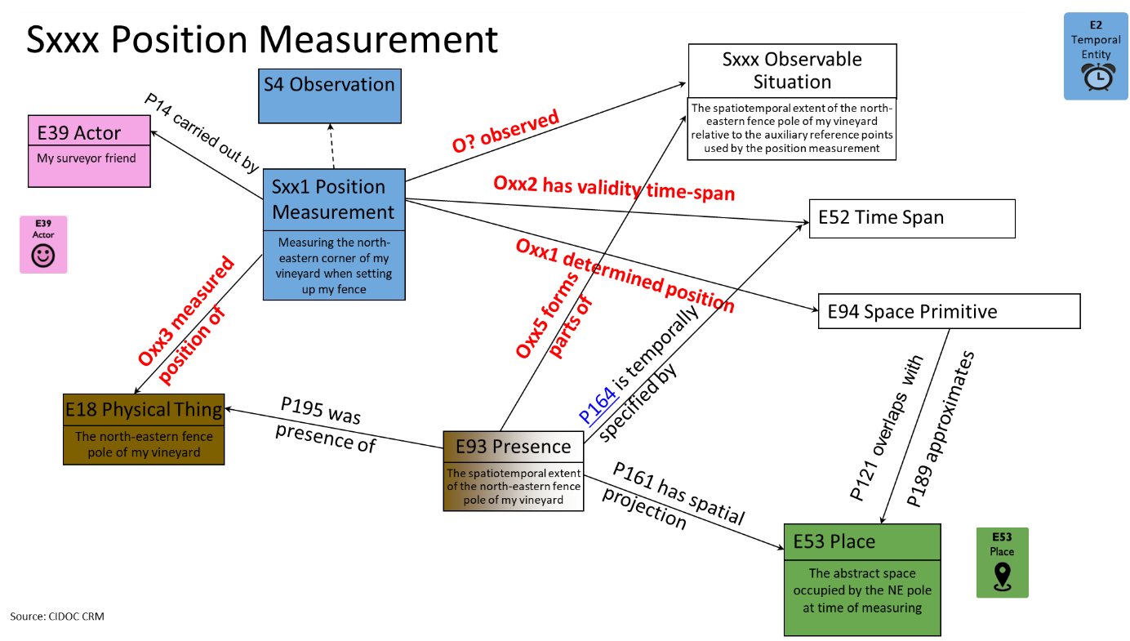

Use case illustrating an instance of the modelling construct
How to deal with measuring from known positions –which is especially relevant for historical documents
