537: How does reducing the range of P39 measured affect CRMsci?
HW presentation by MD –proposed changes are reflected in the diagram below
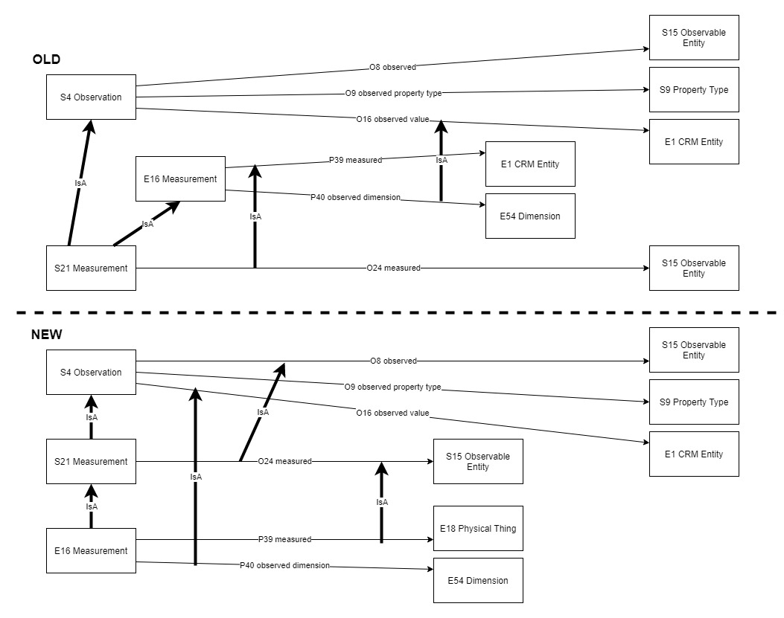
Discussion points:
SdS: The axiom declaring the equivalence btw O12 and E18 from E18 and its specializations only appears in the FOL, not in the scope note. Must be explicitly stated in the scope note too.
Decision:
- To accept changes in the model and in the definitions of S21, O16, O24, O12, O9 (details below).
- Start a new issue on correcting the definition of O12 (addition of the axiom in the scope-note) and resolve it in an e-vote.

Issue closed

Definitions

S21 Measurement
The definition changed

FROM (old)
S21 Measurement

Subclass of: S4 Observation
E16 Measurement
Superclass of: S3 Measurement by Sampling

Scope note: This class comprises actions measuring instances of E2 Temporal Entity or E77 Persistent Items, properties of physical things, or phenomena, states and interactions or events, that can be determined by a systematic procedure. Primary data from measurement devices are regarded to be results of an observation process.

In First Order Logic:
S21(x) ⊃ S4(x)
S21(x) ⊃ E16(x)
Properties:
O24 measured (was measured by): S15 Observable Entity

TO (new)
S21 Measurement
Subclass of: S4 Observation
Superclass of: S3 Measurement by Sampling
E16 Measurement

Scope note: This class comprises actions measuring instances of S15 Observable Entity, properties of physical things, or phenomena, states and interactions or events, that can be determined by a systematic procedure. Primary data from measurement devices are regarded to be results of an observation process.
Examples:
- The magnitude measurement of the earthquake of Mexico city in 2017. (S21) [It had the magnitude 6.2 Richter] (Mindock, 2017) (http://www.independent.co.uk/news/world/americas/mexico-earthquake-today-latest-mexico-city-magnitude-6-tremor-damage-a7963211.html ).
- The sensor measurement by IGME in 1999 which measured the landslide displacement in the area of Parnitha, Greece. (S21) (InGeoCloudS - INspiredGEOdata CLOUD Services D2.2 2012;D2.3 2013)

In First Order Logic:
S21(x) ⊃ S4(x)
Properties:
O24 measured (was measured by): S15 Observable Entity

O16 observed value (value was observed by)
The definition changed

FROM (old):
O16 observed value (value was observed by)
Domain: S4 Observation
Range: E1 CRM Entity
Subproperty of: E13 Attribute Assignment. P141 assigned (was assigned by): E1 CRM Entity
Superproperty of: E16 Measurement. P40 observed dimension (was observed in): E54 Dimension (inconsistent with E21 Measurement as long as Observable Entity is not moved to CRM.)
Quantification: many to one, necessary (1,1:0,n)
Scope note: This property associates a value assigned to an entity observed by S4 Observation.
Examples:
- The surface survey at the bronze age site of Mitrou in east Lokris carried out by Cornell University in 1989 observed value 600 (of sherds).) (Kramer-Hajos and O’Neill , 2008).
In First Order Logic:
O16(x,y) ⊃ S4(x)
O16(x,y) ⊃ E1(y)
O16(x,y) ⊃ P141(x,y)

TO (new):
O16 observed value (value was observed by)
Domain: S4 Observation
Range: E1 CRM Entity
Subproperty of: E13 Attribute Assignment. P141 assigned (was assigned by): E1 CRM Entity
Superproperty of: E16 Measurement. P40 observed dimension (was observed in): E54 Dimension
Quantification: many to one, necessary (1,1:0,n)
Scope note: This property associates a value assigned to an entity observed by S4 Observation.
Examples:
- The surface survey at the bronze age site of Mitrou in east Lokris carried out by Cornell University in 1989 observed value 600 (of sherds).) (Kramer-Hajos and O’Neill , 2008).
In First Order Logic:
O16(x,y) ⊃ S4(x)
O16(x,y) ⊃ E1(y)
O16(x,y) ⊃ P141(x,y)

O24 measured (was measured by)
The definition changed

FROM (old):
O24 measured (was measured by)

Domain: S21 Measurement
Range: S15 Observable Entity
Subproperty of: S4 Observation. O8 observed (was observed by): S15 Observable Entity
E16 Measurement. P39 measured (was measured by): E1 CRM Entity
Quantification: many to one, necessary (1,1:0,n)

Scope note: This property associates an instance of S21 Measurement with the instance of S15 Observable Entity to which it applied. An instance of S15 Observable Entity may be measured more than once. Material and immaterial things and processes may be measured, e.g. the number of words in a text, or the duration of an event.

Examples:
- The sensor measurement by IGME in 1999 (S21) measured the landslide displacement (S15) in the area of Parnitha.(InGeoCloudS - INspiredGEOdata CLOUD Services D2.2 2012;D2.3 2013)

In First Order Logic:
O24(x,y) ⊃ S21(x)
O24(x,y) ⊃ S15(y)
O24(x,y) ⊃ O8(x,y)
O24(x,y) ⊃ P39(x,y)

TO (new):
O24 measured (was measured by)
Domain: S21 Measurement
Range: S15 Observable Entity
Subproperty of: S4 Observation. O8 observed (was observed by): S15 Observable Entity
Superproperty of:E16 Measurement. P39 measured (was measured by): E18 Physical Thing
Quantification: many to one, necessary (1,1:0,n)

Scope note: This property associates an instance of S21 Measurement with the instance of S15 Observable Entity to which it applied. An instance of S15 Observable Entity may be measured more than once. Material and immaterial things and processes may be measured, e.g. the number of words in a text, or the duration of an event.

Examples:
- The sensor measurement by IGME in 1999 (S21) measured the landslide displacement (S15) in the area of Parnitha.(InGeoCloudS - INspiredGEOdata CLOUD Services D2.2 2012;D2.3 2013)

In First Order Logic:
O24(x,y) ⊃ S21(x)
O24(x,y) ⊃ S15(y)
O24(x,y) ⊃ O8(x,y)

O12 has dimension (is dimension of)
The definition changed

FROM (old):
O12 has dimension (is dimension of)

Domain: S15 Observable Entity
Range: E54 Dimension
Quantification: one to many, dependent (0,n:1,1)
Scope note: This property associates an instance of S15 Observable Entity with an instance of E54 Dimension that the observable entity has.
It offers no information about how and when an E54 Dimension was established.

Examples:
- The earthquake of Mexico city in 2017 had dimension magnitude 6.2 Richter (Mindock, 2017, http://www.independent.co.uk/news/world/americas/mexico-earthquake-today-latest-mexico-city-magnitude-6-tremor-damage-a7963211.html ).
- The landslide that was activated in Parnitha in 1999 after the earthquake, had dimension crest length > 70 (InGeoCloudS - INspiredGEOdata CLOUD Services D2.2 2012;D2.3 2013)
In First Order Logic:
O12(x,y) ⊃ S15(x)
O12(x,y) ⊃ E54(y)

TO (new):
O12 has dimension (is dimension of)

Domain: S15 Observable Entity
Range: E54 Dimension
Quantification: one to many, dependent (0,n:1,1)
Scope note: This property associates an instance of S15 Observable Entity with an instance of E54 Dimension that the observable entity has.
It offers no information about how and when an E54 Dimension was established.

Examples:
- The earthquake of Mexico city in 2017 had dimension magnitude 6.2 Richter (Mindock, 2017, http://www.independent.co.uk/news/world/americas/mexico-earthquake-today-latest-mexico-city-magnitude-6-tremor-damage-a7963211.html ).
- The landslide that was activated in Parnitha in 1999 after the earthquake, had dimension crest length > 70 (InGeoCloudS - INspiredGEOdata CLOUD Services D2.2 2012;D2.3 2013)
In First Order Logic:
O12(x,y) ⊃ S15(x)
O12(x,y) ⊃ E54(y)
[O12(x,y) ∧ E18(x)] ⇒ P43(x,y)
[P43(x,y) ∧ E18(x)] ⇒ O12(x,y)

O9 observed property type (property type was observed by)
The definition changed

FROM (old):
O9 observed property type (property type was observed by)

Domain: S4 Observation
Range: S9 Property Type
Subproperty of: E1 CRM Entity. P2 has type: E55 Type
Quantification: one to one (1,1:0,n)
Scope note: This property associates an instance of S4 Observation with the instance of S9 Property Type for which the observation provides a value or evidence, such as “concentration of nitrate” observed in the water from a particular borehole. Encoding the observed property by type, observed entity and value (properties O9, O10, O16) is a method to circumscribe the reification of the observed property by the respective instance of S4 Observation.
In an RDFS encoding, this circumscription can be transformed into an explicit representation of the observed property in terms of a formal ontology either by use of a reification construct or by the use of a Named Graph containing the observed property. The latter representation allows for more formal reasoning with the model, the former is more flexible about the kinds of observations.
Examples:
- The seismic hazard analysis and recording by EPPO in 1990 (S4), in the area of Attiki observed and recorded property type share wave velocity (S9) (InGeoCloudS - INspiredGEOdata CLOUD Services D2.2 2012;D2.3 2013)
- The Gas Chromatography analysis (S4) of the sample “mid-blue paint from the sky” observed property type retention time (S9). (Foister, S. 2015)

TO (new):
O9 observed property type (property type was observed by)
Domain: S4 Observation
Range: S9 Property Type
Subproperty of: E13 Attribute Assignment. P177 assigned property type: E55 Type
Quantification: one to one (1,1:0,n)
Scope note: This property associates an instance of S4 Observation with the instance of S9 Property Type for which the observation provides a value or evidence, such as “concentration of nitrate” observed in the water from a particular borehole. Encoding the observed property by type, observed entity and value (properties O9, O10, O16) is a method to circumscribe the reification of the observed property by the respective instance of S4 Observation.
In an RDFS encoding, this circumscription can be transformed into an explicit representation of the observed property in terms of a formal ontology either by use of a reification construct or by the use of a Named Graph containing the observed property. The latter representation allows for more formal reasoning with the model, the former is more flexible about the kinds of observations.
Examples:
- The seismic hazard analysis and recording by EPPO in 1990 (S4), in the area of Attiki observed and recorded property type share wave velocity (S9) (InGeoCloudS - INspiredGEOdata CLOUD Services D2.2 2012;D2.3 2013)
- The Gas Chromatography analysis (S4) of the sample “mid-blue paint from the sky” observed property type retention time (S9). (Foister, S. 2015)

In First Order Logic:
O9(x,y) ⊃ S4(x)
O9(x,y) ⊃ S9(y)
O9(x,y) ⊃ P177(x,y)

