Issue 547: CRMdig update
GB brought the SIG up to speed with the current state of CRMdig. Following the decision to deprecate a number of classes and properties violating principles or common practices (documented in issues 618, 619), he and VA loaded the last edited version in OntoME and implemented the decisions (class/property deprecations) and issued a new release (v4.0), that is currently on the site.
So far 3 modeling clusters identified as clashing with CRMbase 7.1.1 –to be reviewed by the SIG:
- D13 Digital Information Carrier
- D9 Data Object
- Annotation classes [D29 Annotation Object, D20 Annotation Event, D35 Area]
- Overall scope of the model –old statement, explicit mention to a project that is no longer relevant.

D13 Digital Information Carrier (superclass not defined in CRMbase)
Following the deprecation of E84 Information Carrier in CRMbase, D13 needs to be assigned a different superproperty.
Discussion points: Alternative to the proposal by GB: instead of keeping D13, one could subtype an instance of E22 Human-Made Object. P2 has type: E55 Type {“hard drive”}. But a digital carrier would be substantially different from something that can carry analog information (tape recorders, writing on a paper etc.); it is intended for instances of D1 Digital Object alone. Also, there is a property pointing from D13 to D1 that cannot be substituted by another property in CRM.
Proposal: make D13 IsA E22 Human-Made Object
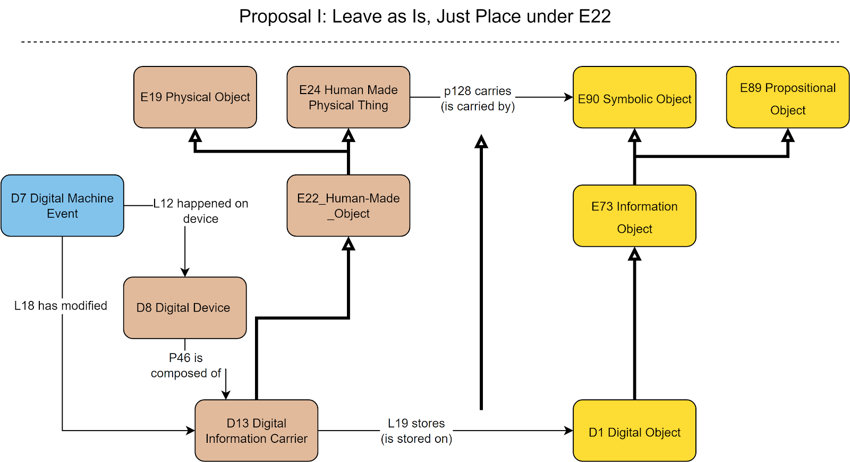
The SIG voted on the proposal
Outcome of the vote.
In favor: 9 (8 in person, 1 online)
Against: None
(15 participants abstained)

Deprecate D9 Data Object –express the concept it through property Lxx encodes dimension [D: D1 Digital Object, R: E54 Dimension]
Discussion points: identity conditions for dimensions and digital objects are incompatible. Neither multiple inheritance nor multiple instantiation should be permitted when the identity conditions of the classes at hand are incompatible.
Proposal: replace D9 with this “encodes dimension” property. Does not come with a ready-made scope note and label for the property, it just documents the intention to deprecate the class and substitute it by a property.

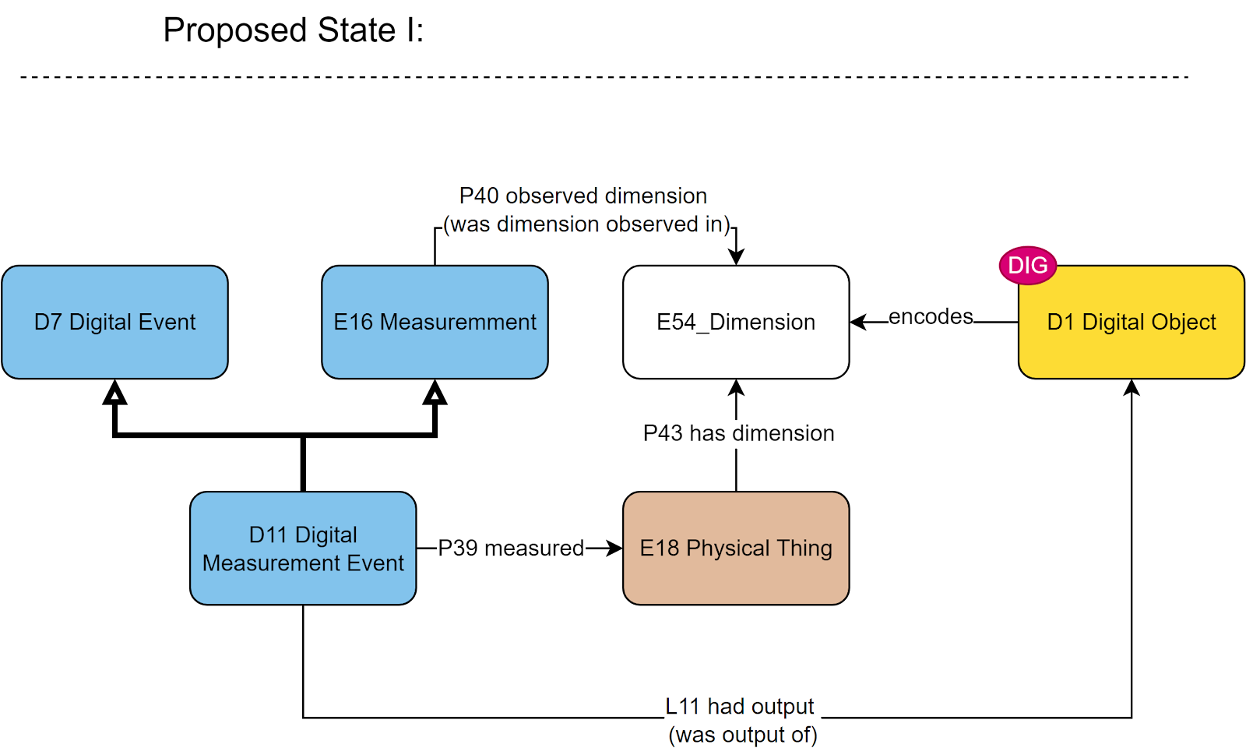
The SIG voted on the proposal
Outcome of the vote.
In favor: 12 (8 in person, 4 online)
Against: None
(12 participants abstained)
HW: GB to draft the definition of the property.

Annotation models – deprecate
Problems with annotation classes listed below:
- D35 Area (IsA D1 Digital Object AND IsA E26 Physical Feature), which is ontologically impossible. Proposal to deprecate it and reconsider what happens to the properties L49 and L50.
- D29 Annotation Object (relates to argumentation based on its semantics) and D30 Annotation Event do not fall in scope with CRMdig – should move to a different model (CRMinf)
Discussion points:
- For D35: the concept describes a section on a digital object. The software that visualizes digital objects (for the purpose of annotating them). This model here misses the association with a string encoding the “digital place primitive” information. The relation to E26 Physical Feature definitely has to be broken off.
- D29, D30: unwillingness to deprecate. They have reportedly been used in projects. Better decide where to move them before deprecating them. An obvious candidate is CRMinf (discussion on named graphs)
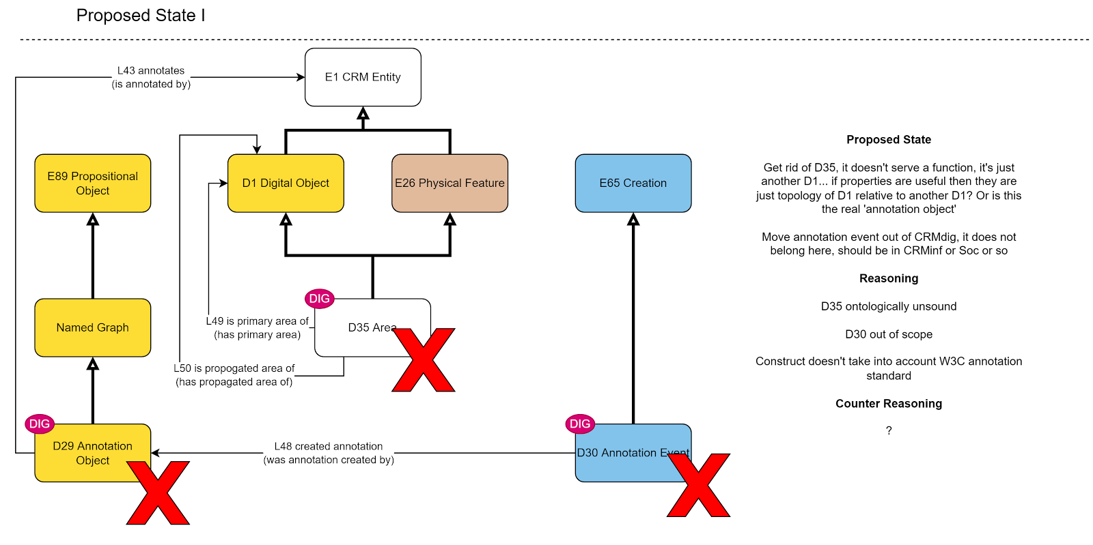
Proposals:
- Keep D35 Area, but make it exclusively IsA D1 Digital Object. Add a property to it, to express its relation to a content string (in a parallel to S6 Declarative Place for physical objects)
- D29, D30 (and relevant set of properties) to be moved to CRMinf. Then once they’re safely stored in CRMinf, they can be removed from CRMdig.
The SIG voted on the proposal (a)
Outcome of the vote.
In favor: 9 (7 in person, 2 online)
Against: None
(15 participants abstained)
HW: MD to draft the definition of the property connecting to a “digital place primitive”.
The SIG voted on the proposal (b)
Outcome of the vote.
In favor: 7 (5 in person, 2 online)
Against: None
(17 participants abstained)

Overall scope update
Rewrite the formal ontological description of the CRMdig, update the list of editors.
Discussion points: Not ready to change the status to Stable.
Editors: GB, MD, can ask NC, RS, and anyone else who has worked on it.
Decisions:
- Make D13 Digital Information Carrier IsA E22 Human-Made Object
- Deprecate D9, introduce Lxx encodes dimension
HW: GB to provide definition
- Make D35 ISA E26, add property (for association with a digital place primitive)
HW: MD to draft the property definition
- D29, D30 to be moved to CRMinf instead
- HW: Provide a new scope, name editors (MD, GB)

