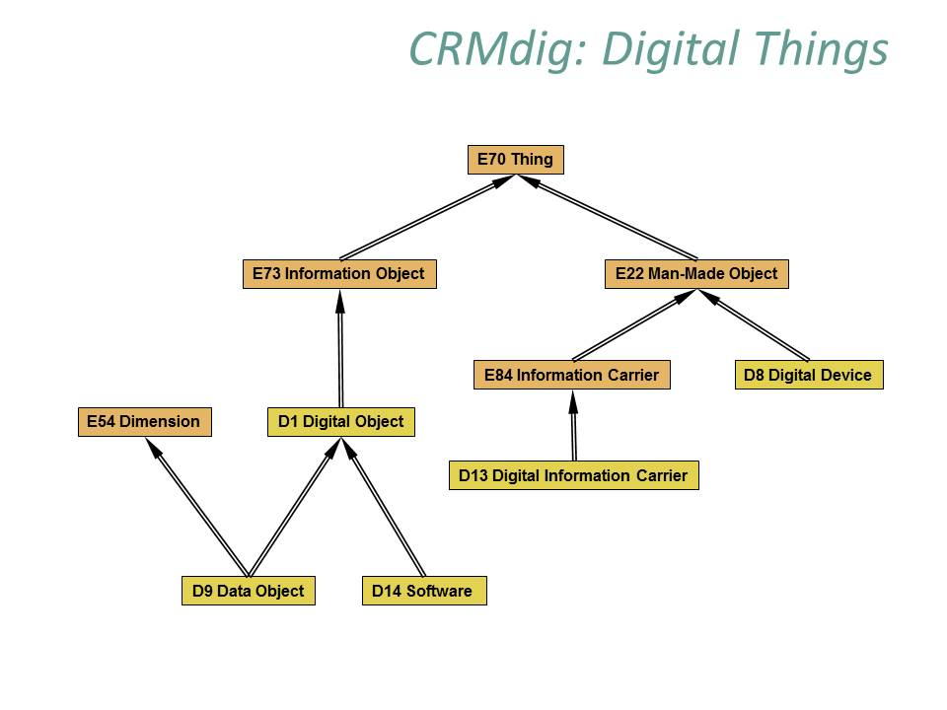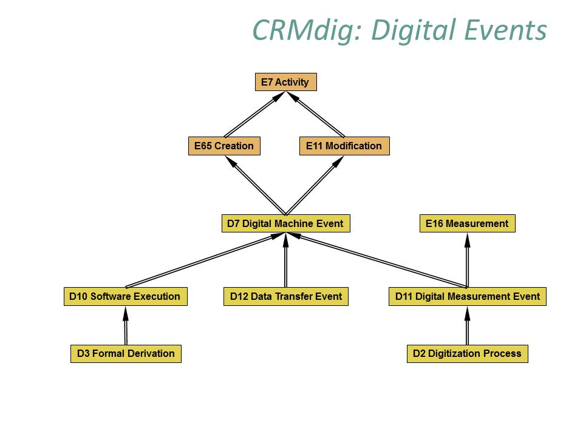**CRMdig is an ontology and RDF Schema** to encode metadata about the steps and methods of production ("**provenance**") of digitization products and synthetic digital representations such as 2D, 3D or even animated Models created by various technologies (see Figure 1, Figure 2). Compared to competitive models, its distinct features are the complete inclusion of the initial physical measurement processes and their parameters.

It needs to be **harmonized** with **CRMinf, CRMsci**, **Prov-O** and the **PARTHENOS Entity Model**, which is proposed for review as approved CRM extension. It is **used** at least by IGD Fraunfofer, Darmstadt. It was **successful** for describing **3D scanning** of objects, and **inferring metadata of derived objects**.

Not even the Tutorial is on the CRM site.

**OVERVIEW:**





**Critical Concepts:**

**D9 Data Object IsA Dimension** and **PE22 Persistent Dataset** in **PARTHENOS**

**D3 Formal Derivation** and **S6 Data Evaluation** in **CRMsci**

**D7 Digital Machine Event** as **E7 Activity ,** versus **triggering** or “setting traps”.

**Parthenos:**

The Parthenos Entities (PE) propose an ontological model and RDF schema to encode data of use in supporting the activities and aims of research infrastructures to pool and **connect services, software, datasets** and to enable users of such services to reach the actors and **understand the knowledge generation processes** which generated the offered datasets. Research infrastructures integrate highly heterogeneous resources for an often equally heterogeneous public. A central component of the activity of and RI in a digital environment involves building a data model that will support intuitive and accurate recall of information produced within the domain supported.

**-----------------------------------------------------------------**

**D9 Data Object (CRMdig)**

Subclass of: E54 Dimension

D1 Digital Object

Scope note: This class comprises instances of D1 Digital Object that are the direct result of a digital measurement or a formal derivative of it, containing quantitative properties of some physical things or other constellations of matter.

Properties:

L56 has pixel width: Literal

L57 has pixel height: Literal

**VERSUS: (Parthenos Model)**

|  |  |
| --- | --- |
| **Class Label** | **PE22 Persistent Dataset** |
| **Subclass of** | PE18 Dataset …*IsA D1 Digital Object* PE19 Persistent Digital Object |
| **Superclass of** |  |
| **Scope Note** | This class compromises datasets that contain collections of data, records or information kept as a persistent unit of information in the **knowledge generation process** from primary records up to any level of aggregation or integration.  The identity of a dataset is given by its content on the bit-level of encoding and its provenance. Since large datasets have a very small chance to be “reinvented” with another meaning, it is often practical to base the identity of a dataset on the content only, and apply a respective disambiguation of provenance only in case of obviously accidental identity. Different versions of a dataset are regarded as different datasets. Their relation should be defined by metadata describing the derivation process, rather than by version numbers.  In general, a dataset may be integrated from different sources of provenance, such as a corpus of inscriptions compiled from different publication or a snapshot of a complete digital library. The integrated dataset may preserve the units of information of the source from which it has taken components. The content of knowledge organization systems, such as gazetteers, author lists, thesauri and formal ontologies of terms at a particular point in time, fall under datasets. |

**D3 Formal Derivation (CRMdig)**

Subclass of: D10 Software Execution

Scope note: This class comprises events that result in **the creation of a D1 Digital Object from another one following a deterministic algorithm, such that the resulting instance of digital object shares representative properties with the original object**.

In other words, this class describes the transition from an immaterial object referred to by property L21 used as derivation source (was derivation source for) to another immaterial object referred to by property L22 created derivative (was derivative created by) preserving the representation of some things but in a different form. Characteristic examples are colour corrections, contrast changes and resizing of images.

Properties:

L21 used as derivation source (was derivation source for): D1 Digital Object

L22 created derivative (was derivative created by): D1 Digital Object

**VERSUS:**

**S6 Data Evaluation (CRMsci)**

Subclass of: S5 Inference Making

Scope note: This class comprises the action **of concluding propositions on a respective reality from observational data** by making evaluations based on mathematical inference rules and calculations using established hypotheses, such as the calculation of an earthquake epicenter. S6 Data Evaluation is not defined as S21/E16 Measurement; Secondary derivations of dimensions of an object from data measured by different processes are regarded as S6 Data Evaluation and not determining instances of Measurement in its own right. For instance, the volume of a statue concluded from a 3D model is an instance of S6 Data Evaluation and not of Measurement.

Examples:

* The calculation of the earthquake epicenter of Lokris area in 1989 by IGME (Ganas et al., 2006)The calculation of the intensity distance and assignment of PGA_N using the gcf2sac software from the EPPO shock wave recording of 2/2/1990 in Athens (S4) [1](InGeoCloudS - INspiredGEOdata CLOUD Services D2.2 2012;D2.3 2013)The calculation of the overall height (E54) of the statue of Hercules (S15) in the Temple of Hercules in Amman from the measurement of the size of the fragment of the fingers [https://en.wikipedia.org/w/index.php?title=Temple_of_Hercules_(Amman)&oldid=827687597].

In First Order Logic:

S6(x) ⊃ S5(x)

Properties:

O10 assigned dimension (dimension was assigned by): E54 Dimension

[O11](#_O11_described_(was) described (was described by): S15 Observable Entity

**D7 Digital Machine Event**

Subclass of: E11 Modification

E65 Creation

Superclass of: D10 Software Execution

D11 Digital Measurement Event

D12 Data Transfer Event

Scope note: **This class comprises events that happen on physical digital devices following a human activity that intentionally caused its immediate or delayed initiation** and results in the creation of a new instance of D1 Digital Object **on behalf of the human actor**.

The input of a D7 Digital Machine Event may be parameter settings and/or data to be processed. Some D7 Digital Machine Events may form part of a wider E65 Creation event. In this case, all machine output of the partial events is regarded as creation of the overall activity.

Properties:

L10 had input (was input of): D1 Digital Object

L11 had output (was output of) : D1 Digital Object

L12 happened on device (was device for): D8 Digital Device

L18 has modified (was modified by): D13 Digital Information Carrier

L23 used software or firmware (was software or firmware used by):

D14 Software

L31 has starting date-time (was starting date-time of): Literal

L32 has ending date-time (was ending date-time of): Literal

L61 was ongoing at: Literal

**DECISION to be taken:**

Working Group and responsible editor needed.

1.