Wednesday 20/5/2015

Discussion about FOL representation of shortcuts
Formalization of shortcuts: two action points (1) to control all the quantifications and (2) all subproperties.

P2 :
Events allow a more detailed path from E1 CRM Entity through P41 classified (was classified), E17 Type Assignment, P42 assigned (was assigned by) to E55 Type for assigning types to objects compared to the shortcut offered by P2 has type (is type of).
There exists at least one event of type E17 such that…This may be part of the epistemological layer.
May cause infinite recursion!
Knowledge creation events cannot be inferred within the same named graph.
This is a weak shortcut.
Action: We have to distinguish knowledge. Øyvind will make a statement about knowledge creation process and shortcuts. If one who maintains the knowledge base takes a stamp of the observer. Knowledge creation events cannot be inferred by rule. (if you are the God, you don’t describe yourself in the graph you may describe other gods). George Bruseker and Øyvind will work in this.

P43 :
It is a weak shortcut, dimension could be computed
P44:
This shortcut concerns the epistemological layer

P48:
This is a property of type “current”. The long path cannot infer its validity at the time of recording. This is not a shortcut. There is a cardinality conflict!:
It is decided that Martin and CEO will check the FOL for shortcut Logic

P49:
This shortcut supposes the existence of at least one representative part standing physically for the whole. Discuss knowledge revision process if a piece taken to be the representative of the whole must be regarded piece of another. Things kept may have parts in other hands.
A comment should be stated. Steve, MD, Athinak should think together

P50:
“current” cannot be inferred, it is not a weak shortcut

P51:
It is a weak shortcut, it does not pertain to all parts.

P52:
“current” cannot be inferred, it is not a weak shortcut. We drew the following figure in the board
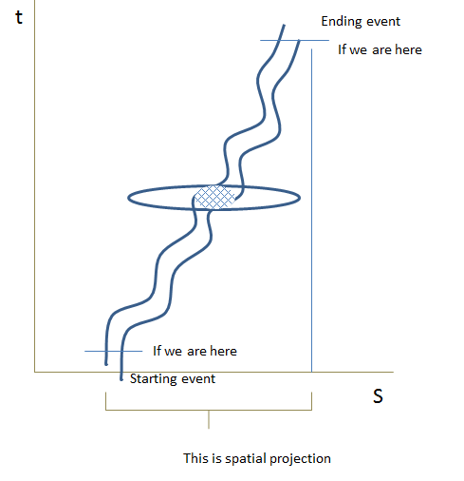

Action : to be discussed in the sense of causality. It is complicated because of E53 Place.
P53:
The inverse is weak because create the shortcut from the link and not from the whole path. It should be discussed.
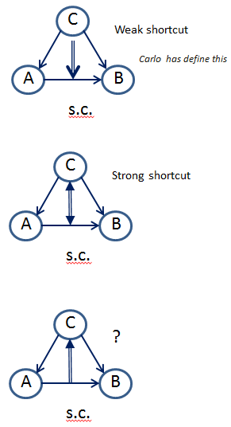

Thursday 21/5/2015

Discussion about formalization of shortcuts (cont.).

P55:
It is a weak shortcut, alternatives are ambiguous

P56:
It is a strong shortcut

P59:
It is a weak shortcut, alternatives are ambiguous

P62:
to be elaborated by Steve

P105:

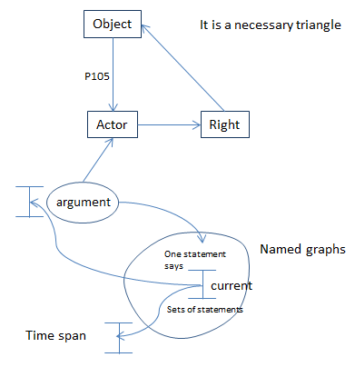

There is a problem with the “current” when data is aggregated. There is no problem with local data. Maybe an addition is needed to CRMinf to propose how a property is current.
Wolfgang Schmidle and Pierre Choppe, will send what they have understood.
CRM does not restrict any CRM user to CRM concepts since it models only concepts that can be shared for querying across the resources.

P107:
It is a weak shortcut. The sig reviewed the scope note of E66 Formation and it is noted that this doesn’t mean that the members of the group are being enumerated. It is highlighted a part of the scope note, in order to be discussed later. The question to Carlo is how to formulate that an inverse exist in strong shortcuts?
Then a golden rule is formulated :
“CRM concepts and isA hierarchy must be adequate to the states of knowing but not to give a complete account of causality”
We discuss the purpose of introducing the strong shortcuts. There is an aspect of utility denoting the strong shortcuts. We should find those expansions of paths that they are regarded useful for querying. Then the sig made changes to the scope note of E85 Joining.

P152:
It is a weak shortcut. Alternatives are ambiguous. The question is what are the states of not knowing? We have to revise what is the utility of making a strong shortcut inference explicit (question to Carlo)

P130:
MD will change the scope note to reflect the inference

P109:
The scope note is changed. “Being a shortcut is not inherited to subproperties”
The sig decided that in the introduction to CRM it should be stated that someone before read and use CRM, should read certain documents. It should be written an introduction for RDF and OWL representation of CRM. (Mark Fichtner will prepare such documents)

P8:
The scope note is changed. It is a weak shortcut

