CIDOC CRM Diagramming Guidelines

Version 0.1
Authors: Trang Dang and Philippe Michon
Reviewers: Eleni Tsouloucha, ?
Intended audience: CIDOC CRM SIG
Created date: 2023-11-28
Last update: 2024-03-01

Abstract: To represent ontological constructions or knowledge graphs, CIDOC CRM users often use diagrams as visual aids. This document contains guidelines to ensure the standardization of these diagrams in particular in order to facilitate consultation, but also increase their interoperability with specific tools.

Scope and Objectives 1
Diagram components 1
Diagramming tools 2
Requirements 2
CIDOC CRM diagrams styling 3
Classes and Instances 3
Shape 3
Text 4
Data 4
Properties 4
Shape 4
Text 4
Data 4
Examples 5
Ontological representation 5
Knowledge Graph representation 5

Scope and Objectives

Diagram components
This document aims to define parameters so that diagrams illustrating ontological constructions or knowledge graphs based on CIDOC CRM are standardized. It describes how each component of the diagram should be visually represented and not the positioning of each component relative to each other. The positioning issues will be defined when there is consensus on the constituent parts of the CIDOC CRM diagrams described in this document. As such, this document does not define the following:
- The maximum size that a CIDOC CRM diagram should have.
- How to specify the title of the diagram.
- How to position a subclass in relation to its superclass.
- What the legend for each diagram should look like.
- Diagram metadata like its creation date.
- If it is allowed to cross two properties (arrows).

Diagramming tools
There are several solutions on the market for generating diagrams. The CIDOC CRM SIG recognizes that depending on the implementation contexts different tools could be used to create diagrams based on CIDOC CRM. As such, this document attempts to identify parameters that can be replicated across different tools. However, please note that it is impossible to guarantee that everything you find in this document can be implemented in the tool you prefer.
Although the CIDOC CRM SIG does not recommend any particular tool, it does emphasize that using an open source tool can greatly facilitate the interoperability and reuse of your diagrams.
For transparency purposes, the CIDOC CRM SIG would like to indicate that the tests leading to the development of these guidelines were carried out with the open source tool diagrams.net (previously draw.io).

Requirements
The guidelines defined in this document are based on the following list of requirements:
- Whenever possible, stylistic rules should rely on diagrams that are already emerging from the CIDOC CRM community.
- Stylistic choices, particularly colors and shapes, can greatly impact the user's reception of the diagram. These choices must therefore take into account theories on colors and shapes.
- The diagrams should easily be read on a computer, printed on a sheet or projected onto a screen.
- In order to reduce the environmental impact of diagrams, especially when printed, the style must remain as minimalist as possible.
- So that the user can easily anticipate the positioning of each entity in a complete diagram, the shapes used must be of similar size.
- Diagrams must be able to easily represent ontological constructs (e.g. no instances, but include cardinality) and knowledge graph samples (e.g. instances, but no cardinality).
- The diagrams must be understood by all types of CIDOC CRM users and not only IT specialists.
- Ideally, there should be a link between the class or property depicted and its URI.

CIDOC CRM diagrams styling

Classes and Instances

Shape
- Rounded rectangle
- Border:
  - solid
  - black
  - 1 pt
- Width: 140
- Height: 70
- Fill:
E2 Temporal Entity (#82c3ec)
E55 Type (#fab565)
E52 Time-Span (#86bcc8)
E41 Appellation (#fef3ba)
E53 Place (#94cc7d)
E77 Persistent Item (#ffffff)
E28 Conceptual Object (#fddc34)
E18 Physical Thing (#e1ba9c)
E39 Actor (#ffbdca)
E1 CRM Entity (#ffffff)
PC Classes (#cc80ff)
Instances (#ffffff)

Text
- Font: Helvetica
- Size: 16
- Color: black
- Horizontal align: center
- Vertical align: middle
- Weight: bold
- Word wrap
- Value: entity name without underscore

Data
- URI
- Labels in available languages
- No scope note
- Link (clickable)

Properties

Shape
- One-way arrow
- Stroke width: 2 pt
- Color: black

Text
- Font: Helvetica
- Color: black
- Size: 14
- Weight: bold
- Background color: white
- Horizontal align: center
- Vertical align: middle
- Value: entity name without underscore, quantifications

Data
- URI
- Labels in available languages
- No scope note
- Link (clickable)

Examples
The following examples were generated using diagrams.net and are intended only to quickly demonstrate the stylistic rendering. The positioning of elements in relation to each other is not a formal recommendation.

Ontological representation
In this example, the property is linked directly to classes and includes its quantifications. Property's label includes both forward and backward values.
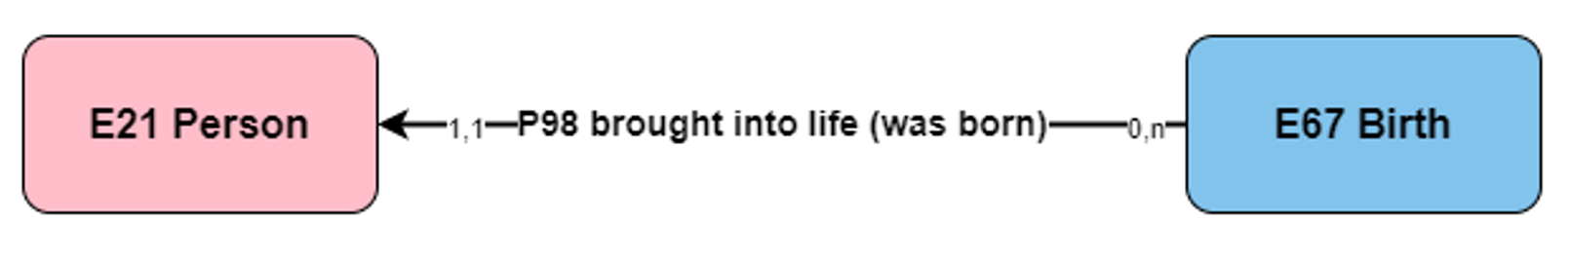

Knowledge Graph representation
In this example, the property is linked directly to instances and does not include quantifications. Instances are attached directly under the classes they are associated with. Property's label includes only forward value.
