CIDOC-CRM URIs NAMESPACE MECHANISM (using 303-redirect)
Christos Georgis
Centre for Cultural Informatics / FORTH-ICS
20/11/2018

Description of mechanism
Below we describe CIDOC CRM generic (version independent) namespace mechanism for the interpretation of the CIDOC CRM as RDF schema: http://www.cidoc-crm.org/cidoc-crm. It provides details on current implementation (v5.0.4 or later), changes from previous namespace implementations and backward compatibility.
Each entity represented in a particular data set leads to the minting of at least three URIs:
- a URI for the real-world object itself
- a URI for a related information resource that describes the real-world object and has an HTML representation
- a URI for a related information resource that describes the real-world object and has an RDF/XML representation
In order to publish the CIDOC-CRM vocabulary and to provide the above three URIs, we followed the W3C Working Group Note “Best Practice Recipes for Publishing RDF Vocabularies” . We have extended the configuration for a 'slash namespace‘, using a single HTML document.
We configured our server to provide either human-readable (HTML) or machine-processable (RDF) content from the vocabulary URI, depending on what is requested, and to redirect the client from class and property URIs to the appropriate content locations containing the current version of HTML or RDF file, again depending on what is requested. The HTML documentation is served as a single file.
So we were able to use URI http://www.cidoc-crm.org/cidoc-crm to:
- Dereference the vocabulary URI, requesting HTML content
- Dereference the vocabulary URI, requesting RDF content
- Use it as vocabulary namespace
while we use URIs such as: http://www.cidoc-crm.org/cidoc-crm/E5_Event and http://www.cidoc-crm.org/cidoc-crm/P148_has_component to:
- Dereference the URI of a class or property, requesting HTML content
- Dereference the URI of a class or property, requesting RDF content

This behavior is illustrated by the following diagrams:
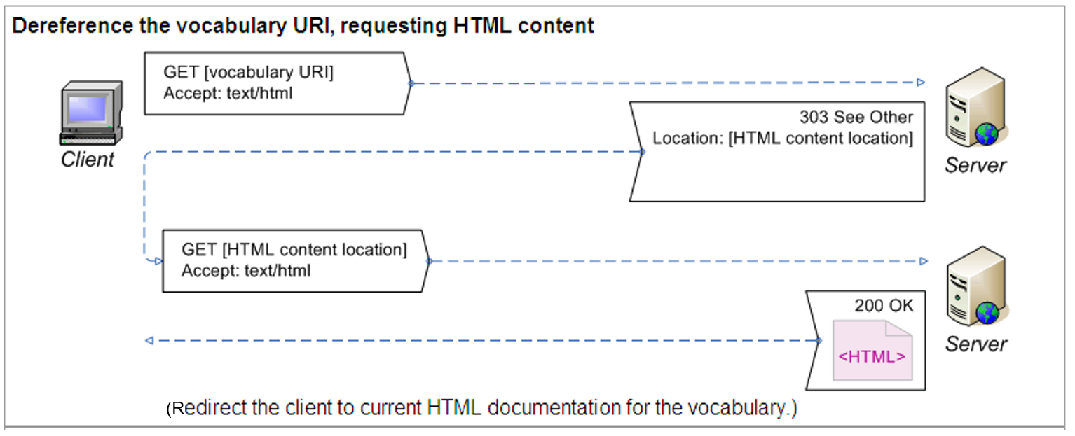
4
http://www.cidoc-crm.org/cidoc-crm
redirects (303 see other) to
http://www.cidoc-crm.org/html/5.0.4/cidoc-crm.html

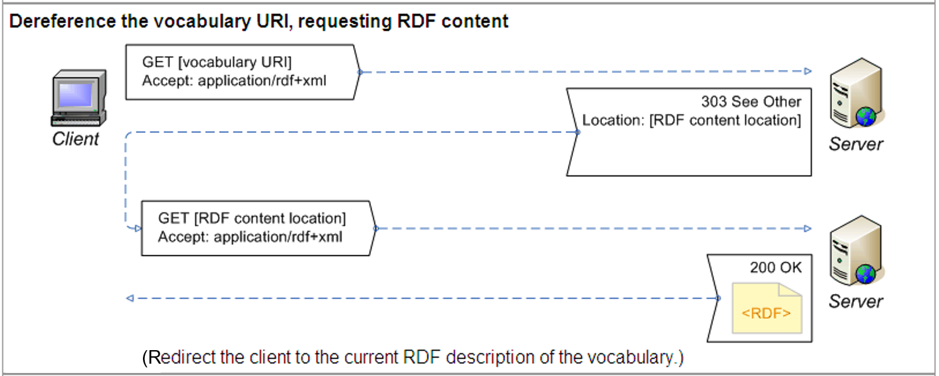
http://www.cidoc-crm.org/cidoc-crm
redirects (303 see other) to
http://www.cidoc-crm.org/rdfs/5.0.4/cidoc-crm.rdf

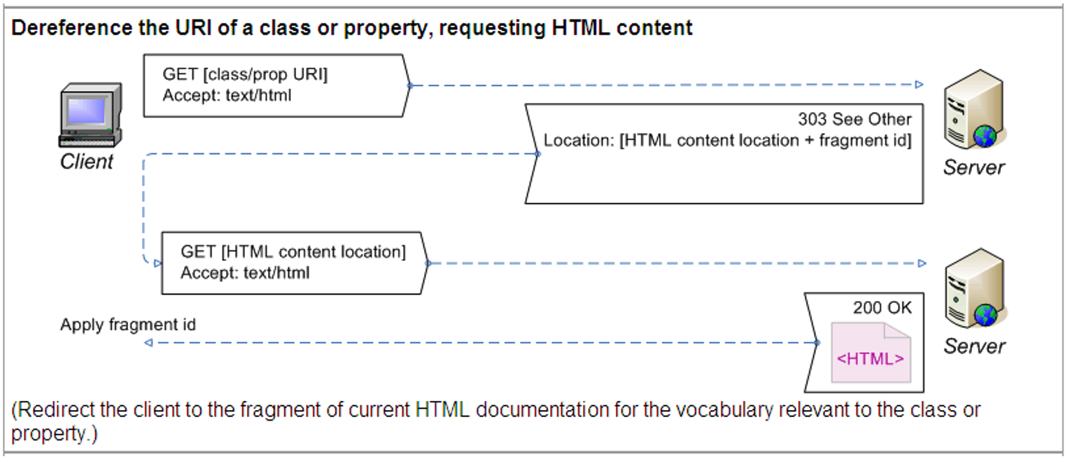
http://www.cidoc-crm.org/cidoc-crm/E5_Event
redirects (303 see other) to
http://www.cidoc-crm.org/html/5.0.4/cidoc-crm.html#E5
and
http://www.cidoc-crm.org/cidoc-crm/P148_has_component
redirects (303 see other) to
http://www.cidoc-crm.org/html/5.0.4/cidoc-crm.html#P148

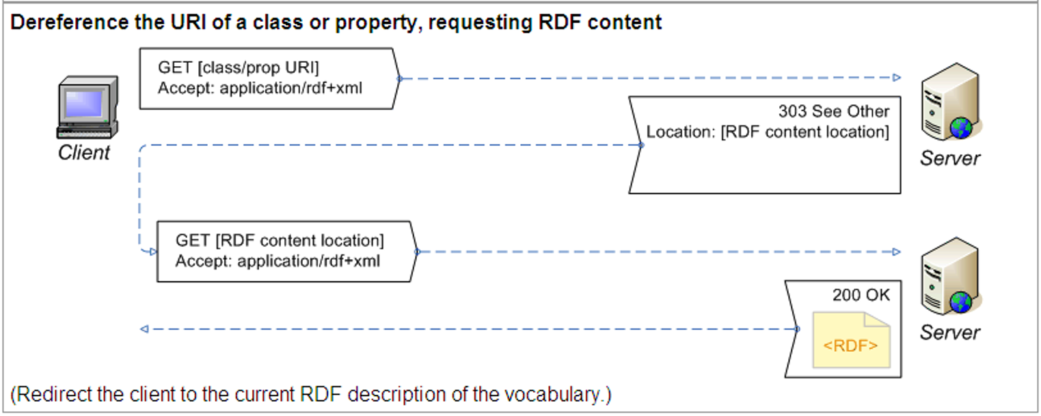
http://www.cidoc-crm.org/cidoc-crm/E5_Event
redirects (303 see other) to
http://www.cidoc-crm.org/rdfs/5.0.4/cidoc-crm.rdf
and
http://www.cidoc-crm.org/cidoc-crm/P148_has_component
redirects (303 see other) to
http://www.cidoc-crm.org/rdfs/5.0.4/cidoc-crm.rdf

Backwards compatibility
For backwards compatibility we configured our server to resolve old-formatted URIs such as:
- http://www.cidoc-crm.org/cidoc-crm/E5 to be valid and to redirect (303 see other) to URI http://www.cidoc-crm.org/cidoc-crm/E5_Event
- http://www.cidoc-crm.org/cidoc-crm/P148, http://www.cidoc-crm.org/cidoc-crm/P148F to be valid and to redirect (303 see other) to URI http://www.cidoc-crm.org/cidoc-crm/P148_has_component
- http://www.cidoc-crm.org/cidoc-crm/P148i, http://www.cidoc-crm.org/cidoc-crm/P148B to be valid and to redirect (303 see other) to URI http://www.cidoc-crm.org/cidoc-crm/P148i_is_component_of

Obsolete URIs
The following old-formatted URIs are obsolete:
- http://www.cidoc-crm.org/crm-concepts/#E5 is no longer valid and should be replaced with http://www.cidoc-crm.org/cidoc-crm/E5_Event
- for properties: http://www.cidoc-crm.org/cidoc-crm/P11F and http://www.cidoc-crm.org/cidoc-crm/P11B are no longer valid and should be replaced with http://www.cidoc-crm.org/cidoc-crm/P11_had_participant and http://www.cidoc-crm.org/cidoc-crm/P11i_participated_in respectively.
- http://www.cidoc-crm.org/crm-concepts is obsolete
- http://www.cidoc-crm.org/crm-concepts/#E5 is obsolete

The following namespaces are now obsolete:
- http://www.cidoc-crm.org/rdfs/cidoc-crm is no longer valid and should be replaced with http://www.cidoc-crm.org/cidoc-crm
- http://www.cidoc-crm.org/rdfs/cidoc-crm is obsolete
- http://www.cidoc-crm.org/rdfs/cidoc-crm-english-label is obsolete

Tom Heath and Christian Bizer (2011) Linked Data: Evolving the Web into a Global Data Space (1st edition). Synthesis Lectures on the Semantic Web: Theory and Technology, 1:1, 1-136. Morgan & Claypool. http://linkeddatabook.com/editions/1.0/ (see sections 2.3.1 and 4.1.3).
http://www.w3.org/TR/swbp-vocab-pub/#recipe4
In the following of this report, we consider v5.0.4 as the current CIDOC-CRM version.

