TGN Place Type list:
https://www.getty.edu/research/tools/vocabularies/guidelines/tgn_4_6_appendix_f_place_types.html

Geographic places in the TGN include terms to describe physical features such as continents, rivers, and mountains; and political entities, such as empires, nations, states, districts, townships, cities, and neighborhoods.
Place types with codes between 20000 and 29999 are physical features, meaning they were formed by natural forces on planet Earth.

PARTIAL PLACE TYPE LIST FOR PHYSICAL FEATURES (see excel)
ocean pond river creek
lakes lake intermittent lake bay
strait glacier river mouth waterfall
desert oasis wetland marsh
continent subcontinent fault volcano
dunes arroyo canyon fluvial island
mountain mountain range mountain system hill
hills plateau valley basin
field plain cape island group
island peninsula reef shore
cave crater depression pampa
prairie savanna jungle forest

Geographic places also include entities defined by political and administrative boundaries, such as empires, nations, states, districts, townships, and cities.
Place types with any code outside the range 20000-29999 (e.g., 10000-19999, 50000-59999, and 80000-89999) are administrative entities, which refers not only to places with administrative functions (such as nations or states), but to all places with boundaries, features, or other associations that have been formed by or influenced by human habitation or endeavors (e.g., inhabited places, archaeological sites, reservoirs)

PARTIAL PLACE TYPE LIST FOR ADMINISTRATIVE AND POLITICAL ENTITIES (see excel)

primary political unit independent sovereign nation empire
federation nation kingdom
dependent state first level subdivision country
bailiwick autonomous municipality canton
city-state special city colony
commissary commonwealth metropolitan area
independent city county department
dependency parish (political) province
region shire state
territory external territory unincorporated territory
overseas territory possession occupied territory
second level subdivision diocese archdiocese
parish (ecclesiastical) third level subdivision arrondissement
borough precinct township
inhabited place locale rural community
hamlet village town
city American Indian reservation Aboriginal reserve
Administrative entities include those defined by boundaries set up by standard, independent sovereign states. In addition, administrative entities in the TGN may include those with government and boundaries defined by other authorities, such as ecclesiastical or tribal authorities.
Administrative subdivisions and neighborhoods of the largest cities are within the scope of the TGN.
Included are subdivisions such as urban districts, quarters, neighborhoods, or suburbs.
Also, within the scope of the TGN are large physical or man-made features within the boundaries of a city, including streams, hills, woods, or large parks. Smaller features typically found within the boundaries of a city are outside the scope of the TGN. Therefore, generally excluded from the TGN are buildings, landmarks, and streets within cities. Note that buildings are occasionally considered within the scope of the TGN; these are limited to structures that are located in the countryside (for example, abbeys, villas, and shopping centers), where they serve as a place name in the absence of a larger populated place.
Likewise, some other large, major man-made features are within the scope of the TGN, for example theGreat Wall of China and the Via Appia.
Cultural and political groups are outside the scope of the TGN; however, the political state of a cultural or political group, and the territory within its boundaries, are within the TGN’s scope. For example, the Ottoman Turks are outside the scope of the TGN, though the Ottoman Empire could be included in TGN. The scope of the TGN may include places that are no longer extant. This includes deserted settlements, such as ghost towns and archaeological sites. Lost physical feature could include features such as submerged islands.
Within the scope of the TGN are included “general regions,” which are recognized, named areas with undefined, controversial, or ambiguous borders. Examples include the Middle East, which refers to an area in SW Asia and NE Africa, but which has no defined borders and may be variously interpreted to mean different sets of nations. General regions are not organized political entities, though they may have their roots in historical entities such as kingdoms, duchies, or traditional tribal areas.
Historical entities may also be included; the number of historical entities will grow through contributions. Historical names and information regarding extant places may also be included in the TGN. For example, the record for the extant Turkish city of Pamukkale includes the historical name Hierapolis, as well as notes and dates describing the history of the city.

Place types are indexing terms based on the structured vocabulary of the AAT, where possible (see below an example of “inhabited places” from AAT).
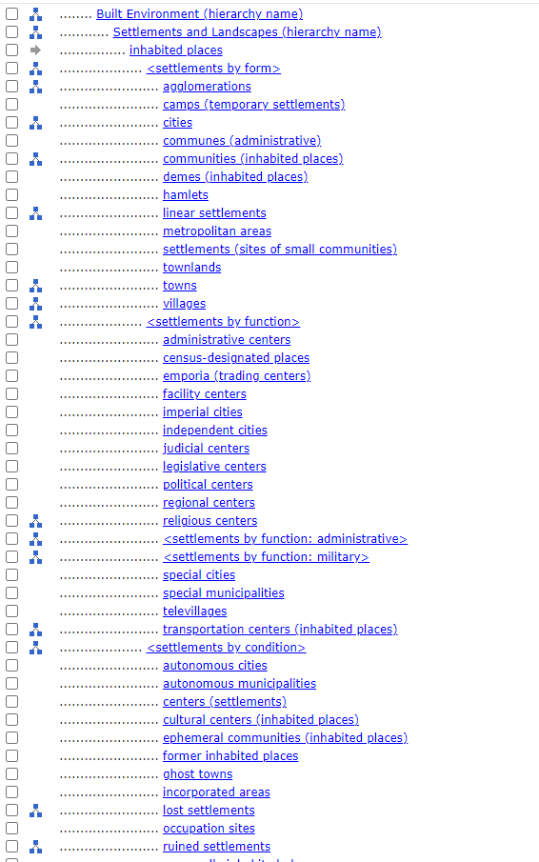

REFERENCES:
User’s Guide to the TGN Data Releases, version 2.0 / compiled and edited by Patricia Harpring, Los Angeles: J. Paul Getty Trust 2000.
https://www.getty.edu/research/tools/vocabularies/tgn/about.html

