Issue 471

Past Proposals (discussed in 46th SIG)

Martin had proposed this graphic

S
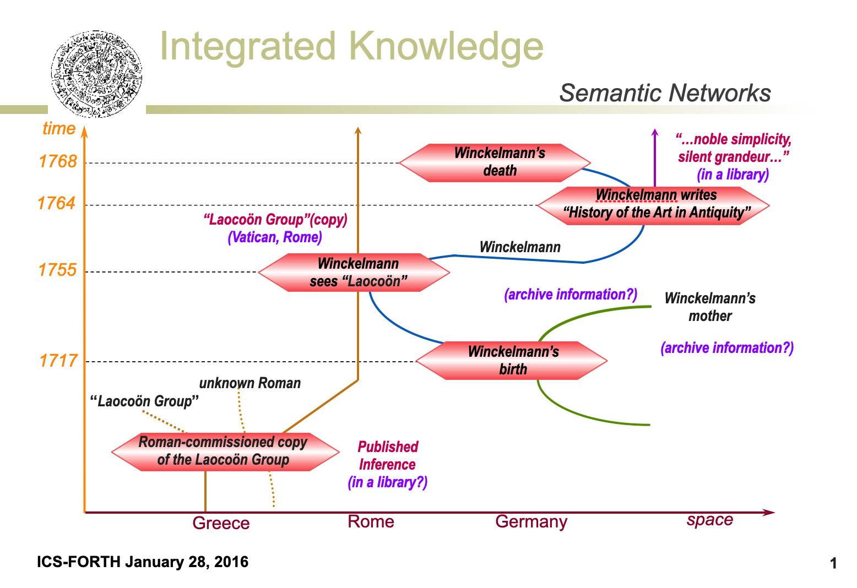

Current Proposal (for discussion and decision):

Martin took into account some discussion of whether the manner of graphic representation made understanding the geographic trajectory unclear and now proposes this graphic:

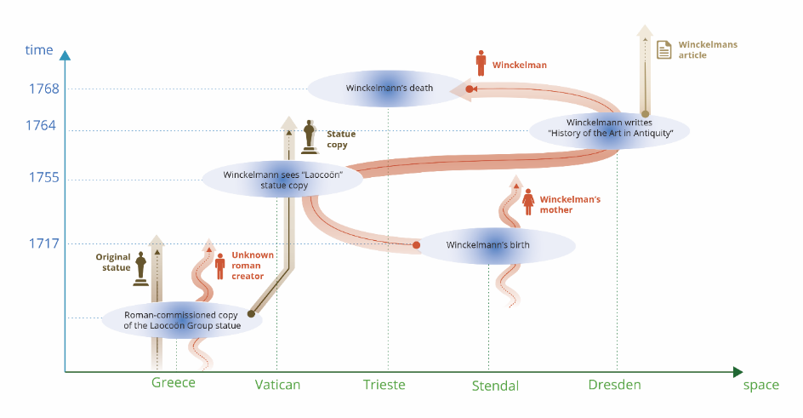

47th Sig Discussion

Is this a good symbolic presentation of these concepts?

SS: likes it in general, nice that you have the different kinds of objects interacting. Capitalise Roman
GH: 3d diagrams could be helpful… making the space one dimensional is hard…
MD: 3d doesn’t help. If you add 2 dimensions for the space, but there is actually a geometric connection… wants to be close to what archaeologists do (have columns and boxes for duration… always one dimensional space line)
GH: could make it easier for people to depict these things
TV: events stretch across different geographic areas. Smaller bubbles of text maybe // gradient color: used to denote uncertainty why mark space as gradient?
SS: place doesn’t cease to exist after the end of an event. So dotted lines continue to the top of the graphic
CEO: would like to take away the green arrow at the bottom of the diagram --no moving space.
MD: keep the line, remove the arrowhead in space.
GB: add a legend
Pg. 22 CIDOC CRM document (add a legend there)
GH: add CRM Classes, would help people understand better.
GB: if this kind of diagram becomes a regular thing, then we’d have to give it more consideration.
SS: fullstops instead of arrows at the end of existence for people (Winkelmann, his mother, the roman sculptor etc)
MD HW for the graphics.

47th Sig Decision
Email vote will be issued

47th Sig Homework Assignment
MD HW for the graphics as shown above.

