Objective:
Finalizing/formatting developed examples for the use of the class E93 Presence

People involved:
AG; MD; PF; GH
roles:
formatting examples pedagogical material for E93: AG
RDF file: PF
graphic representation: AG, GH?
reviewer: MD;

Status of the document: ongoing draft (Nero example 1 and 2: ok
VanHumbold example: ongoing
add link to Notre-Dame reperage mapping)

Issue link:
https://docs.google.com/document/d/18YVuATXXA1Fa7Gw1OC7YGtrQHEn2G65XXjI8M9khhdg/edit?usp=sharing

Graphic representation of examples:
https://drive.google.com/file/d/1b7U0VzmQ2tx_BcJvd4zOfmaOc9dZf4vw/view?usp=sharing

Why the need for developed examples for the application and use of E93_Presence?
When and how to apply the modeling with E93 Presence rather than Event and Activity?
How to understand the ontological modeling about Presence in the CIDOC CRM?
The understanding of E93 Presence is related to E92 Spacetime Volume
Synthesis about STV
Presence in regards to STV

E93 Presence (as in cidoc_crm_version_7.2.2.pdf)
Subclass of: E92 Spacetime Volume
Scope note: This class comprises instances of E92 Spacetime Volume whose temporal extent has been chosen in order to determine the spatial extent of a phenomenon over the chosen time-span. Respective phenomena may, for instance, be historical events or periods, but can also be the diachronic extent and existence of physical things. In other words, instances of this class fix a slice of another instance of E92 Spacetime Volume in time. The temporal extent of an instance of E93 Presence typically is predetermined by the researcher so as to focus the investigation particularly on finding the spatial extent of the phenomenon by testing for its characteristic features. There are at least two basic directions such investigations might take. The investigation may wish to determine where something was during some time or it may wish to reconstruct the total passage of a phenomenon’s spacetime volume through an examination of discrete presences. Observation and measurement of features indicating the presence or absence of a phenomenon in some space allows for the progressive approximation of spatial extents through argumentation typically based on inclusion, exclusion and various overlaps.
Examples: the Roman Empire on 19 August AD 14 (Clare and Edwards, 1992)
Johann Joachim Winckelmann’s whereabouts in December 1775 (Leppmann, 1970)
Johann Joachim Winckelmann’s whereabouts from 19th November 1755 until 9 th April 1768 (Leppmann, 1970)
In first-order logic: E93(x) ⇒ E92(x)
Properties:
P164 is temporally specified by (temporally specifies): E52 Time-Span
P166 was a presence of (had presence): E92 Spacetime Volume
P167 was within (includes): E53 Place
P195 was a presence of (had presence): E18 Physical Thing
P197 covered parts of (was partially covered by): E53 Place

[reference: Spatiotemporal relations in CIDOC CRM SIG (2022) v7.2.2 pp.41-43:
CIDOC CRM SIG (2022) ‘Definition of the CIDOC Conceptual Reference Model Version 7.2.2’. Edited by C. Bekiari et al. Available at: https://www.cidoc-crm.org/sites/default/files/cidoc_crm_version_7.2.2.pdf.]

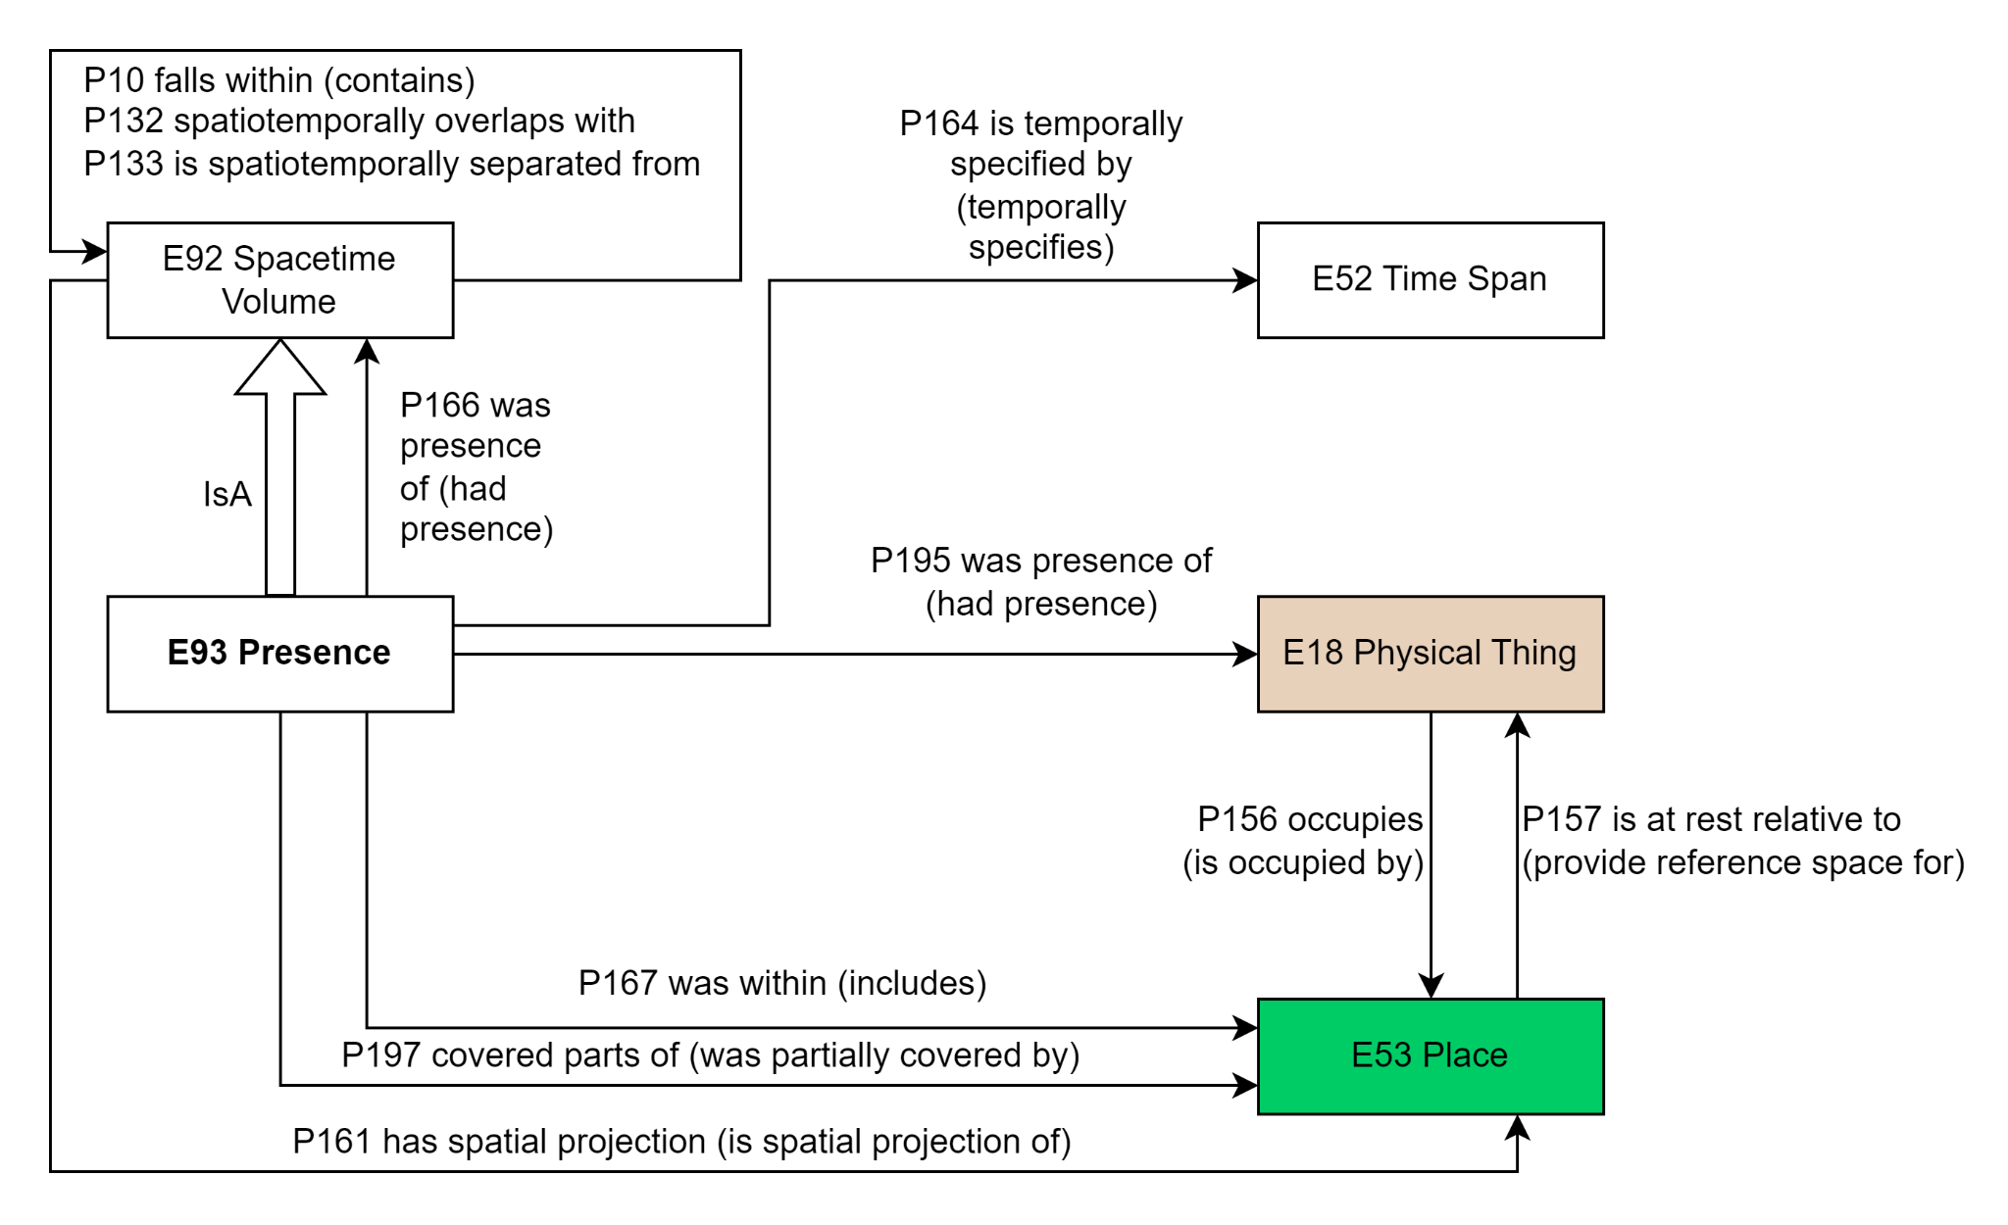
Figure: Representation diagram of E93 Presence and the direct related classes and properties in CIDOC CRM v.7.2.2. !!!!add P1,P2,p3etc inheritance!!!! Target, origin…

Explication of the figure here
More drawing-like illustration?

1/Nero and the Great Fire of Rome example

Description of the example in natural language (En):
At the time of the fire (July 19th, 64AD), Nero may not have been in the city but 35 miles away at his villa in Antium,^{[7]} and possibly returned to the city before the fire was out.^{[8]}

The example of Nero allows to explore 2 possible alternative semantic representations:
- Nero was in Antium while the Great Fire started in Rome in July 19th, 64 AD.
- Nero was in Rome singing while watching the fire in July 19th, 64 AD.

- In this first example of mapping, the objective is to express that Nero was NOT in Rome during the Great Fire of July 19th 64AD, but in Antium.

[Explication for the modeling with the class Presence]
With CIDOC CRM modeling, the Great Fire of Rome is an instance of E5_Event that is identified (P1) by a E41_Appellation “incendium magnum Romae” and happened at a specific place (P7): Rome 64 AD, Italy (E53_Place). This modeling is typical of the CIDOC CRM model.
To express the fact that Nero was not in Rome but in Antium while the fire was happening, the typical pattern of modeling cannot express the non-presence of Nero in Rome during the Fire. The CRM model uses a different pattern of modeling based on E92_Spacetime_Volume and E93_Presence. More specifically, the E5_Event of the Great Fire and the E93_Presence of Nero. The E92_STV of Nero and the E92_STV of the Great Fire do not overlap: it is through the instance of E93_Presence that one can assert that the presence of Nero in July 19, 64 AD and the Great Fire do not overlap. The E5_Event of the Great Fire and the E93_Presence of Nero July 19, 64 AD are disjoint in space.

Graphic representation of examples:
https://drive.google.com/file/d/1b7U0VzmQ2tx_BcJvd4zOfmaOc9dZf4vw/view?usp=sharing
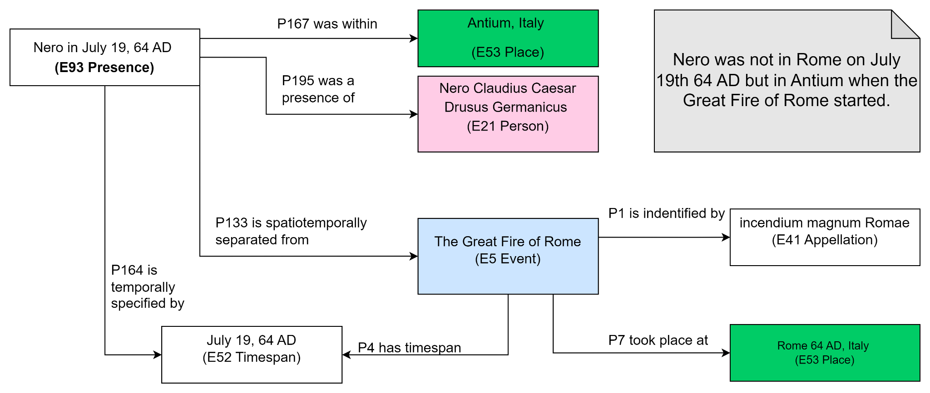
Figure: representation of the example “Nero not being in Rome during the Great Fire” using E93 Presence.

Mapping: (as proposed by MD/PF)
Nero in July 19, 64 AD (E93_Presence)
P164 is temporally specified by: July 19, 64 AD (E52_Timespan)
P195 was a presence of: Nero Claudius Caesar Drusus Germanicus (E21_Person)
P167 was within Antium, Italy (E53 Place)
P133 is spatiotemporally separated from: The Great Fire of Rome (E5_Event)
P1 is identified by: incendium magnum Romae (E41_Appellation)
P4 has timespan: July 19-27, 64 AD (E52_Timespan)
P7 took place at : Rome in 64AD, Italy (E53_Place)
RDF snippet representing the mapping 1: (PF)
…

- Nero was in Rome singing, while watching the fire in July 19th, 64 AD.

[Explication for the modeling with the class Presence]
The mapping of the E5_Event of the Great Fire is the same as before: the Great Fire of Rome is an instance of E5_Event that is identified (P1) by a E41_Appellation “incendium magnum Romae” and happened at a specific place (P7): Rome 64 AD, Italy (E53_Place).
The mapping differs insofar the E93_Presence of Nero is present during the E5_Event of the Fire: E93_Presence of Nero falls_within (P10) the E5_Event of the Great Fire. The E7_Activity of Nero singing has the same time span as the E5_Event of the Great Fire: July 19th, 64 AD. Both took place (P7) in the E53_Place of Rome.

The modeling with E93_Presence allows the linking of …

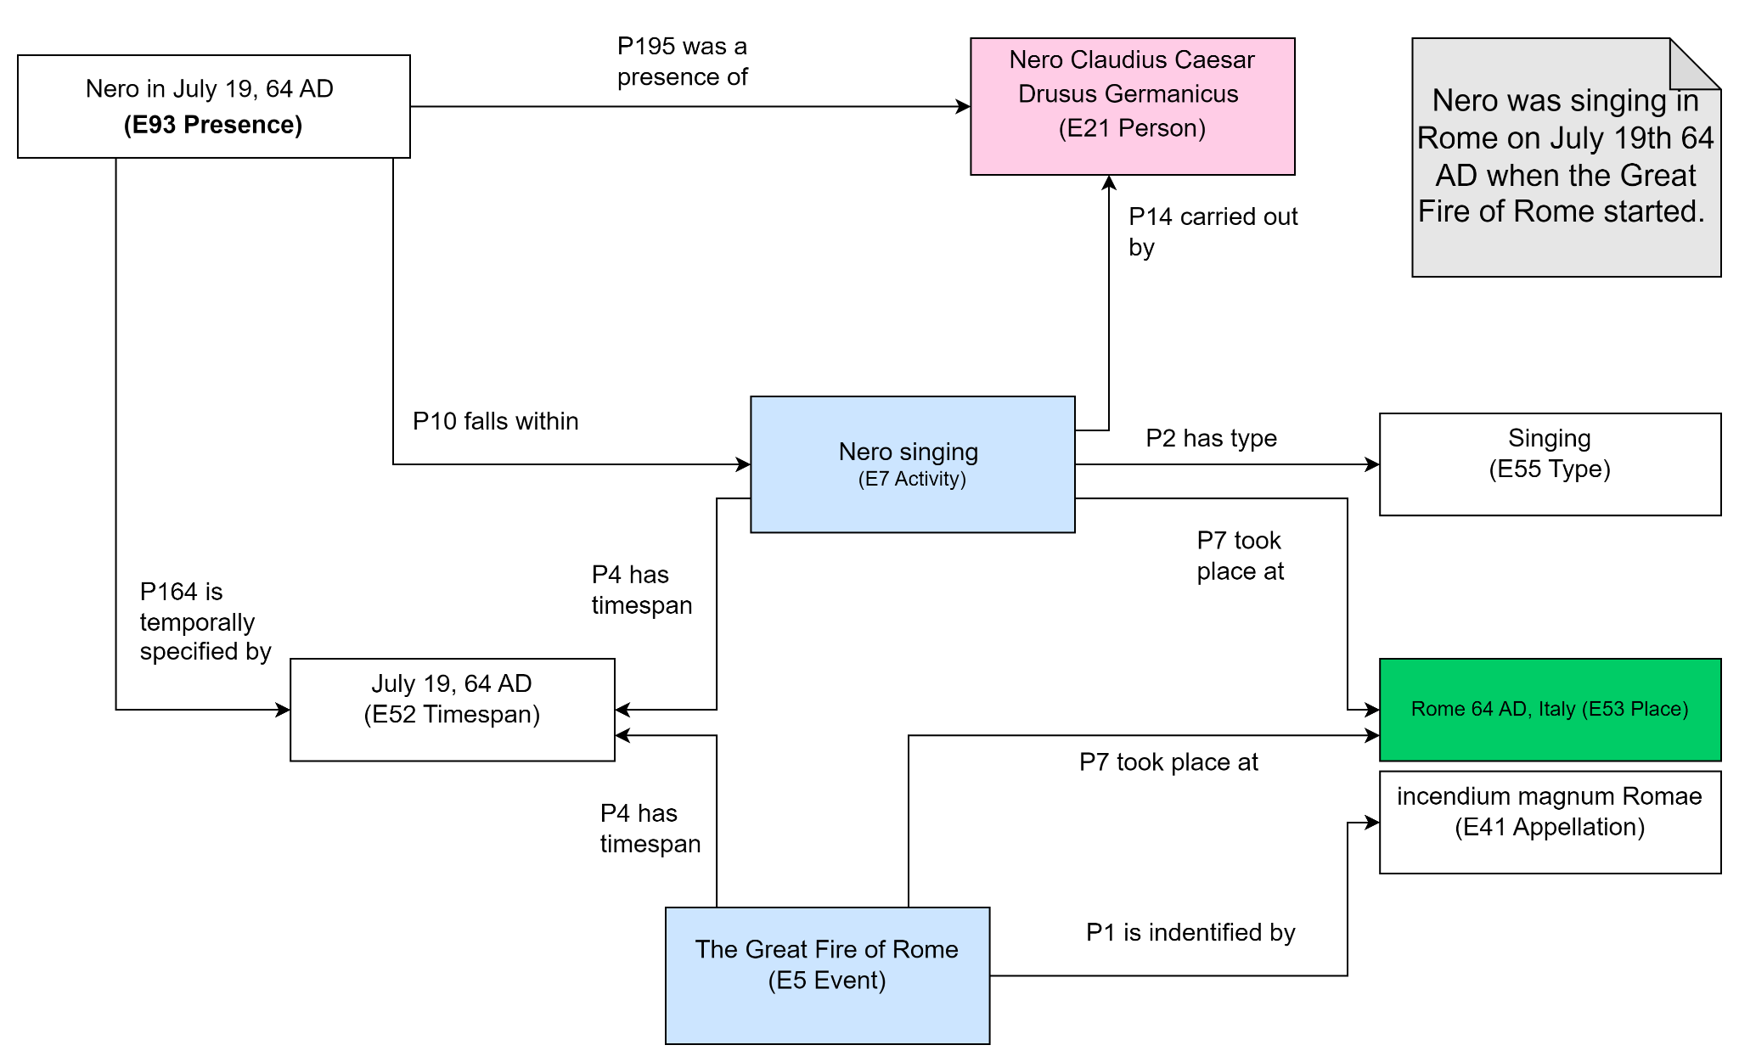
Figure: representation of the example “Nero Singing while Rome is burning” with E93 Presence.

Mapping 2: (as proposed by MD/PF)

Nero July 19, 64 AD (E93 Presence)
P164 is temporally specified by: July 19, 64 AD (E52 Timespan)
P195 was a presence of: Nero Claudius Caesar Drusus Germanicus (E21 Person)
P167 was within Rome in 64AD, Italy (E53 Place)
P10 falls within (contains): Nero Singing (E7 Activity)
P2 has type: Singing (E55 Type)
P14 carried out by: Nero Claudius Caesar Drusus Germanicus (E21 Person)
P4 has timespan: July 19, 64 AD (E52 Timespan)
P7 took place at : Rome in 64AD, Italy (E53 Place)
P132 spatiotemporally overlaps with: The Great Fire of Rome (E5 Event)
P1 is indentified by: incendium magnum Romae (E41 Appellation)
P4 has timespan: July 19-27, 64 AD (E52 Timespan)
P7 took place at : Rome in 64AD, Italy (E53 Place)

Conclusion [on the 2 possible mapping for the Nero example]:
…

-Bibliography [Harvard citation style]:
‘Great Fire of Rome’ (2023) Wikipedia. Available at: https://en.wikipedia.org/w/index.php?title=Great_Fire_of_Rome&oldid=1150939672 (Accessed: 11 May 2023).
Reference: Bologna, F. (2021) Who was Nero?, The British Museum. Available at: https://www.britishmuseum.org/blog/who-was-nero (Accessed: 12 May 2023).

2/Von Humbold example

To test:
https://markwhen.com/

-Link to Von Humbold example (Martin’s document) https://docs.google.com/document/d/1UGnNFvTYEQrhDUykiRxXBc8wybcdfAxitv_kKwDcjew/edit?usp=sharing

-Bibliography [Harvard citation style]:
Alexander von Humboldts Südamerikareise (no date). Available at: http://www.whg-lu.de/is2000/avh/regenwald/suedamerikareise.htm (Accessed: 11 May 2023).
Olivier, J.M. (2010) ‘Les Canaries au carrefour des grandes campagnes maritimes du XVIIIe siècle’, Études sur le XVIIIe siècle, 38 (Dossier ‘Portés par l’air du temps: les voyages du capitaine Baudin’, sous la direction de Michel Jangoux), pp. 71–83.
-Graphic representation of examples:
https://drive.google.com/file/d/1b7U0VzmQ2tx_BcJvd4zOfmaOc9dZf4vw/view?usp=sharing

-Description of Von Humbold example:
…
-Figure timeline
…

