Temporal Relation Primitives

based on fuzzy boundaries

Martin Doerr, Manos Papadakis

Information Systems Lab

Institute of Computer Science

Foundation for Research and Technology - Hellas

December 2016

Last edit by Martin Doerr, 4/12/2016

Table of Contents

Introduction 3

Notation 4

Overview of Temporal Relation Primitives 5

Scope notes 7

# Introduction

It is characteristic for sciences dealing with the past, such as history, archaeology or geology, to derive temporal topological relations from stratigraphic and other observations and from considerations of causality between events. For this reason the CIDOC CRM introduced in version 3.3 the whole set of temporal relationships of Allen’s temporal logic (properties P114 to P120). It was regarded at that time as a well-justified, exhaustive and sufficient theory to deal with temporal topological relationships of spatiotemporal phenomena relevant to cultural historical discourse. Allen’s temporal logic is based on the assumption of known, exact endpoints of time intervals (time-spans), described by an exhaustive set of mutually exclusive relationships.

Since many temporal relations can be inferred from facts causal to them, e.g., a birth necessarily occurring before any intentional interaction of a person with other individuals, or from observations of material evidence without knowing the absolute time, the temporal relationships pertain in the CIDOC CRM to E2 Temporal Entities, and not their Time-Spans, which require knowledge of absolute time. If absolute times are known, deduction of Allen’s relation is a simple question of automated calculus and not the kind of primary scientific insight the CRM, as a core model, is interested in. However, their application turned out to be problematic in practice for two reasons:

**Firstly,** facts causal to temporal relationships result in expressions that often require a disjunction (logical OR condition) of Allen’s relationships. For instance, a child may be stillborn. Ignoring states at pregnancy as it is usual in older historical sources, birth may be *equal to* death, *meet* with death or be *before* death. The knowledge representation formalism chosen for the CRM however does **not allow** for specifying **disjunctions**, except within queries. Consequently, simple properties of the CRM that imply a temporal order, such as *P134 continued*, cannot be declared as subproperties of the temporal relationship they do imply, which would be, in this case: “before, meets, overlaps, starts, started-by, contains, finishes, finished-by, equals, during or overlapped by” (see *P174 starts before the end of*).

**Secondly,** nature does not allow us to observe equality of points in time. There are three possible interpretations of this impossibility to observe these equality of points. Common to all three interpretations is that they can be described in terms of fuzzy boundaries. The model proposed here is consistent with **all** three of these intepretations.

1. Any observable phenomenon that can be dated has a **natural temporal extent** with **fuzzy boundaries** of **gradual transition** from not existing to definitely existing and then to no longer existing.
2. These fuzzy boundaries can also be interpreted as the time intervals about which experts, even with a complete knowledge of the described phenomenon, may not agree as to whether this phenomenon is already ongoing or not, or still ongoing or not.
3. Under a third interpretation, the fact that an instance of E2 Temporal Entity is ongoing is **not observable** within the fuzzy boundaries.

Consider, for instance, a birth. Extending over a limited and non-negligible duration in the scale of hours it begins and ends gradually (1), but can be given alternative scientific definitions of start and end points (2), and neither of these can be determined with a precision much smaller than on a scale of minutes (3). The fuzzy boundaries **do not** describe the relation of incomplete or imprecise knowledge to reality. Assuming a lowest granularity in time is an approach which does not help, because the relevant extent of fuzziness varies at a huge scale even in cultural reasoning, depending on the type of phenomena considered. The only exact match is between arbitrarily declared time intervals, such as the end of a year being equal to the beginning of the next year, or that “Early Minoan” ends exactly when “Middle Minoan” starts, whenever that might have been.

Consequently, we introduce here a new set of “temporal relation primitives” with the following characteristics:

* It is a minimal set of properties that allows for specifying all possible relations between two time intervals given by their start and end points, either directly, or by conjunction (logical AND condition) of the latter.
* Start and end points are interpreted as “thick” fuzzy boundaries as described above.
* Conditions of equality of end points are relaxed to the condition that the fuzzy boundaries **overlap**. Therefore knowledge of the shape of the fuzzy function is **not** needed.
* All of Allen’s relationships can be expressed either directly or by conjunctions of these properties.
* In case of time intervals without or with negligibly short fuzzy boundaries, all of Allen’s relationships can exactly be described by adequate conjunctions of these properties.
* No relationship is equal to the inverse of another. Inverses are specified by exchanging the roles of domain and range.

## Notation

We use the following notation:

Comparing two instances of E2 Temporal Entity, we denote one with capital letter A, its (fuzzy) starting time with Astart and its (fuzzy) ending time with Aend, such that A = [Astart,Aend]; we denote the other with capital letter B, its (fuzzy) starting time with Bstart and its (fuzzy) ending time with Bend, such that B = [Bstart,Bend].

We identify a temporal relation with a predicate name (label) and define it by one or more (in)equality expressions between its end points, such as:

A *starts before the end of* B if and only if (≡) **Astart < Bend**

We visualize a temporal relation symbolizing the temporal extents of two instances A and B of E2 Temporal Entity as horizontal bars, considered to be on an horizontal time-line proceeding from left to right. The fuzzy boundary areas are symbolized by an increasing/decreasing color gradient. The different choices of relative arrangement the relationship allows for are symbolized by two extreme allowed positions of instance A with respect to instance B connected by arrows. The reader may imagine it as the relative positions of a train A approaching a station B. If the relative length of A compared to B matters, two diagrams are provided.

**

## Overview of Temporal Relation Primitives

The final set of temporal relation primitives can be separated into two groups:

1) Those based on improper inequalities, such as Astart ≤ Bend (odd number items in the list below)

2) Those based on proper inequalities, such as Astart < Bend (even number items in the list below).

Improper inequalities with fuzzy boundaries are understood as extending into situations in which the fuzzy boundaries of the respective endpoints may overlap. In other words, they include situations in which it cannot be decided when one interval has ended and when the other started, but there is no knowledge of a definite gap between these endpoints. In a proper inequality with fuzzy boundaries, the fuzzy boundaries of the respective endpoints must not overlap, i.e., there is knowledge of a definite gap between these endpoints, for instance, a discontinuity between settlement phases based on the observation of archaeological layers.

1. **P173 starts before or with the end of**
   * Astart ≤ Bend
2. **P174 starts before the end of** 
   * Astart < Bend
3. **P175 starts before or with the start of** 
   * Astart ≤ Bstart
4. **P176 starts before the start of** 
   * Astart < Bstart
5. **P182 ends before or with the start of** 
   * Aend ≤ Bstart
6. **P183 ends before the start of** 
   * Aend < Bstart
7. **P184 ends before or with the end of**
   * Aend ≤ Bend
8. **P185 ends before the end of**
   * Aend < Bend

Table 1. temporal relation primitives without inverse labels

# Scope notes

#### P173 starts before or with the end of (ends after or with the start of)

Domain: E2 Temporal Entity

Range: E2 Temporal Entity

Subproperty of:

Superproperty of: E2 Temporal Entity. P174 starts before the end of (ends after the start of): E2 Temporal Entity

E2 Temporal Entity. P119i is met in time by: E2 Temporal Entity

Quantification: many to many (0,n:0,n)

Scope note:

This property specifies that the temporal extent of the domain instance A of E2 Temporal Entity starts before or simultaneously with the end of the temporal extent of the range instance B of E2 Temporal Entity.

In other words, if A = [Astart, Aend] and B = [Bstart, Bend], we mean Astart ≤ Bend is true.

This property is part of the set of temporal primitives P173 – P176, P182 – P185.

This property corresponds to the disjunction (logical OR) of the following Allen temporal relations [Allen, 1983]: {before, meets, met-by, overlaps, starts, started-by, contains, finishes, finished-by, equals, during, overlapped by}

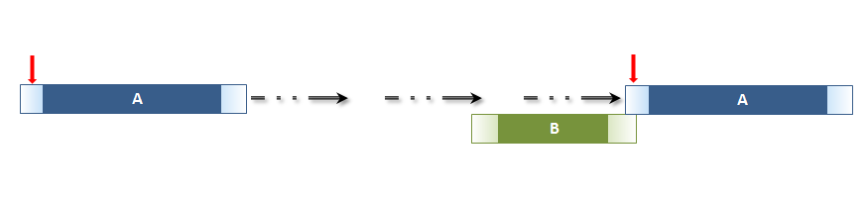

Figure 1: Temporal entity A starts before or with the end of temporal entity B. Here A is longer than B

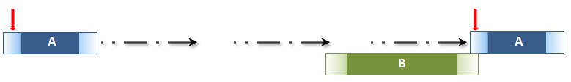

Figure 2: Temporal entity A starts before or with the end of temporal entity B. Here A is shorter than B

#### P174 starts before the end of (ends after the start of)

Domain: E2 Temporal Entity

Range: E2 Temporal Entity

Subproperty of:E2 Temporal Entity. P173 starts before or with the end of (ends after or with the start of): E2 Temporal Entity

Superproperty of: E2 Temporal Entity. P175 starts before or with the start of (starts after or with the start of):E2 Temporal Entity

E2 Temporal Entity. P184 ends before or with the end of (ends with or after the end of): E2 Temporal Entity

E7 Activity. P134 continued (was continued by): E7 Activity

E2 Temporal Entity. P118i is overlapped in time by: E2 Temporal Entity

Quantification: many to many (0,n:0,n)

Scope note:

This property specifies that the temporal extent of the domain instance A of E2 Temporal Entity starts definitely before the end of the temporal extent of the range instance B of E2 Temporal Entity.

In other words, if A = [Astart, Aend] and B = [Bstart, Bend], we mean Astart < Bend is true.

This property is part of the set of temporal primitives P173 – P176, P182 – P185.

This property corresponds to a disjunction (logical OR) of the following Allen temporal relations [Allen, 1983] :{before, meets, overlaps, starts, started-by, contains, finishes, finished-by, equals, during, overlapped by}

Typically, this property is a consequence of a known influence of some event on another event or activity, such as a novel written by someone being continued by someone else, or the knowledge of a defeat on a distant battlefield causesing people end their ongoing activities.

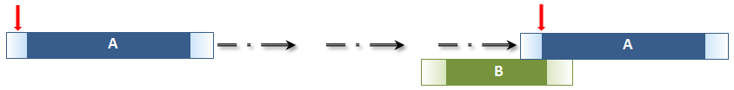

Figure 3: Temporal entity A starts before the end of temporal entity B. Here A is longer than B

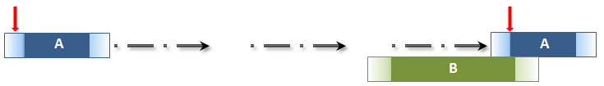

Figure 4: Temporal entity A starts before the end of temporal entity B. Here A is shorter than B

#### P175 starts before or with the start of (starts after or with the start of)

Domain: E2 Temporal Entity

Range: E2 Temporal Entity

Subproperty of: E2 Temporal Entity. P174 starts before the end of (ends after the start of):

E2 Temporal Entity

Superproperty of:

E2 Temporal Entity. P176 starts before the start of (starts after the start of): E2 Temporal Entity

E2 Temporal Entity. P116 starts (is started by): E2 Temporal Entity

E2 Temporal Entity. P116i is started by: E2 Temporal Entity

E2 Temporal Entity. P114 is equal in time to: E2 Temporal Entity

Quantification: many to many (0,n:0,n)

Scope note:

This property specifies that the temporal extent of the domain instance A of E2 Temporal Entity starts before or simultaneously with the start of the temporal extent of the range instance B of E2 Temporal Entity.

In other words, if A = [Astart, Aend] and B = [Bstart, Bend], we mean Astart ≤ Bstart is true.

This property is part of the set of temporal primitives P173 – P176, P182 – P185.

This property corresponds to a disjunction (logical OR) of the following Allen temporal relations [Allen, 1983]: {before, meets, overlaps, starts, started-by, contains, finished-by, equals}

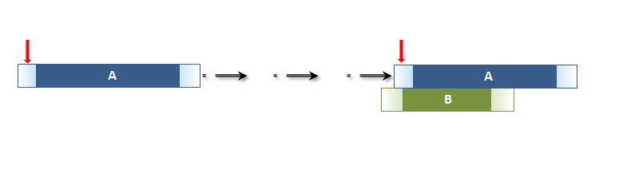

Figure 5: Temporal entity A starts before or with the start of temporal entity B. Here A is longer than B

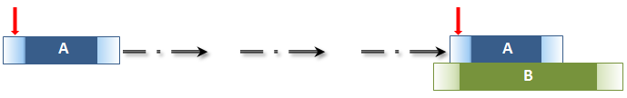

Figure 6: Temporal entity A starts before or with the start of temporal entity B. Here A is shorter

than B

#### P176 starts before the start of (starts after the start of)

Domain: E2 Temporal Entity

Range: E2 Temporal Entity

Subproperty of: E2 Temporal Entity. P175 starts before or with the start of (starts after or with the start of):E2 Temporal Entity

Superproperty of: E2 Temporal Entity. P182 ends before or with the start of (starts after or with the end of): E2 Temporal Entity

E2 Temporal Entity. P118 overlaps in time with (is overlapped in time by): E2 Temporal Entity

E2 Temporal Entity. P115i is finished by: E2 Temporal Entity

E2 Temporal Entity. P117i includes: E2 Temporal Entity

Quantification: many to many (0,n:0,n)

Scope note:

This property specifies that the temporal extent of the domain instance A of E2 Temporal Entity starts definitely before the start of the temporal extent of the range instance B of E2 Temporal Entity.

In other words, if A = [Astart, Aend] and B = [Bstart, Bend], we mean Astart < Bstart is true.

This property is part of the set of temporal primitives P173 – P176, P182 – P185.

This property corresponds to a disjunction (logical OR) of the following Allen temporal relations [Allen, 1983]: {before, meets, overlaps, contains, finished-by}

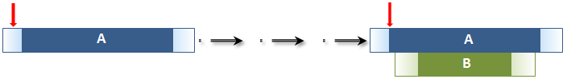

Figure 7: Temporal entity A starts before the start of temporal entity B. Here A is longer than B

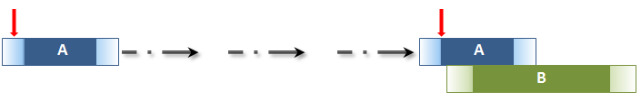

Figure 8: Temporal entity A starts before the start of temporal entity B. Here A is shorter than B

#### P182 ends before or with the start of (starts after or with the end of)

Domain: E2 Temporal Entity

Range: E2 Temporal Entity

Subproperty of: E2 Temporal Entity P176 starts before the start of (starts after the start of): E2 Temporal Entity

E2 Temporal Entity. P185 ends before the end of (ends after the end of): E2 Temporal Entity

Superproperty of: E2 Temporal Entity. P183 ends before the start of (starts after the end of): E2 Temporal Entity

E2 Temporal Entity. P119 meets in time with (is met in time by): E2 Temporal Entity

Quantification: many to many (0,n:0,n)

Scope note:

This property specifies that the temporal extent of the domain instance A of E2 Temporal Entity ends before or simultaneously with the start of the temporal extent of the range instance B of E2 Temporal Entity.

In other words, if A = [Astart, Aend] and B = [Bstart, Bend], we mean Aend ≤ Bstart is true.

This property is part of the set of temporal primitives P173 – P176, P182 – P185.

This property corresponds to a disjunction (logical OR) of the following Allen temporal relations [Allen, 1983]: {before, meets}

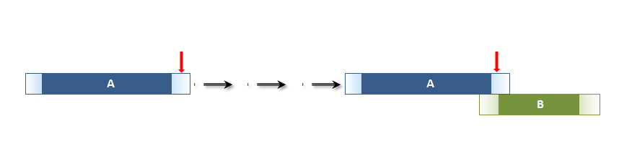

Figure 9: Temporal entity A ends before or with the start of temporal entity B. Here A is longer than B

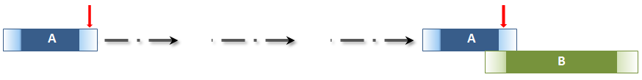

Figure 10: Temporal entity A ends before or with the start of temporal entity B. Here A is shorter

than B

#### P183 ends before the start of (starts after the end of)

Domain: E2 Temporal Entity

Range: E2 Temporal Entity

Subproperty of: E2 Temporal Entity. P182 ends before or with the start of (starts after or with the end of): E2 Temporal Entity

Superproperty of: E2 Temporal Entity. P120 occurs before (occurs after): E2 Temporal Entity

Quantification: many to many (0,n:0,n)

Scope note:

This property specifies that the temporal extent of the domain instance A of E2 Temporal Entity ends definitely before the start of the temporal extent of the range instance B of E2 Temporal Entity.

In other words, if A = [Astart, Aend] and B = [Bstart, Bend], we mean Aend < Bstart is true.

This property is part of the set of temporal primitives P173 – P176, P182 – P185.

This property corresponds to a disjunction (logical OR) of the following Allen temporal relations [Allen, 1983]: {before}



Figure 11: Temporal entity A ends before the start of temporal entity B. Here A is longer than B

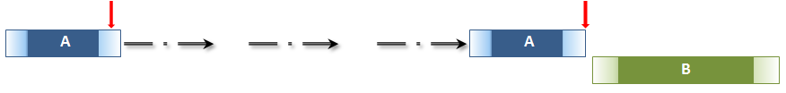

Figure 12: Temporal entity A ends before the start of temporal entity B. Here A is shorter than B

#### P184 ends before or with the end of (ends with or after the end of)

Domain: E2 Temporal Entity

Range: E2 Temporal Entity

Subproperty of: E2 Temporal Entity. P174 starts before the end of (ends after the start of): E2 Temporal Entity

Superproperty of: E2 Temporal Entity. P185 ends before the end of (ends after the end of): E2 Temporal Entity

E2 Temporal Entity. P114 is equal in time to: E2 Temporal Entity

E2 Temporal Entity. P115 finishes (is finished by): E2 Temporal Entity

E2 Temporal Entity. P115i is finished by: E2 Temporal Entity

Quantification: many to many (0,n:0,n)

Scope note:

This property specifies that the temporal extent of the domain instance A of E2 Temporal Entity ends before or simultaneously with the end of the temporal extent of the range instance B of E2 Temporal Entity.

In other words, if A = [Astart, Aend] and B = [Bstart, Bend], we mean Aend ≤ Bend is true.

This property is part of the set of temporal primitives P173 – P176, P182 – P185.

This property corresponds to a disjunction (logical OR) of the following Allen temporal relations [Allen, 1983]: {before, meets, overlaps, finished by, start, equals, during, finishes}

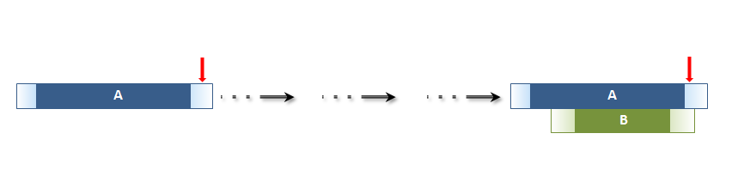

Figure 13: Temporal entity A ends before or with the end of temporal entity B. Here A is longer than B

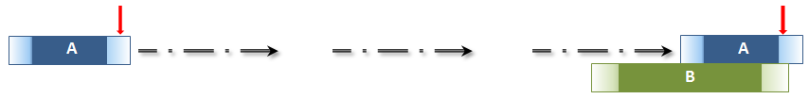

Figure 14: Temporal entity A ends before or with the end of temporal entity B. Here A is shorter than B

#### P185 ends before the end of (ends after the end of)

Domain: E2 Temporal Entity

Range: E2 Temporal Entity

Subproperty of: E2 Temporal Entity. P184 ends before or with the end of (ends with or after the end of): E2 Temporal Entity

Superproperty of:

E2 Temporal Entity. P182 ends before or with the start of (starts after or with the end of): E2 Temporal Entity

E2 Temporal Entity.P116 starts (is started by): E2 Temporal Entity

E2 Temporal Entity.P117 occurs during (includes): E2 Temporal Entity

E2 Temporal Entity.P118 overlaps in time with (is overlapped in time by): E2 Temporal Entity

Quantification: many to many (0,n:0,n)

Scope note:

This property specifies that the temporal extent of the domain instance A of E2 Temporal Entity ends definitely before the end of the temporal extent of the range instance B of E2 Temporal Entity.

In other words, if A = [Astart, Aend] and B = [Bstart, Bend], we mean Aend < Bend is true.

This property is part of the set of temporal primitives P173 – P176, P182 – P185.

This property corresponds to a disjunction (logical OR) of the following Allen temporal relations [Allen, 1983]: {before, meets, overlaps, starts, during}

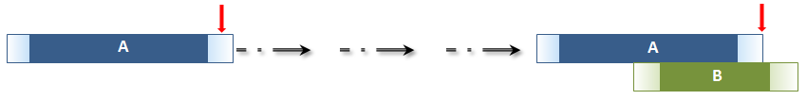

Figure 15: Temporal entity A ends before the end of temporal entity B. Here A is longer than B

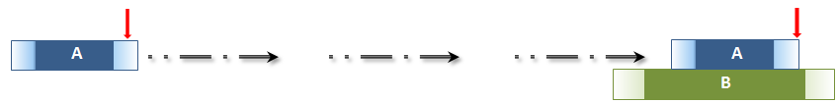

Figure 16: Temporal entity A ends before the end of temporal entity B. Here A is shorter than B